COMHAIRLE CONTAE ÁTHA CLIATH THEAS
SOUTH DUBLIN COUNTY COUNCIL

MEETING OF CLONDALKIN AREA COMMITTEE
Wednesday, September 18th, 2013
HEADED ITEM NO. 17

Pursuant to SI332/2012 all weight restrictions on the public road network are required to be reviewed. On the 1st of October all existing restrictions will no longer be valid as the basis for the selection of weight restriction is to be modified. The applicable limits are now prescribed by Gross vehicle weight instead of vehicle carrying capacity as heretofore. Existing restrictions on Council roads need to be altered in accordance with the HGV Mobility Policy recently adopted by the Council and it is also proposed to remove any obsolete restrictions. The proposals for the Clondalkin area are as follows:

Road Name | Description and sign locations | Installed | Reasons for Restriction | Review and Proposal
Clondalkin Village area | Convent Road At a point on adjacent access to Tuthills Car park, restricting access onto Tower Road, from Convent Road. Monastery Road At a point east of its junction with Laurel Park, restricting access onto Main Street (Clondalkin)  New Road  Ninth Lock Road At a point approx 15m north of entrance to the Mill Centre restricting access onto Orchard Lane  Old Nangor Road At its junction with Tower Road, restricting access from Tower Road (onto Old Nangor Road) and onto Ninth Lock Road (from Old Nangor Road)  Watery Lane At its junction with Orchard Lane, at point approx 25m east, restricting access onto Orchard Lane. | 09/08/00  3ton limit | To protect village centre from large vehicles | Current restriction is poorly configured.  Retain with a 7.5 tonne restriction zone M50 - R113, N7 - R134 Cell but excludes Monastery Road east of roundabout and St. Brigid’s Cottages. [See Fig. 1 below]  Further study of the weight restriction will be carried out within Clondalkin Village traffic report.
Clondalkin Village area | Woodford Walk  Between New Nangor Road and Monastery Road | 12/02/2010  3ton limit | Between Redcow and Nangor Road  Avoiding Longmile Road junction
Clondalkin Village area | Knockmeenagh Lane From its junction with St. Brigid’s Cottages to its junction with Newlands Avenue  St. Brigid’s Cottages From it junction with the N7 to its junction with Knockmeenagh Lane | 30/01/98  3ton limit | Narrow road with 90deg bend
Athgoe Road | From a point North East of entrance to Johnston Logistics (off the N7), to it junction with the Hazelhatch Road | 11/06/08  3ton limit | Cross country route to avoid R120 and Newcastle Village towards Celbridge from N7 | Retain with a 7.5 tonne restriction
Boot Road | Boot Road On the left side of Boot Road, at its junctions with Fonthill Road and the N7  Old Naas Road On the left side of Old Naas Road at its junction with Boot Road.  Green Isle Slip Road On Green Isle Slip Road, from a point 5m East of the entrance to Carbery Nurseries | 16/07/1997  and  20/06/2005  3Ton limit | Queue avoidance | Retain with a 7.5 tonne restriction
Mahon’s Lane | Between its junction with the N81 (Blessington Road) and its junction with Millbridge Cross-Embankment Cross Road (aka Boherboy Road). | 07/07/95  3ton limit | Narrow single lane road does not allow for vehicles to pass. | Retire and Replace with a 2.15m vehicle width restriction,  [RSU 052 (width limit sign) signs]
Mount Seskin Road | From it junction with Aghfarrell Road to its junction with the N81 (Blessington Road), one sign on the left side of Mount Seskin, southward | 29/01/2007  3ton limit | Traffic Calming and Gradient over hill | Retain with a 7.5 tonne restriction
Quarryvale | Greenfort Ave On both sides of Greenfort Ave, at points approx 55m north, from centre of Coldcut Road Roundabout. On both sides of Greenfort Avenue, at approx 25m north of its western junction with Coldcut Road  Shancastle Ave On both sides of Shancastle Ave, at points approx 25m from tip of traffic island at Liffey Road roundabout. | 29/06/2000  3ton limit | Congestion avoidance | Retire this restriction as the N4, M50 and interchange upgrades have now been completed.
Slade Road | Slade Road, between Mill Road/Millbridge Cross-Embankment Cross Road and its junction with the N81. | 28/11/1996  3ton limit | Traffic Management – prevent HGVs linking N81 and Saggart/N7 via Slade Road | Retain with a 7.5 tonne restriction  Non-residential narrow road and with gradient
Windmill Hill Road | On both sides of Windmill Hill Road (aka Windmill Road) at approx 5m, South West, of its Junction with Whitehouse Lane, and on both sides at approx 35m, North East, of its junction with Farmersvale Road (aka Blackchurch Lane) | 20/02/2003  3ton limit | Narrow rural road, N7 avoidance prior to upgrade | Retain with a 7.5 tonne restriction due to suitability of road

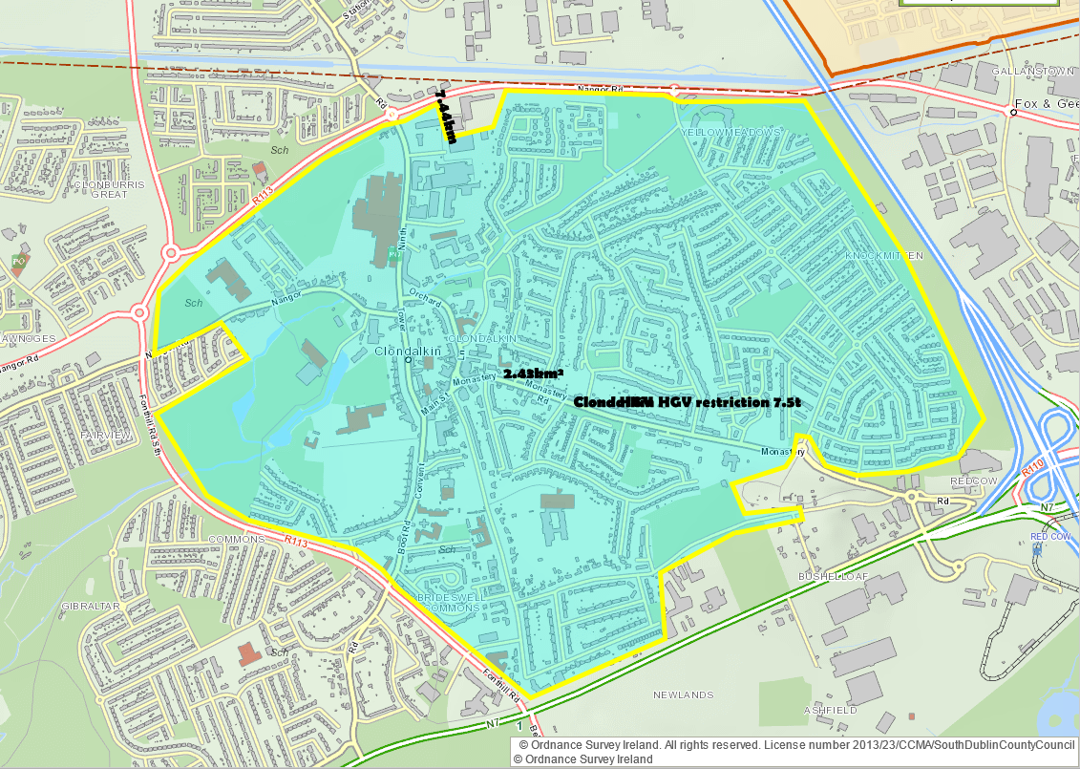
Fig. 1 Clondalkin 7.5 tonne restriction zone

