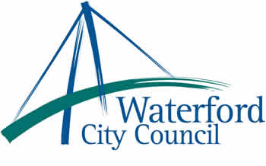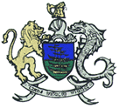

18th July 2013

To: The Meetings Administrator

The following motions were unanimously adopted by Waterford City Council at its monthly meeting held on 8th July 2013:

(a) “Waterford City Council commends the 10 former workers from Waterford Crystal in
respect of their pensions, welcomes of the decision of the European Court of Justice,
recognises the European Court of Justice has found the former Government failed in its
obligations to the workers, accepts that the judgement must go back to the High Court
but calls on the Government not to drag its heels on the issue. This Council also calls
on the Government to compensate all former workers of Waterford Crystal and to
transpose into Irish law the 2008 EU Directive and insure it gives protection to all Irish
workers and their pensions in the future.”

(b) “That Waterford City Council recognizes that the trafficking, exploitation and abuse of
women and girls is taking place in Waterford and throughout the country as a direct
result of prostitution. That Waterford City Council believes human rights abuses can be
ended by targeting the demand for prostitution by introducing laws which make it an
offence to pay for sex and is seeking such laws. We note the success of similar laws
in other European countries. That Waterford City Council will convey its views to the
Minister for Justice.”

Yours sincerely,

Billy Duggan
Meetings Administrator

