COMHAIRLE CONTAE ATHA CLIATH THEAS

SOUTH DUBLIN COUNTY COUNCIL

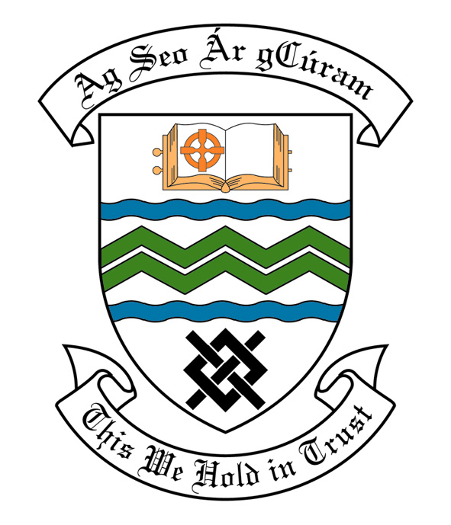
MEETING OF SOUTH DUBLIN COUNTY COUNCIL
MONDAY, 08th July, 2013
HEADED ITEM NO. H-I (2)(a)

Report of Rathfarnham Area Committee Meeting held on
Tuesday, June 11, 2013
HEADED ITEM NO. 14

Application for Grants.
Application for a grant under South Dublin County Council's Community Grants Scheme has been received from the organisation listed below. Payment of this grant, in accordance with the conditions of the Scheme and in the amount set out hereunder, is recommended for approval:-
Ref: | Name of Group | Type of Application | Date Received | Amount
GF2168 | Glendoher & District Residents Association | Environmental Improvements Grant | 29/04/13 | €500

It was proposed by Councillor P. Cosgrave, seconded by Councillor J. Lahart and RESOLVED:
“That this Committee recommends that South Dublin County Council APPROVE the grant as recommended in the foregoing report.”

