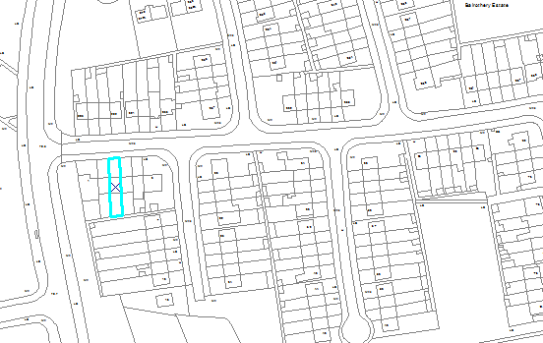
3 Balrothery Estate
Balrothery Estate

Department:  Development, Economic and Transport Planning | Small Builders Scheme-  Outlined in Blue
House No:  3 | Address:  Balrothery Estate
Townland :  Tallaght | Owners:  Peter and Maria Nolan

