COMHAIRLE CONTAE ATHA CLIATH THEAS

SOUTH DUBLIN COUNTY COUNCIL

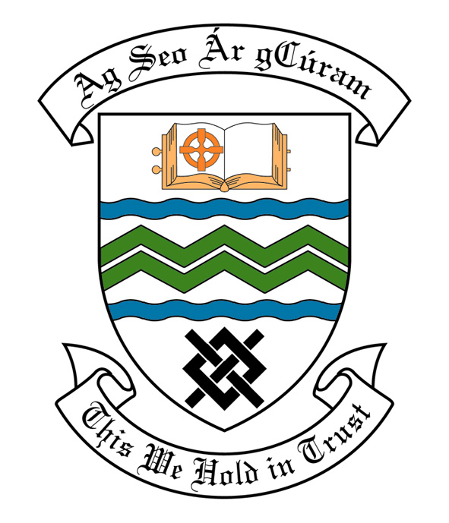
MEETING OF SOUTH DUBLIN COUNTY COUNCIL
MONDAY, 08th July, 2013
HEADED ITEM NO. H-I (2)(b)

MEETING OF CLONDALKIN AREA COMMITTEE

Wednesday 19th June, 2013

HEADED ITEM NO: H- I (12)

APPLICATION FOR GRANTS

REPORT
“Application for an Arts Grant under Section 6 of the Arts Act 2003 has been received from the organisation listed below. Payment of this grant, in accordance with the conditions of the Scheme and in the amount set out hereunder, is recommended for approval:-“
Ref: | Name of Group | Type of Application | Date Received | Amount
Agf791 | Sruleen Art Group | Art material for a studio and gallery as a community space | 17th May 2013 | €600
It was proposed by Councillor M. McDonagh and seconded by Councillor T. Gilligan:

“That this Committee recommends that South Dublin County Council APPROVE the grants as recommended in the forgoing report.”

