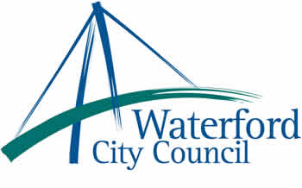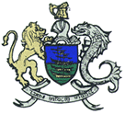

21st June 2013

To: The Meetings Administrator

The following motion was unanimously adopted by Waterford City Council at its monthly meeting held on 10th June 2013:

“This Council supports: The families of all the missing and their rights to have their loved ones returned to them. That all human remains be given a dignified burial after all scientific investigations have been carried out. The establishment of a web page, with particulars of unidentified remains/bodies that can be accessed by the public.”

Yours sincerely,

Billy Duggan
Meetings Administrator

