COMHAIRLE CHONTAE ATHA CLIATH THEAS

SOUTH DUBLIN COUNTY COUNCIL

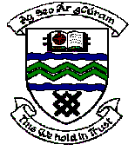

MEETING OF SOUTH DUBLIN COUNTY COUNCIL

MONDAY 14th November 2005

ITEM NO. Qu 1

Question: Councillor Jim Daly

To ask the Manager to report to the Council on his efforts this year to control bonfires?

Reply:
Staff from the Parks Department have been collecting bonfire material from Parks and open spaces from the beginning of October to Halloween. The concentration of effort was in areas where it was considered there could be a danger to persons and to property.
The Council, prior to Halloween also undertook a media / poster campaign discouraging householders from disposing of unwanted household material for bonfires.
Clean up of open spaces and removal of residue material resulting from bonfires is currently being undertaken.
Records are being compiled at present of numbers and locations of bonfires and amounts of material removed and a further report will issue to Area Committees when completed.

