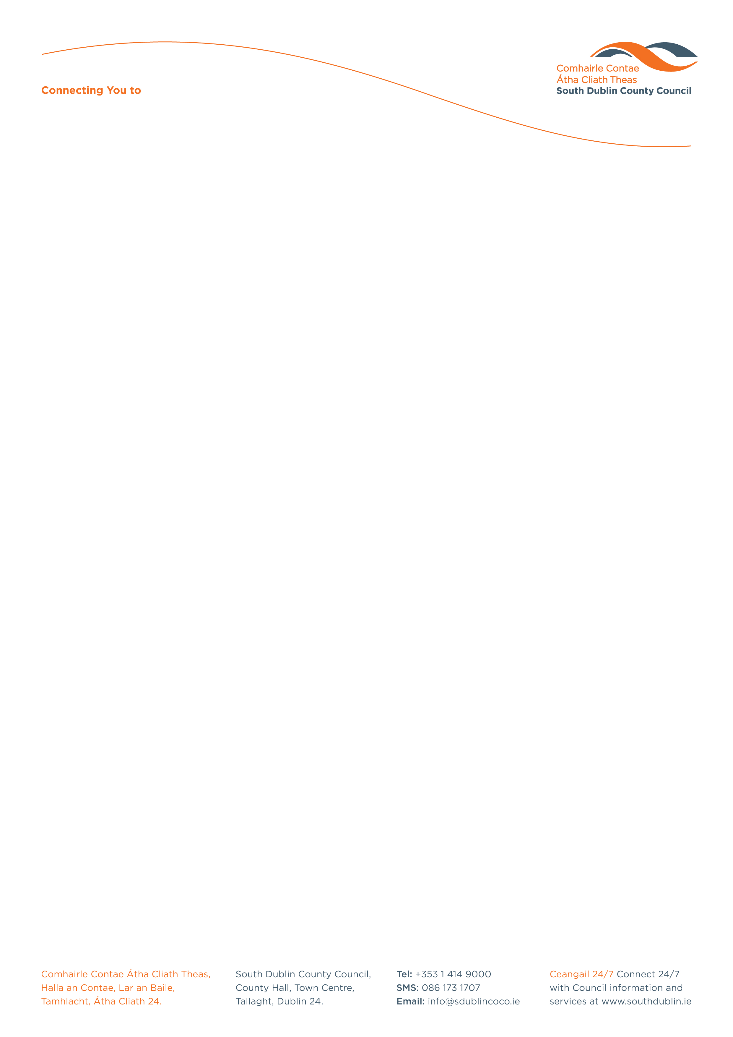

Halla an Chontae, Lár an Bhaile County Hall, Town Centre
Tamhlacht, Baile Átha Cliath 24 Tallaght, Dublin 24
Telefon: 01-4149052 Telephone: 01-4149052

Facs: 01-4149332 Fax: 01-4149332

www.southdublin.ie
Mr Pat Davitt
Chief Executive
Institute of Professional Auctioneers & Valuers
129 Lower Baggot Street
Dublin 2
May 15th, 2013

RE: Tallaght Area Committee Meeting – 29th April, 2013

Dear Sir/ Madam,

At South Dublin County Council’s Tallaght Area Committee Meeting, held on 29th April, 2013, the following Motion was passed:
“That this Committee discusses the appropriateness of Estate agents using private rented properties to advertise their business given the negative impact and transient impression this can give of entire housing estates and communities and considers proposing a voluntary code of conduct to estate agents managing and letting residential properties in the Tallaght area.”
Having discussed the matter the Area committee would wish to bring to your attention the issue of the non removal and profusion of ‘ To let’ signs in the Tallaght area. The Committee would ask the Institute to communicate with their members to remind them of their responsibilities in the removal of these signs and to be more proactive in reducing their numbers.

I should be obliged if you would let me have a reply on both matters at your earliest convenience.

Thanking you in anticipation,

Yours sincerely,

Eamon Conlon,
STAFF OFFICER,
HOUSING ADMINISTRATION.

Housing Administration

