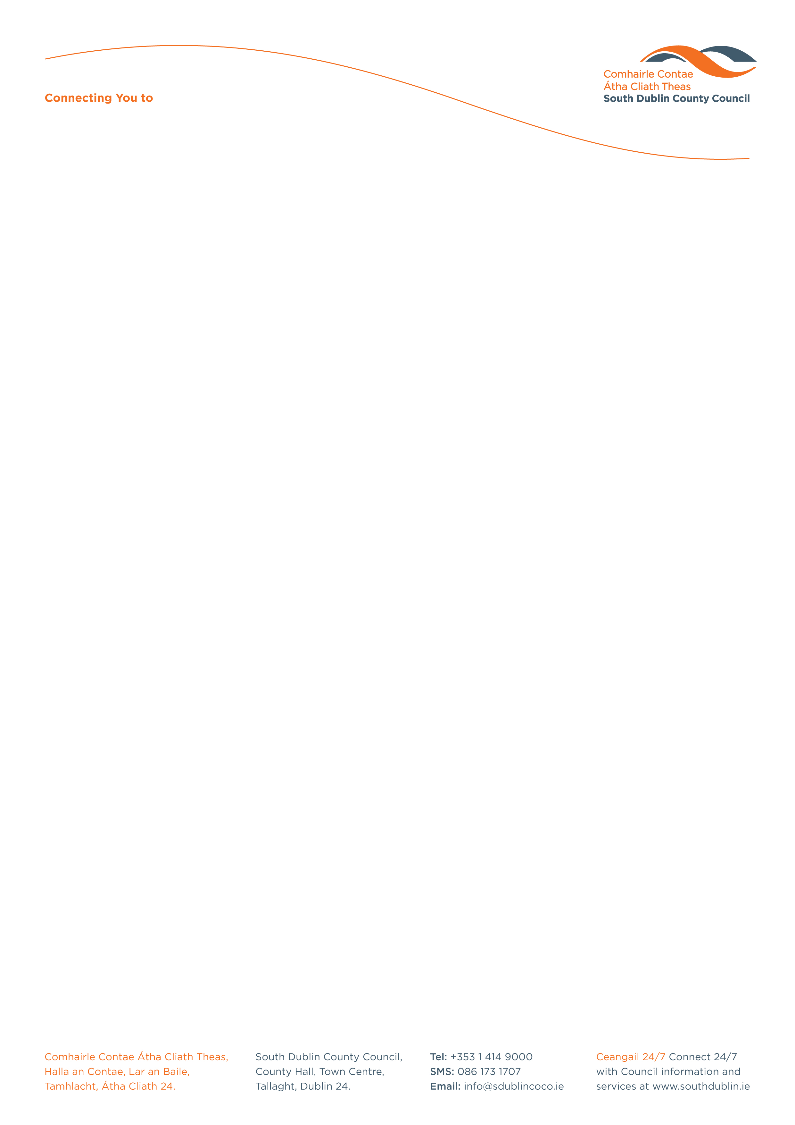

Halla an Chontae, Lár an Bhaile County Hall, Town Centre
Tamhlacht, Baile Átha Cliath 24 Tallaght, Dublin 24
Telefon: 01-4149052 Telephone: 01-4149052

Facs: 01-4149332 Fax: 01-4149332
www.southdublin.ie

Mr Roderick Smyth
94 Drumcairn Avenue
Fettercairn
Tallaght
Dublin 24

DATE: 31st May 2013

Dear Roderick,

The Mayor, Councillor C. King, and the members of South Dublin Tallaght Area Committee at its meeting held on Monday 27th May 2013 asked me to convey to you their deepest sympathy on the death of your wife, Deborah.

The Manager on her own behalf and on behalf of the Staff of the County Council wished to be associated with this expression of sympathy.

Yours sincerely,

_________________________
Eamon Conlon
Meetings Administrator,
Housing Department.

Housing Administration

