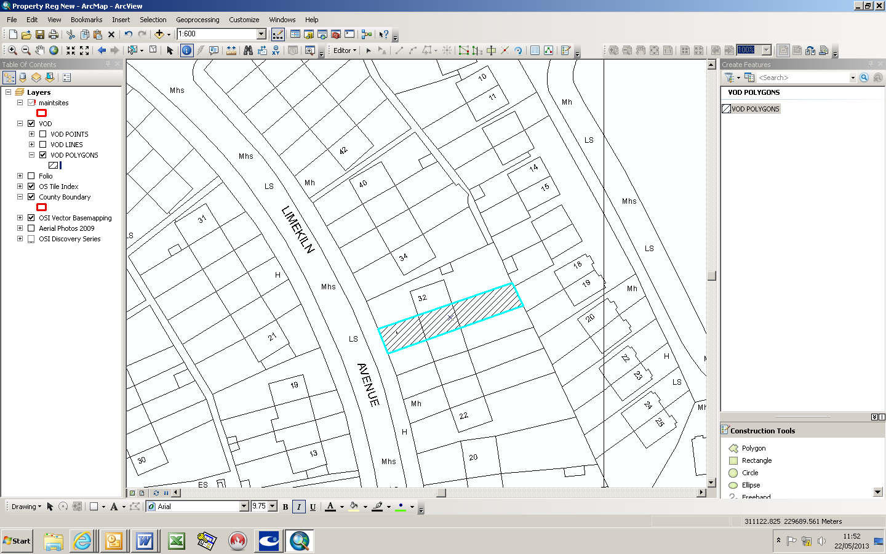

Development, Economic and Transport Planning Department | Small Builders Scheme-  Outlined in Blue hatched Grey
House no .  30 | Address:  Limekiln Road
Townland :  Limekilnfarm | Owners:  Maurice and Dolores O’Connor

