COMHAIRLE CONTAE ATHA CLIATH THEAS

SOUTH DUBLIN COUNTY COUNCIL

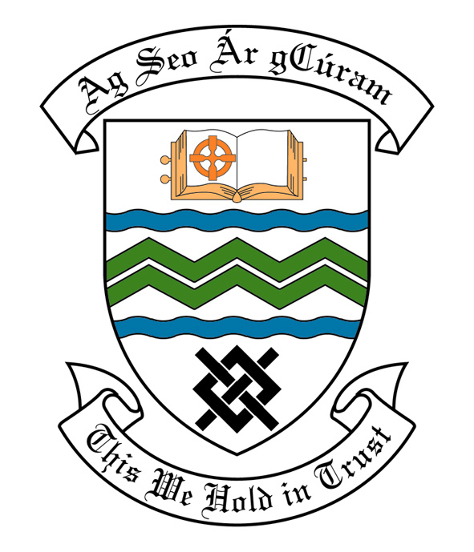
MEETING OF SOUTH DUBLIN COUNTY COUNCIL
MONDAY, 10th June, 2013
HEADED ITEM NO. H-I 2 ( b)

MEETING OF CLONDALKIN AREA COMMITTEE

Wednesday 15th May, 2013

HEADED ITEM NO: H- I (19)

APPLICATION FOR GRANTS

REPORT:
“Application for grants under South Dublin County Council’s Community Grants Scheme have been received from the organizations listed below. Payment of these grants, in accordance with the conditions of the Scheme and in the amounts set out hereunder, is recommended for approval:-“
Ref: | Name of Group | Type of Application | Date Received | Amount
SP 29 2013 | Summer Bratz | Community Activity Grant | 09/04/13 | €500
SP 27 2013 | Knockmitten Youth & Community Centre | Community Activity Grant | 08/04/13 | €500

It was proposed by Councillor B. Bonner and seconded by Councillor T. Ridge.

“That this Committee recommends that South Dublin County Council APPROVE the Grant as recommended in the forgoing report.”

