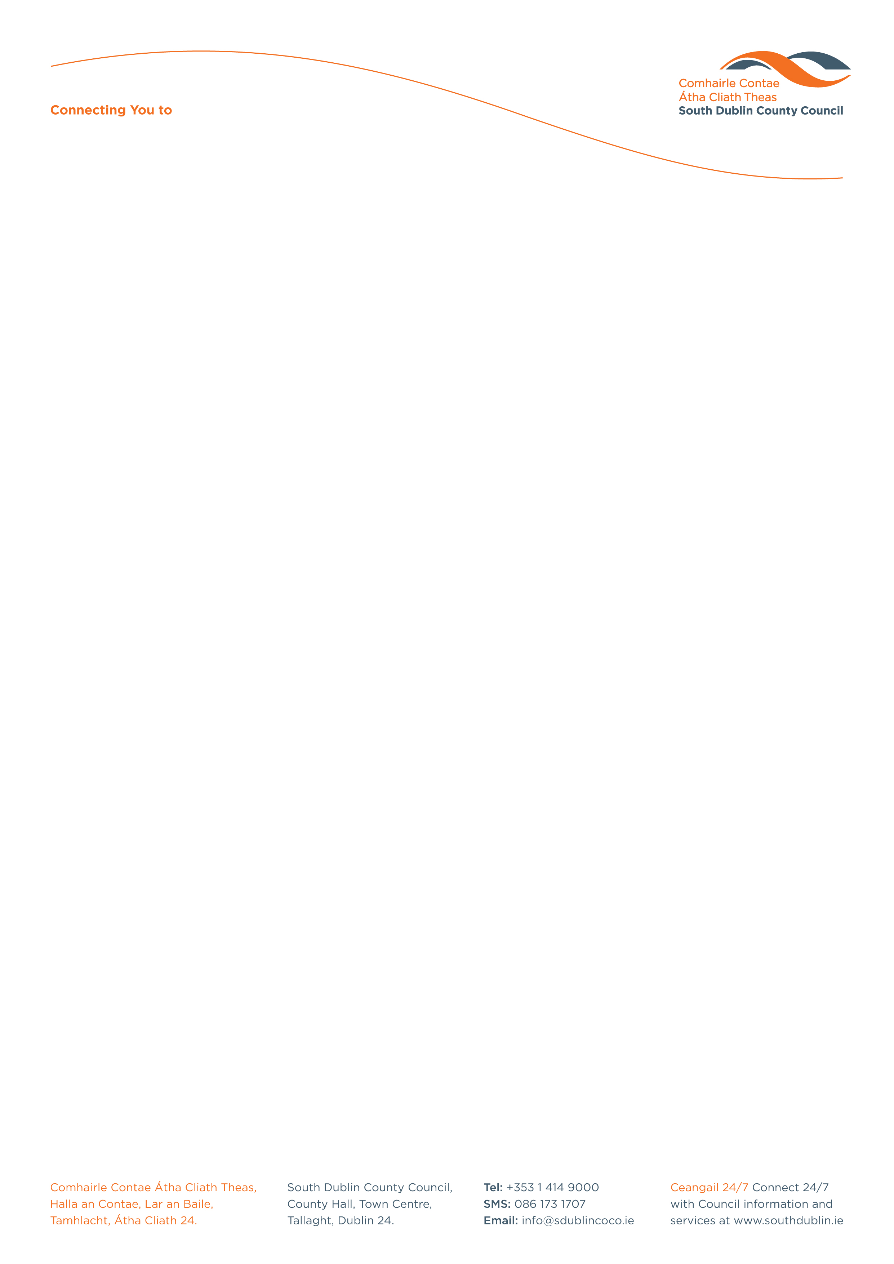

Halla an Chontae, Lár an Bhaile County Hall, Town Centre
Tamhlacht, Baile Átha Cliath 24 Tallaght, Dublin 24
Telefon: 01-4149052 Telephone: 01-4149052

Facs: 01-4149332 Fax: 01-4149332
www.southdublin.ie

Mr Alan Shatter
Minister for Justice & Equality,
94 St. Stephen's Green,
Dublin 2

May 2nd, 2013

RE: Tallaght Area Committee Meeting – 29th April, 2013

Dear Minister,

At South Dublin County Council’s Tallaght Area Committee Meeting, held on 29th April, 2013, the following question was passed:
"To ask the Minister for Justice to outline the current situation with regard to Garda accommodation in Tallaght and to indicate what plans are in place to improve the situation in the near future given the increasing need for an adequately resourced Garda cohort in the Tallaght area?"
I should be obliged if you would let me have a reply on the matter at your earliest convenience.

Thanking you in anticipation.

Yours sincerely,

Eamon Conlon,
STAFF OFFICER,
HOUSING ADMINISTRATION.

Housing Administration

