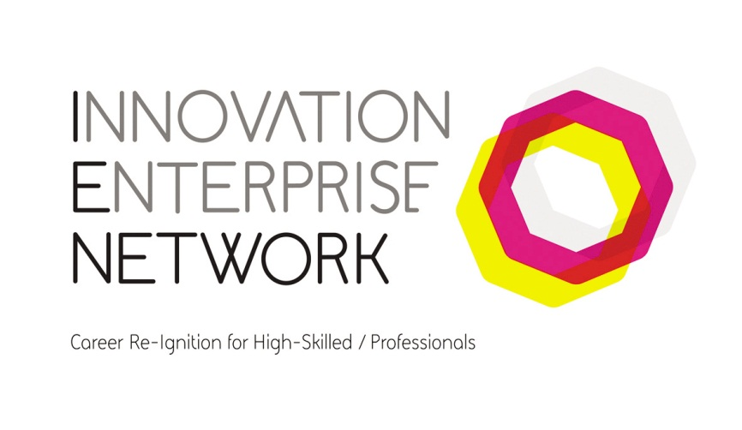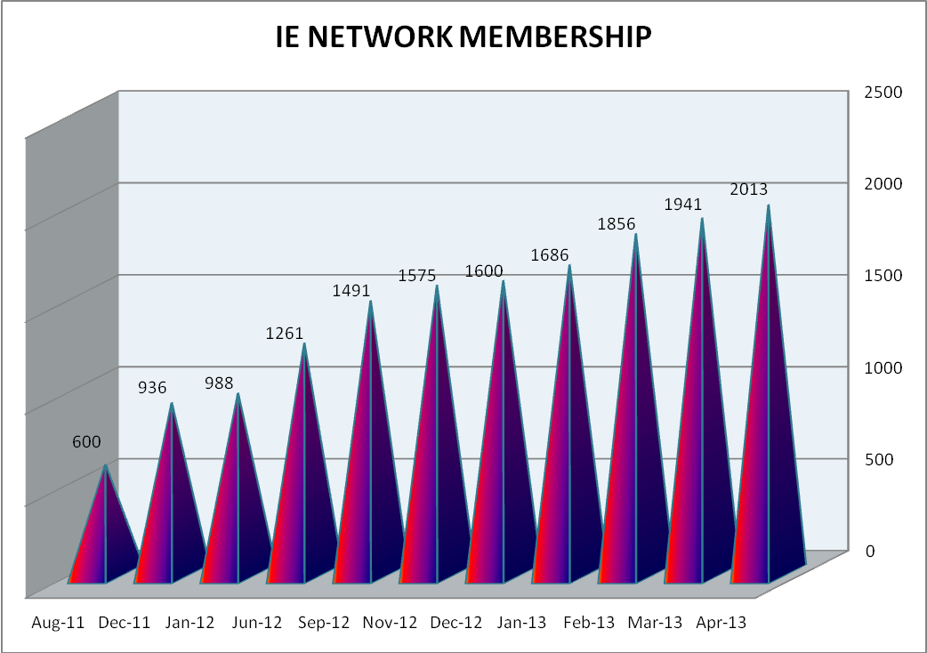

**IE Network Membership breakdown**

This is a breakdown of IE network membership by Council area, this information is voluntary and not all members state which council area they live in.

**IE Network Membership Breakdown**

* Dublin City Centre 38%
* Dun Laoghaire Rathdown 17%
* Fingal 17%
* South Dublin 28%

The information given by the members of the IE Network is voluntary; therefore not all members provide information on what their occupation was or how they are willing to help.

The figures below are from those members who were willing to share that information]

**With Industry experience in**

Admin/Support (24) Advertising/Media/Marketing (29)

Design/Multimedia (22) Education/Training (35)

Financial/Legal Services (24) IT/Software Development (52)

Sales/Business Development (41)

**Who can offer advice on**

Business Planning (96) Business Writing (79) Consultancy (158)

Desire to Help (245) Distribution (27) Feasability Study (63)

Financial Control (36) Idea Generation (226) Legal (16)

Market Research (69) Marketing and Promotion (91) Mentoring (121)

Operations (78) Reviewing (98) Sales Strategy (63)

Website Development (82) Web (9)

**IE Network Objectives**

* To support our members in their early stage of job seeking.
* To give members a purpose and focus that re-ignites their passion and drive to reach their true potential
* To bring together like-minded people and share ideas and upskill options.
* To provide stimulating & motivational seminars and workshops
* To empower our members to have the inner belief that they have the skills and the knowledge to go and setup their own business.
* Provide mentors and guidance from within the IE Network so the network can be a free source of knowledge and expertise.
* To provide an environment within the IE Network that will open members’ minds to innovation in all its different formats.
* To reinforce to members that change is good and that they can effect change, to embrace the ethos  
  “You can change, BE THE CHANGE

**IE Network Activities**

The IE Network has delivered 125 events up to 20th December 2012 and have delivered 36 events so far in 2013. The topics in these events cover a wide and variety of subjects,

* Social Media - Twitter LinkedIn Facebook Google + Pint rest
* Starting your own business Marketing Sales Business Planning Cash Flow
* Goal setting Motivational talks Career Guidance Interview Techniques

**Coner Stone Venues**

We have 2 venues in which we hold weekly meetings.

Thursday County Library Tallaght- averaging 20 attendees

Friday’s Motor Tax Office, Queen Street, D7 – averaging 30 attendees

Looking to establish 2 more venues in DLR and Fingal

We are looking to the network members to act as facilitators for the 4 venues.

We would require 3 facilitators for each region.

This would allow the delivery of 4 events every week throughout the Region

With the above established it allows us to focus on also delivering talks in other libraries across Dublin.

* Received an Outstanding Achievement Award at the IITD National Training Awards March 2013

**AchievEments**

* 45 members have returned to work in 2012
* 9 members so far have returned to work in 2013
* Assisted 3 members to set up their own companies
* Companies now use the network as a resource pool for potential employees
* Immeasurable support to members through vibrant networking.
* Increased sense of wellbeing and self-esteem
* Free training places through collaboration with Skillnet

**Networking & Collaboration**

The IE Network has collaborated with certain Skillnet groups and will have secured for the members of the IE network over €250,000 worth of training.

* Positive 2 work Skillnet
* IPFMA Skillnet
* Design Print & Packaging Skillnet
* Social Media Skillnet
* ISME Skillnet
* ITAA Skillnet
* First Polymer Training Skillnet
* CITA Skillnet
* Wind Skillnet
* Irish Franchising Skillnet

Other networks;

* Job Care – 28a Pearse Street, Dublin 2
* Job Link – Dillon House, Blanchardstown
* Dodder Valley Partnership
* Knocklyon Network Group
* Incubation Hub, Bray
* Common Purpose
* First Step
* Fumbally – Dublin City
* Fumbally Exchange –Balbriggan

It is vital on many levels that Innovation Enterprise Network continues to support the non-traditional unemployed grouping of high-skilled / professionals.

The IE Network has an 80% male membership and networking and collaboration contributes to increased self-esteem, well-being and improved mental health.

IITD Training Award

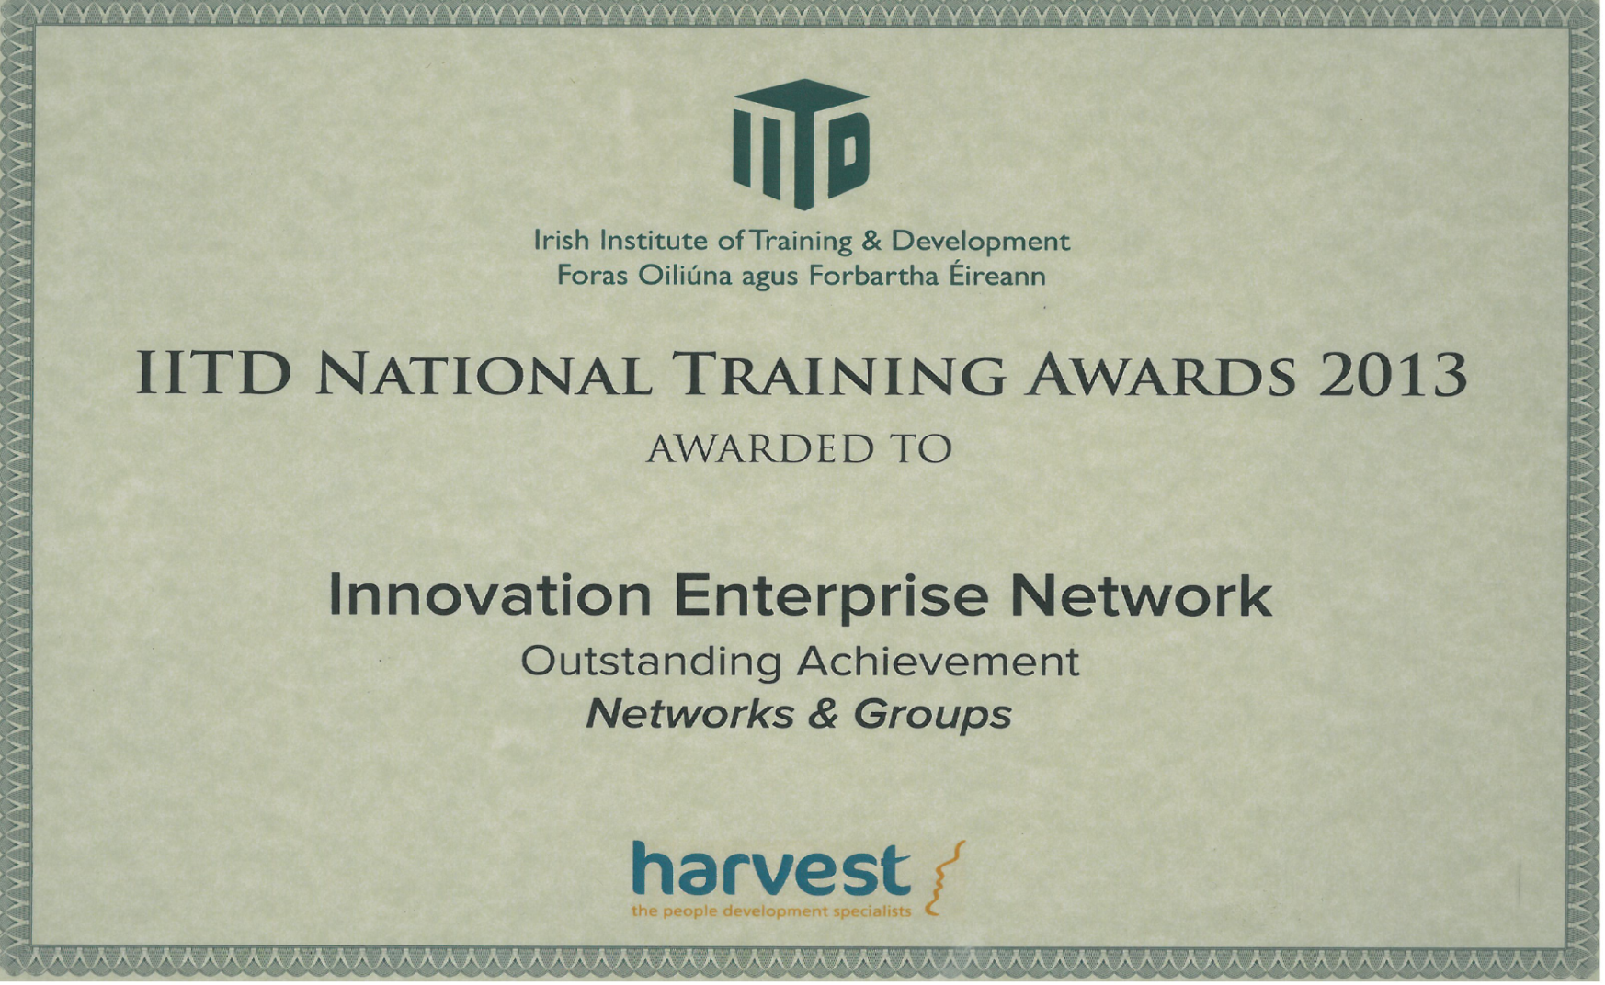

***Testimonials***

*I wanted to drop you a quick email to let you know how grateful I am for the training opportunities and the opportunity to connect with others who are in the same situation. It has been of great benefit to me personally, it has helped me return to the workforce and maintain a positive attitude in what are difficult times.   
  
I'm happy to say that I have now found my ideal job and will be starting in January.*

*Paul Fyffe (31-12-2011)*

*------------------------------------------------------------------------------------------------------------------------------------------*

*Just writing this to say a big thank you for the excellent & diligent way you perform your job within the IE Network. The emails, information and job opportunities you send out & pass on are incredible and you seem to work all the time sending out emails with last minute places, job offers etc:*

*I am currently taking the Java Programming Course at IACT leading (hopefully) to the Sun/Oracle Certified Exam on “The Fundamentals of the Java Programming Language”.*

*I am also currently taking a Springboard course at DBS in "Advanced Project Management for the ICT Professional".*

*I also completed Una Aherns excellent "Designing Your Future III" course.  
  
All these courses I discovered through your emails and I would like to sincerely thank you for the opportunities you have made me aware of.  It’s given me a fantastic opportunity to up skill through Skillnets & Springboard and the chance to move forward and progress my career.*

*Thomas Maguire (24/10/2012)*

*------------------------------------------------------------------------------------------------------------------------------------------*

*I actually started work last year at Mercer (Investment Managers) - I stayed on the emails as I was sending the links to jobs to my cousin, but he is working now too in a sports shop.*

*The IE Network is a great resource, I think the availability of courses etc. is great and there are so many free things available to the unemployed that we probably wouldn't know anything about otherwise.*

*Thanks a million and best of luck in the future.*

*Debbie Slevin (04/03/2013)*