COMHAIRLE CHONTAE ATHA CLIATH THEAS

SOUTH DUBLIN COUNTY COUNCIL

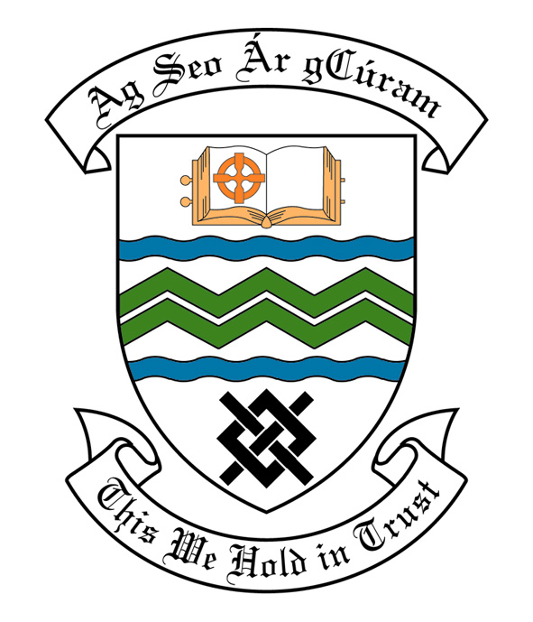

MEETING OF SOUTH DUBLIN COUNTY COUNCIL

Monday 14th November, 2005.

MEETING OF THE LUCAN/ CLONDALKIN AREA COMMITTEE(2)

Tuesday 25th October, 2005

HEADED ITEM NO: H-I 2 (f)

Application for Grants

Application for grants under the Council’s Community Grants Scheme have been received from the organisations listed below. Payment of these grants to these organisations, in accordance with the conditions of the scheme, in the amounts set out hereunder, is recommended for approval:-

Ref: | Group | Type of Application | Date of Application | Amount
57/GF 1352 | Rowlagh Village Centre,  Rowlagh,  Clondalkin,  Dublin 22. | Upgrading of Existing Community Centre | 18/10/05 | €10,000
472/GF 1353 | Ballyowen Castle Community Centre,  Ballyowen Castle Shopping Centre,  Lucan,  Co. Dublin. | Adaptation of Existing Building | 18/10/05 | €40,000
SCRA 1653/ GF 1343 | Elaine Kavanagh School of Irish Dancing,  20 St. John’s Wood,  Clondalkin,  Dublin 22. | 4.1b Major Community International Activity held in South Dublin County towards hosting a Feis in Colaiste Chillian,Clondalkin | 04/10/05 | €1,500
SCRA 1655/ GF 1351 | Lucan Sports & Leisure Centre,  Griffeen Valley Park,  Lucan,  Co. Dublin. | Upgrading of Existing Community Centre towards the installation of heating for the Centre. | 17/10/05 | €8,000
SCRA 605/ GF 1335 | Peamount United Football Club,  89 Aylmer Road,  Newcastle,  Co. Dublin. | Single Interest Grant(development of sports facility) | 06/09/05 | €40,000

Arts Grants

Application for a grant under the Council’s Arts Grant Scheme has been received from the organisation listed below. Payment of this grant to this organization, in accordance with the conditions of the Scheme, in the amount set out hereunder, is recommended for approval.

Ref: | Group | Type of Application | Date of application | Amount
SCRA 251 AGF 506 | Palmerstown One Act Drama Festival  C/O 14 Turret Road  Palmerstown  Dublin 20 | One act Drama Festival 05 | 8/9/05 | €650

It was proposed by Councillor F. Mc Carthy, seconded by Councillor D. Keating and RESOLVED:

“That this Committee recommends that South Dublin County Council approve payment of the above grants recommended in the foregoing report”.

