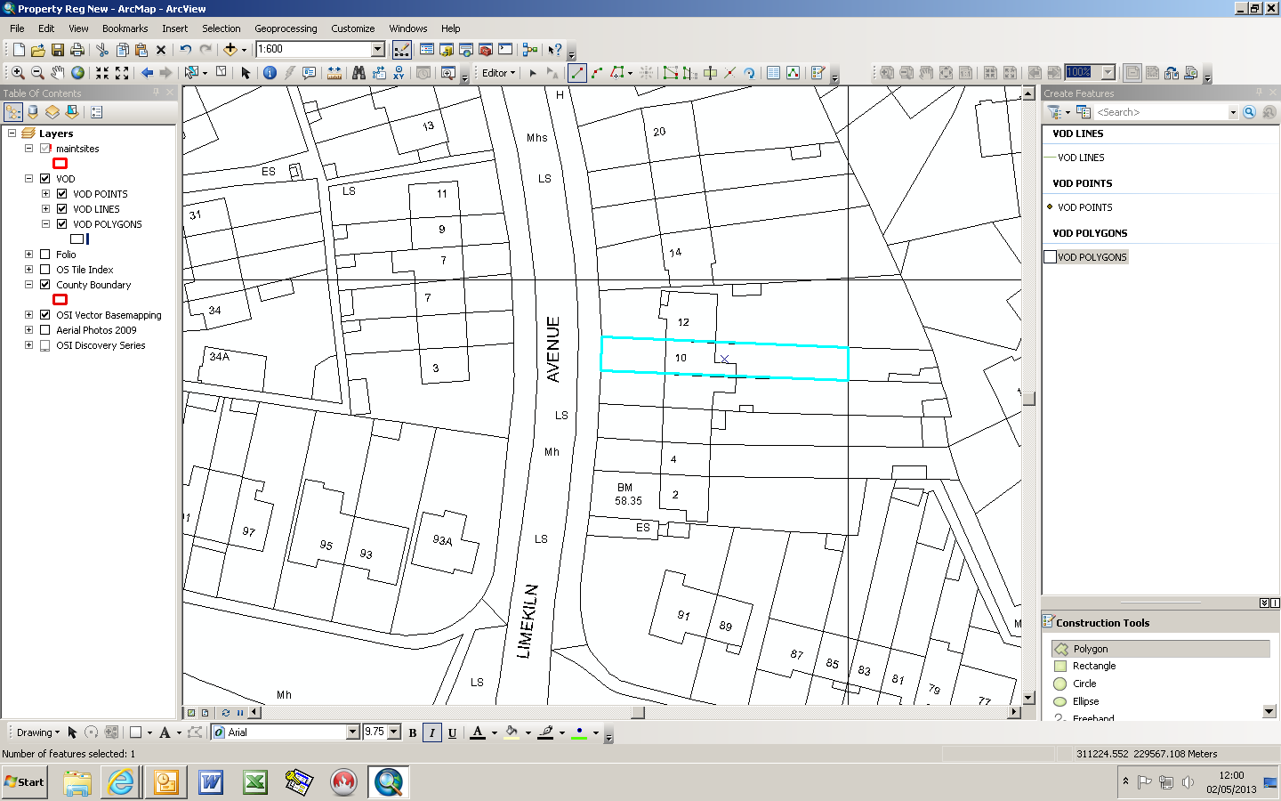

10 Limekiln Avenue, Walkinstown, Dublin 12.

