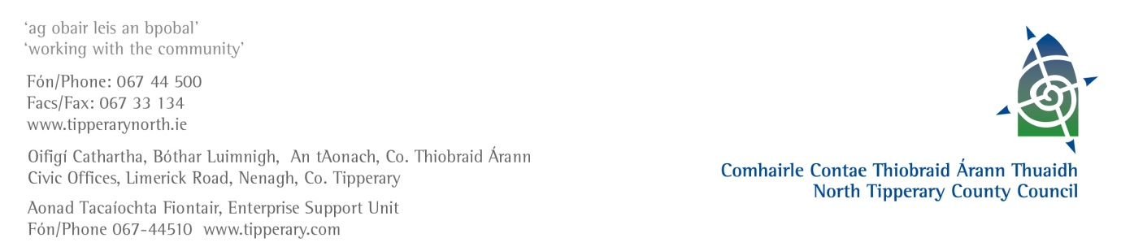

22nd April 2013

Mr. Brendan Howlin, TD

Minister for Public Expenditure and Reform

Government Buildings

Upper Merrion Street

Dublin 2

Dear Minister

At the April Meeting of North Tipperary County Council members discussed the responses received in relation to previous correspondence on rates, particularly in relation to rural public houses.  Members requested that this matter be re-considered and it was their view that some amendment could be included in the Valuation (Amendment) Bill 2012 to redress the matter.  It was considered that this could be done on the basis of providing a mechanism for an apportionment of valuation to allow parts of premises which were not in use or only used on a very occasional basis to be derated without the necessity for structural alterations to the building.  North Tipperary County Council has already been proactive in terms of reducing the Annual Rate on Valuation – a 10% reduction has been effected since 2010.  This is in recognition of the difficulties being experienced by the business sector.  Rate reductions such as this, however, are more beneficial to the larger ratepayers whereas there are a large number of rural pubs for whom the effects of such a reduction are minimal and the real difficulty is the valuation.  We are all aware of the large number of premises of this nature that have already closed down.  In rural Ireland these pubs are part of the fabric of rural society and are of huge social importance to local communities.  It is considered that some form of concession should be introduced and that this could best be done through the valuation systems.  Members requested that this be re-examined.

I would be grateful if you would reply to my letter so that I may appraise the members of same.

Yours sincerely

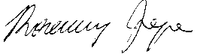

Rosemary Joyce

Senior Executive Officer/Meetings Administrator

Corporate Support

Tel: 067 44563

Email: [rjoyce@northtippcoco.ie](mailto:rjoyce@northtippcoco.ie)