COMHAIRLE CONTAE ATHA CLIATH THEAS

SOUTH DUBLIN COUNTY COUNCIL
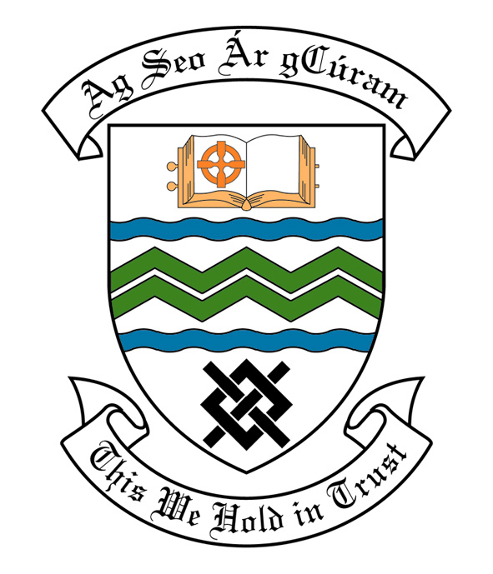
MEETING OF SOUTH DUBLIN COUNTY COUNCIL
MONDAY, 13th May, 2013
HEADED ITEM NO. H-I ( 2b )

MEETING OF CLONDALKIN AREA COMMITTEE

Wednesday 17TH April, 2013.

HEADED ITEM NO: H- I (2)

APPLICATION FOR GRANTS

REPORT ON SUMMER PROJECTS 2013

Summer Projects are aimed at providing a supervised programme of recreational and educational activities for young people over a consecutive number of weeks in the summer period. Emphasis is placed on community involvement and the development of resources and groups within localities. A wide range of activities are encouraged such as arts & crafts, sports, educational trips, drama, films, games etc. The use of available community facilities (schools, community centres, halls, open spaces) is also encouraged.

South Dublin County Council assists Summer Projects in the County area by way of grant-aid, assistance in kind, organised activities and staff support. In 2013 it is estimated that approximately 6,000 young people in the Council’s administrative area will participate in projects.

County Dublin V.E.C has agreed to continue their financial support to Summer Projects for the year 2013. These grants will be complementary to the above resulting in co-ordination between the two authorities, ensuring there is added value from this approach.

Catholic Youth Care provides insurance cover for Summer Projects.

It should be noted that in some cases the necessary insurance cost will be deducted from the grant provided by South Dublin County Council and will be paid directly to Catholic Youth Care.

Name of Project: Duration of Project Grant Amount
Rowlagh/ Neilstown
Summer Project 2 Weeks €1,000
Clondalkin Youth Service
Village Project 3 Weeks €1,500
Sruleen Summer Project 3 Weeks €1,500
Knockmitten Summer Project 3 Weeks €1,500

Bawnogue Summer Project 3 Weeks €1,500

St. Ronan’s/ Deansrath
Summer Project 3 Weeks €1,500

Bawnogue Youth & Community
Centre Summer Festival 2 Weeks €1,000

Clondalkin Travellers
Development Group 2 Weeks €1,000

Quarryvale Summer Project 2 Weeks €1,000

Application for Arts Grants
Application for an Arts Grant under Section 6 of the Arts Act 2003, has been received from the organisation listed below. Payment of this grant, in accordance with the conditions of the Scheme and in the amount set out hereunder, is recommended for approval:-
Ref: | Name of Group | Type of Application | Date Received | Amount
Agf778 | St Mary’s SNS | Towards the cost of music workshops | 7/2/2013 | €500

It was proposed by Councillor M. McDonagh and seconded by Councillor B. Bonner

“That this Committee recommends that South Dublin County Council APPROVE the grants as recommended in the forgoing report

