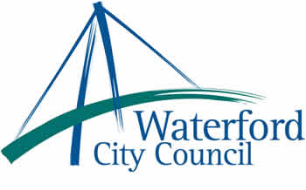

27th March 2013

To: The Meetings Administrator

The following motion was unanimously adopted by Waterford City Council at its monthly meeting held on 11th March 2013:

“That this Council calls on the Minister of Education Ruairi Quinn to recognize the very special place the Waterford College of Further Education plays in deliverance and facilitating access to full scale 3rd level education and to reverse the education cuts that directly affect the Waterford College of Further Education, who will lose 4 to 6 teachers under his proposal and as many as 120 students.
This at a time when the City of Waterford is experiencing severe job losses and education is identified as a pathway to securing jobs.”

Yours sincerely,

Billy Duggan
Meetings Administrator

