COMHAIRLE CONTAE ATHA CLIATH THEAS

SOUTH DUBLIN COUNTY COUNCIL

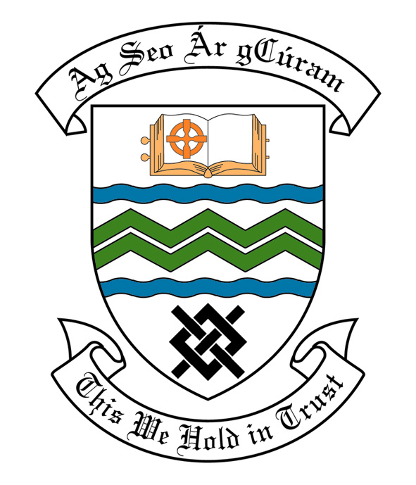
MEETING OF SOUTH DUBLIN COUNTY COUNCIL
MONDAY, 11th March, 2013
HEADED ITEM NO. H2b)

REPORT OF MEETING OF CLONDALKIN AREA COMMITTEE

Wednesday 20th February 2013

HEADED ITEM NO: H- I .(10)

Application for Arts Grants

Application for an Arts Grant under Section 6 of the Arts Act 2003, has been received from the organisations listed below. Payment of these grants, in accordance with the conditions of the Scheme and in the amounts set out hereunder, is recommended for approval:-

Ref: | Name of Group | Type of Application | Date Received | Amount
Agf773 | Clondalkin Youth Theatre | Grant towards the cost of drama workshops | 23/01/2013 | €500
Agf776 | Palmerstown One Act Drama Festival | Grant towards the cost of all Ireland one act drama festival | 29/01/2013 | €600

It was proposed by Councillor M. McDonagh and seconded by Councillor T. Gilligan.

“That this Committee recommends that South Dublin County Council APPROVE the grants as recommended in the forgoing report.”

