COMHAIRLE CONTAE ATHA CLIATH THEAS

SOUTH DUBLIN COUNTY COUNCIL

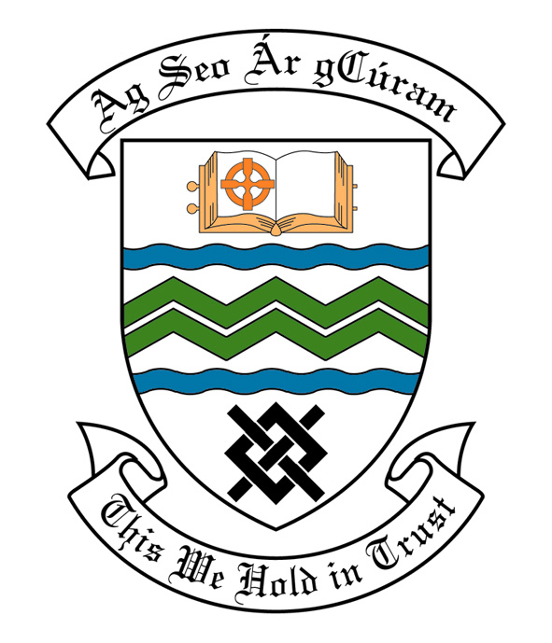
MEETING OF SOUTH DUBLIN COUNTY COUNCIL
MONDAY, 14th January, 2013
HEADED ITEM NO. H-I ( 2d)

MEETING OF CLONDALKIN AREA COMMITTEE

Wednesday 19th December, 2012

HEADED ITEM NO: H- I (16)

Application for Grants

Application for a grant under South Dublin County Council’s Community Grants Scheme has been received from the organisation listed below. Payment of this grant, in accordance with the conditions of the Scheme and in the amount set out hereunder, is recommended for approval:-

Ref: | Name of Group | Type of Application | Date Received | Amount
GF2140 | Round Tower Juvenile Section | Major Equipment Grant | 27/11/12 | €2,400

It was proposed by Councillor T. Gilligan and seconded by Councillor M. McDonagh.

“That this Committee recommends that South Dublin County Council APPROVE the grants as recommended in the forgoing report.”

