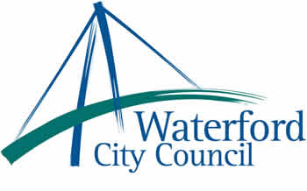

17th December 2012

To: The Meetings Administrator

The following motion was adopted by Waterford City Council at its monthly meeting held on 10th December 2012:

“That Waterford City Council rejects the proposed amalgamation of Waterford City and County Councils as proposed in “Putting People First”, by the Minister for Environment”

Yours sincerely,

Billy Duggan
Meetings Administrator

