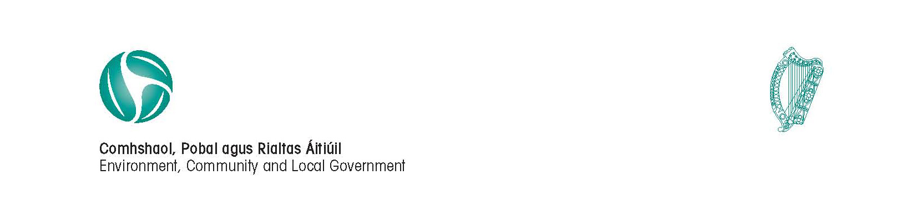
Circular Fin 12/2012

9 November 2012

Re: 2013 Budget Meetings and related matters

Dear Head of Finance,

I am directed by the Minister for the Environment, Community and Local Government to refer to the 2013 Budget meeting and other budget matters.

Prescribed Periods
The prescribed periods that apply for the holding of 2013 Budget meetings are as follows:

- County Councils: 24 November 2012 to 13 January 2013
- City/Borough/Rating Town Councils: 24 November 2012 to 15 January 2013
- Non-Rating Town Councils/Joint Bodies: 15 November 2012 to 16 December 2012

EU “Two Pack” budget requirements
In September 2010 the European Commission presented six new legislative proposals to reinforce economic governance. The new measures, approved in October 2011 and due to come into force in 2012, are generally referred to as the Six-Pack proposals. The new laws toughen the rules of the EU’s Stability and Growth Pact (SGP) and are intended to help Member States limit budget deficits and government debts.

The Six-Pack also introduces strict controls designed to help prevent imbalances such as property bubbles. Rules to raise the standard of financial statistics from Member States so budgetary policy-making and economic monitoring can be more accurate are also included in the six pieces of legislation and financial decision makers will be held more accountable for their actions.

Further legislative proposals were presented late in 2011 in the form of two texts which build on the economic governance "six pack" legislation, hence the name "two pack", and focus on strengthening EU Commission surveillance of national budgetary and economic policy and further economic policy coordination.

The timing of the national Budget will be altered by the two pack proposals which are currently in trialogue negotiations (between the European Parliament, the Commission and the Council). These negotiations have proceeded over an extended period. However, the latest indications from the Department of Finance are that a 15 October requirement for the submission of budgetary proposals will be operational in 2013 in respect of 2014. For local authorities, this means that the main parameters of the sub-sector’s budget will have to be in place for submission to the EU Commission by 15 October 2013 along with the central government draft budgetary plan.

The Department is currently liaising with the CCMA Finance Committee in relation to the mechanisms required in order to meet the “Two Pack” requirements. Authorities should be aware that the budgetary period for Budget 2014 may have to be brought forward in 2013 and that a Capital Budget Plan in respect of 2014 will also be required.

The Department will keep the CCMA Finance Committee informed of progress on the “Two Pack” negotiations at EU level and the resulting impact for local authority budgets for 2014.

Submission of budget information
All CSV’s files, hard copy budgets must be submitted to Ruth Nolan (Ruth.Nolan@environ.ie) and Liz O’Brien (LizM.O'Brien@environ.ie) by Monday 11th February 2013.

To reduce the level of queries, the following checks should be completed prior to submission:

- All checks on the soft copy budget check sheets are at 0
- CSV files should be checked for format errors, such as incorrect line errors, commas, etc.
- Soft copy budget files should be submitted with each CSV file.
- All CSV figures should be rounded to whole numbers.
- All submissions to be checked and submitted by the contact person for the local authority’s budget files in event of any queries arising.

Mise le meas,

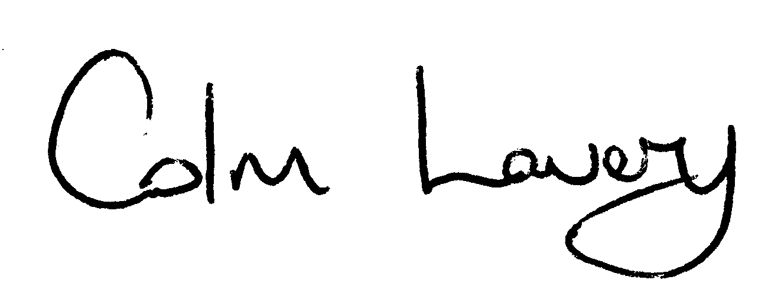
_______________________
Colm Lavery
Principal Officer
Local Government Finance

To: All Local Authorities

