COMHAIRLE CONTAE ÁTHA CLIATH THEAS
SOUTH DUBLIN COUNTY COUNCIL

MEETING OF LUCAN AREA COMMITTEE
Tuesday, November 27, 2012
MOTION NO. 9
MOTION: Councillor E. Higgins
"That the Manager provide a report on bonfires in the Lucan LEA and clean up costs this Halloween?"
REPORT:
Hallowe’en 2012 fell on Wednesday 31st October 2012. As in previous years, bonfire related activity commenced approximately two weeks in advance of Hallowe’en with the first reports received from the public via the Customer Care system being logged on the 15th October 2012.
Pre Halloween Sites
In total, 134 customer care enquiries were logged in the customer care system by close of business on 31st October reporting bonfire materials at locations around the county. While some of these reports were duplicated, they translated into a total of 89 sites to be dealt with. The map below shows the range of locations reported in the Lucan electoral area –

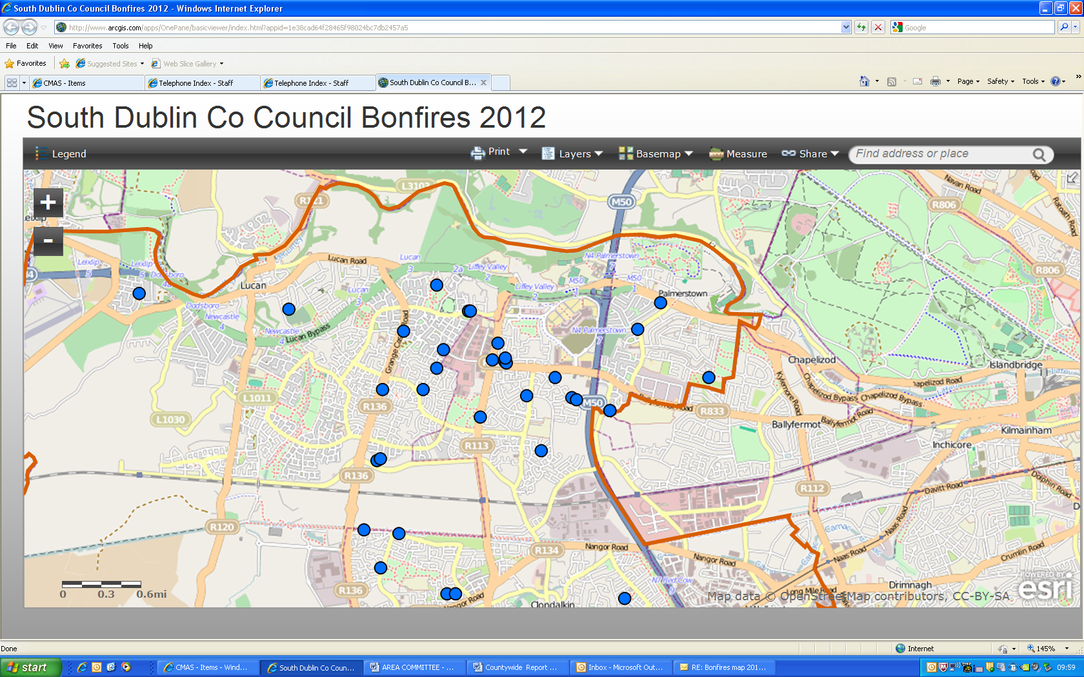
Bonfire Sites
There were 380 recorded bonfires countywide in 2012. This represents an 8% increase on the 2011 figure (351). 30 of these bonfires took place in the Lucan electoral area. The map below shows the locations where bonfires took place.
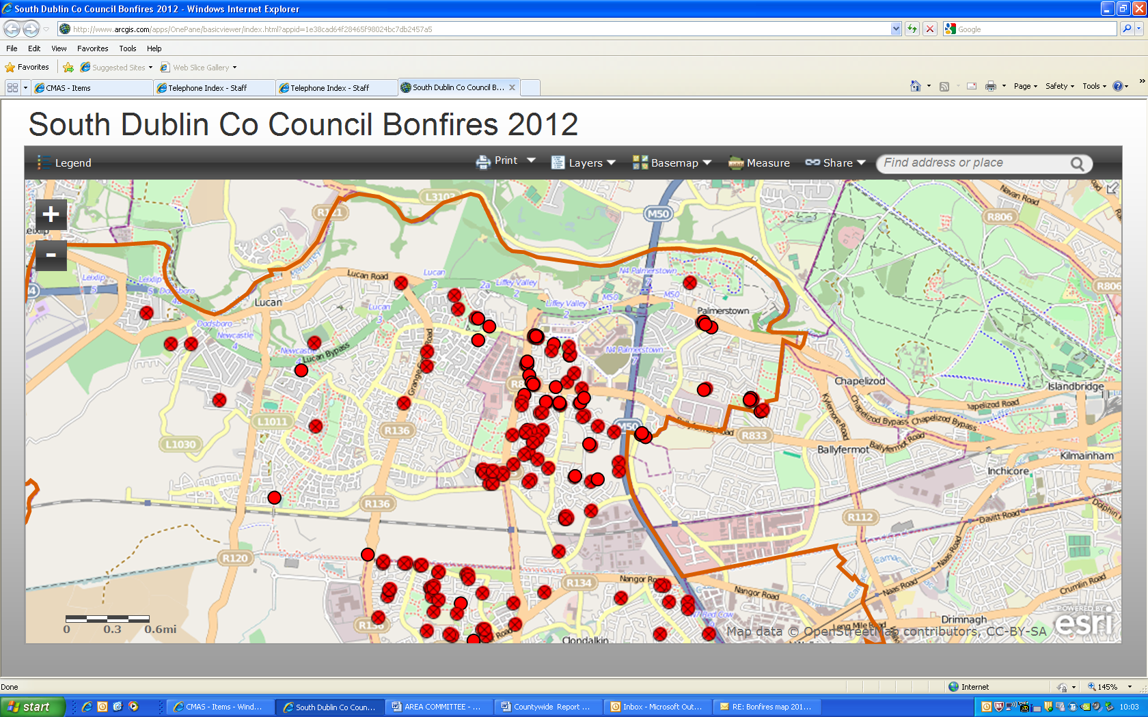
The cleanup has been completed in the LEA and the cost of the operation was approximately €7,000.

