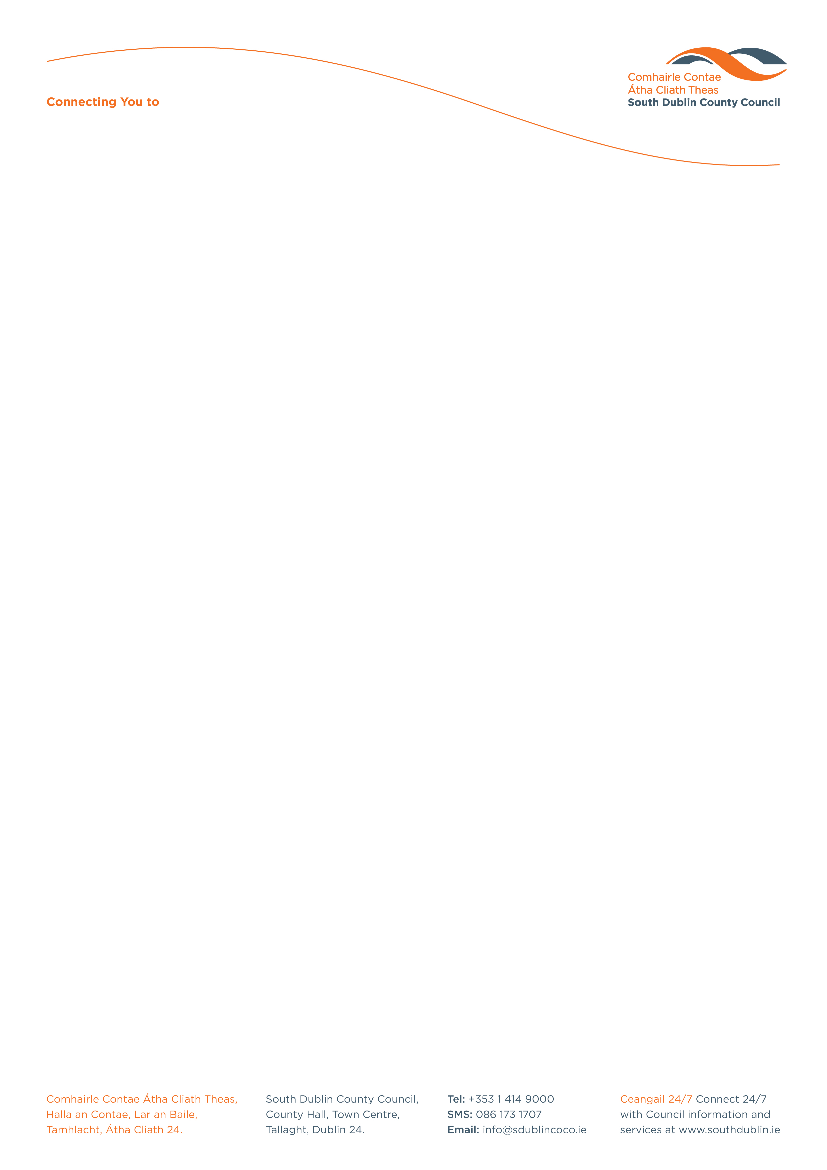

Halla an Chontae, Lár an Bhaile County Hall, Town Centre
Tamhlacht, Baile Átha Cliath 24 Tallaght, Dublin 24
Telefon: 01-4149052 Telephone: 01-4149052

Facs: 01-4149332 Fax: 01-4149332
www.southdublin.ie

Mr. Paddy Doherty,
Chief Executive,
Dublin Bus,
O’Connell Street,
Dublin 1.

October 25, 2012

RE: Tallaght Area Committee Meeting 22nd October, 2012

Dear Mr. Doherty,

At South Dublin County Council’s Tallaght Area Committee Meeting, held on 22nd October, 2012, the following Motion was passed:
“That this committee following recent cuts to the 65B bus route calls on the management of Dublin Bus to desist from any further cuts to bus routes in the area with particular emphasis on the 150 route, as it is inflicting hardship on their customers.”

I should be obliged if you would let me have a reply on the matter at your earliest convenience.

Thanking you in anticipation.

Yours sincerely,

Eamon Conlon,
STAFF OFFICER,
HOUSING ADMINISTRATION.

Housing Administration

