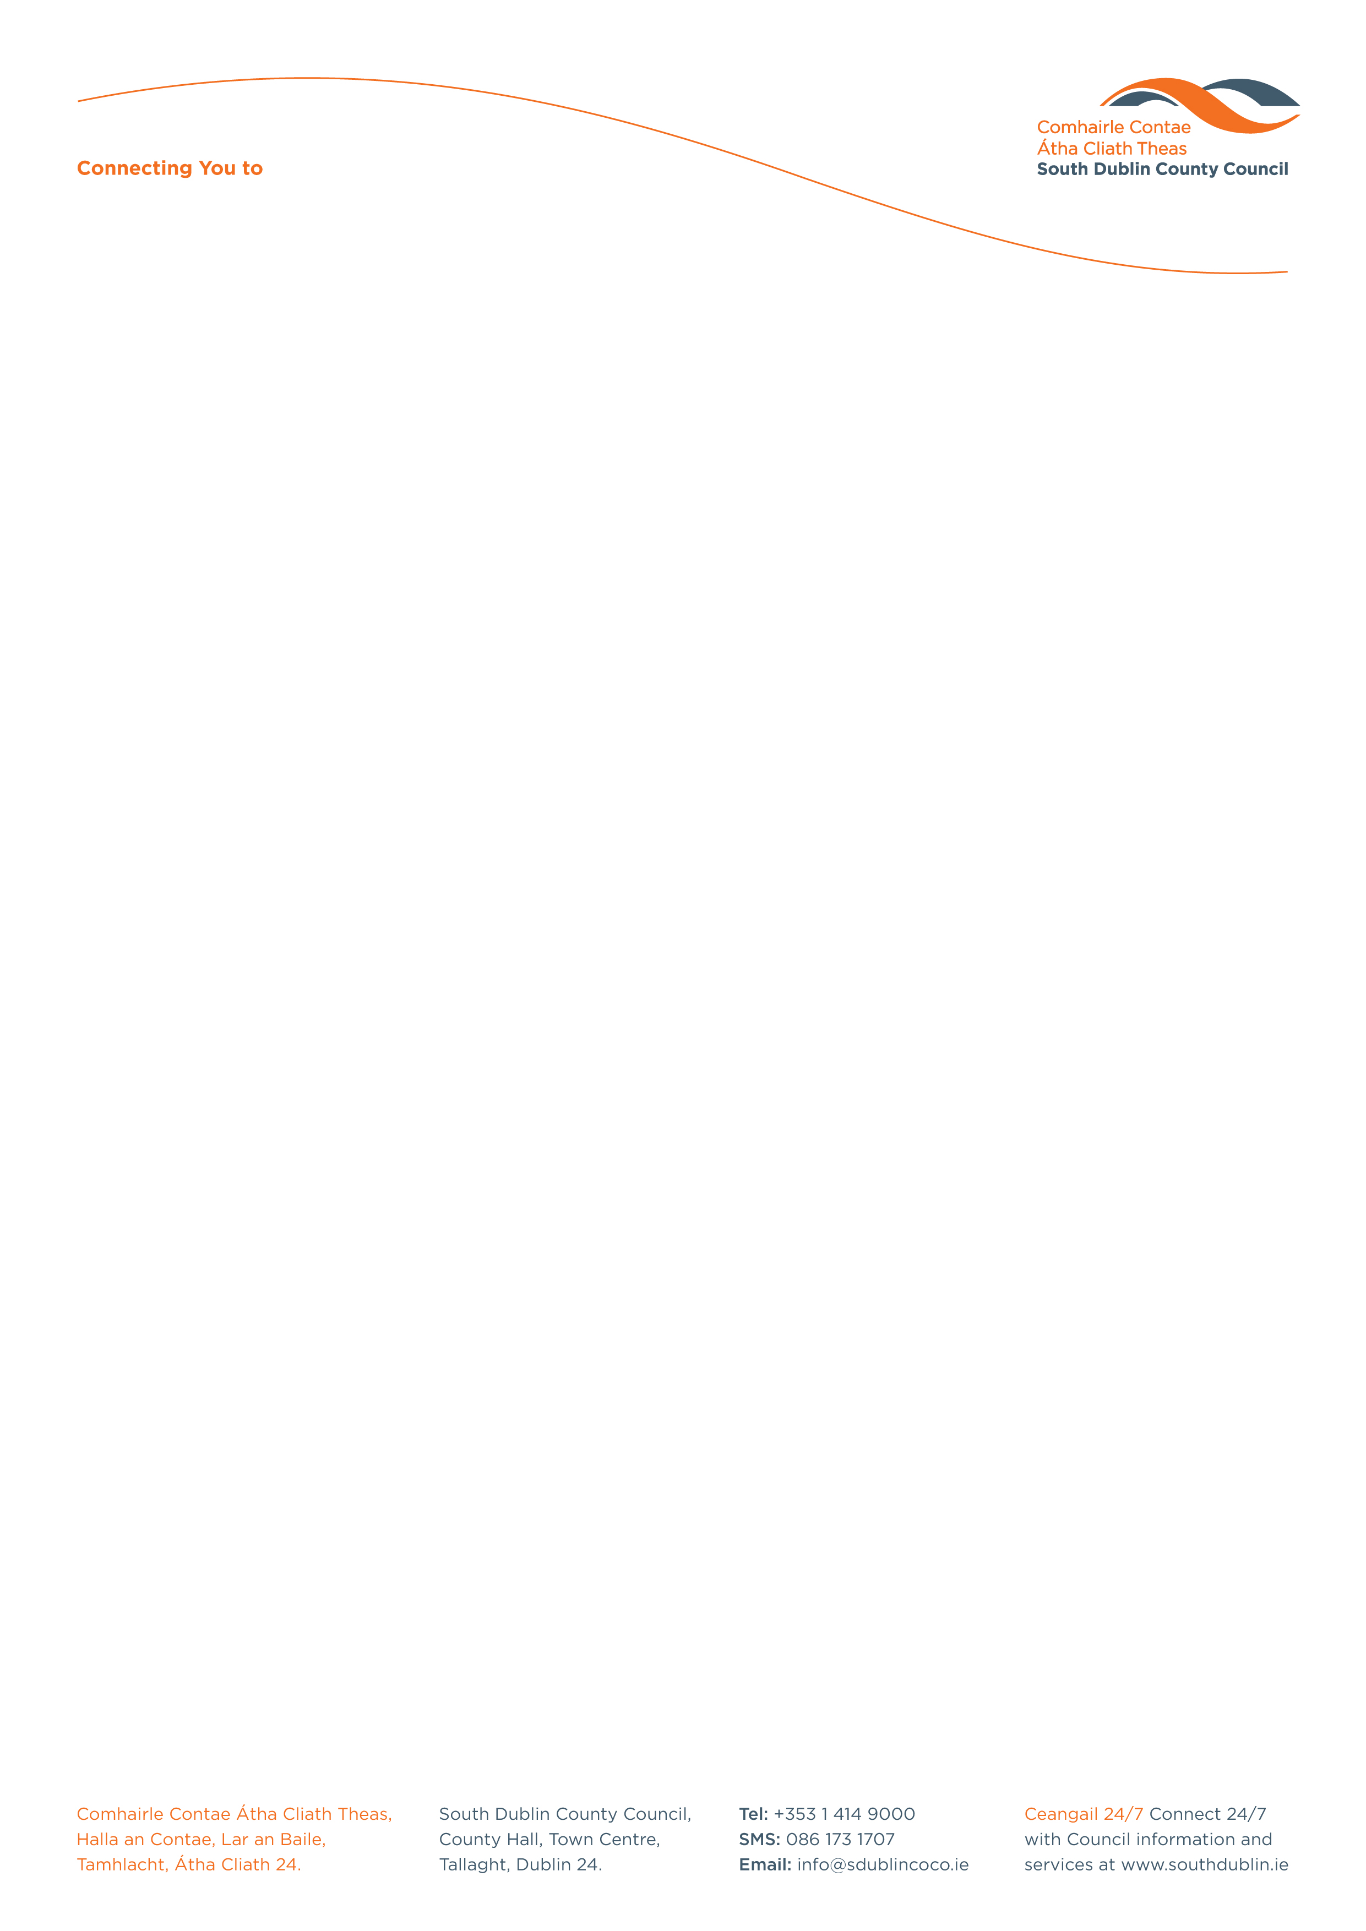

Halla an Chontae, Lár an Bhaile County Hall, Town Centre
Tamhlacht, Baile Átha Cliath 24 Tallaght, Dublin 24
Telefon: 01-4149052 Telephone: 01-4149052

Facs: 01-4149332 Fax: 01-4149332
www.southdublin.ie

Mr. Phil Hogan T.D
Minister for the Environment, Community and Local Government
Custom House Quay
Dublin 1.

October 25, 2012

RE: Tallaght Area Committee Meeting 22nd October, 2012

Dear Minister,

At South Dublin County Council’s Tallaght Area Committee Meeting, held on 22nd October, 2012, the following Motion was passed:
“That this Committee write to the Minister for Environment, Community and Local Government to seek an update on possible local electoral area boundary reviews, and to express the view of this Committee that the name of the "Tallaght Central" local electoral area is unsuitable and should be replaced to also account for areas outside of Tallaght in the LEA.”
I should be obliged if you would let me have a reply on the matter at your earliest convenience.

Thanking you in anticipation.

Yours sincerely,

Eamon Conlon,
STAFF OFFICER,
HOUSING ADMINISTRATION.

Housing Administration

