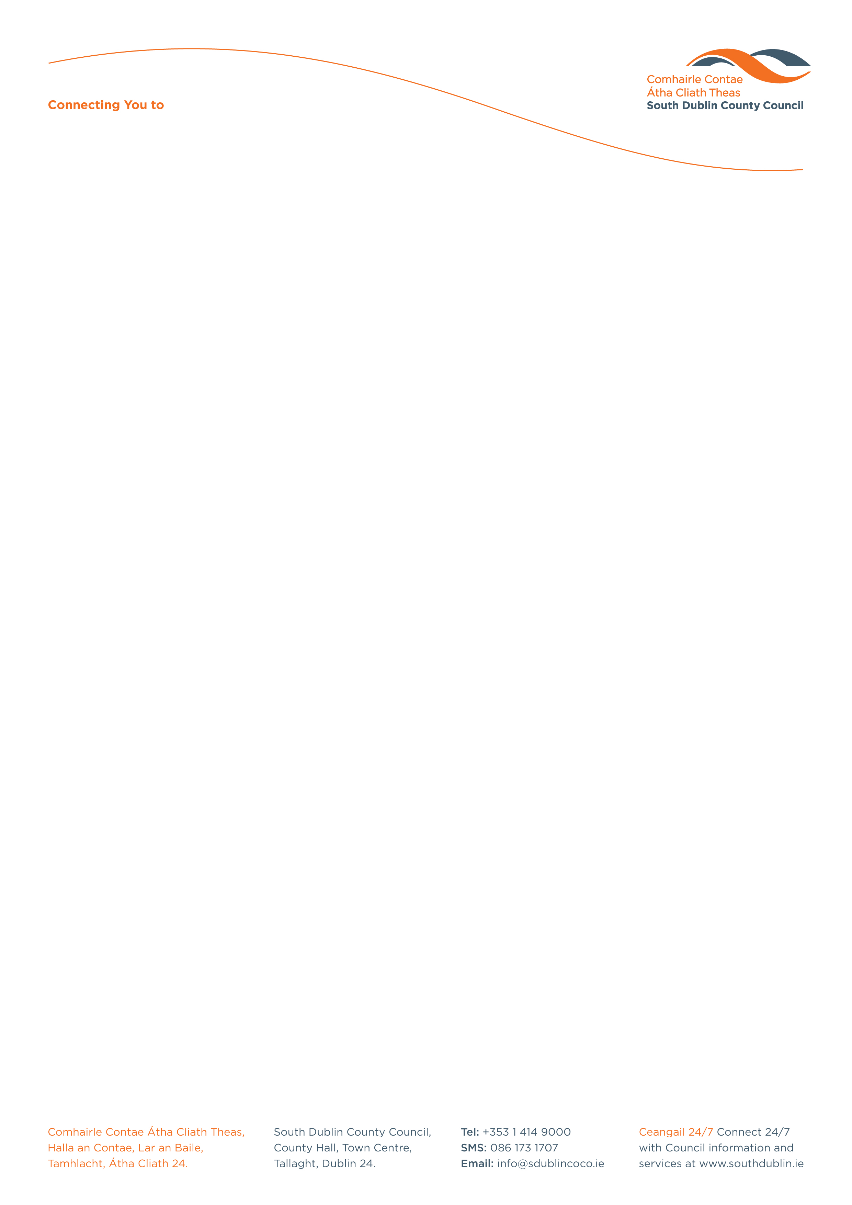

Halla an Chontae, Lár an Bhaile County Hall, Town Centre
Tamhlacht, Baile Átha Cliath 24 Tallaght, Dublin 24
Telefon: 01-4149052 Telephone: 01-4149052

Facs: 01-4149332 Fax: 01-4149332
www.southdublin.ie

The Manager
The National Roads Authority
St. Martin's House,
Waterloo Road,
Dublin 4,
Ireland

October 25, 2012
RE: Tallaght Area Committee Meeting 22nd October, 2012

Dear Sir/ Madam ,

At South Dublin County Council’s Tallaght Area Committee Meeting, held on 22nd October, 2012, the following Question was passed:
"An bhféadfadh leis an gComhairle scríobh chuig an Údarás um Bóithre Náisiúnta faoin méid bruscar atá ar an sliosbhóthar bíseach ar an mótarbhealach N4 ag dul ó thuaidh ag crosbhóthar na Bó Deirge?
Would the Council write to the National Roads Authority on the question of the amount of litter on the spiral sliproad on the N4 motorway going northbound at the Red Cow intersection?"

I should be obliged if you would let me have a reply on the matter at your earliest convenience.

Thanking you in anticipation.

Yours sincerely,

Eamon Conlon,
STAFF OFFICER,
HOUSING ADMINISTRATION.

Housing Administration

