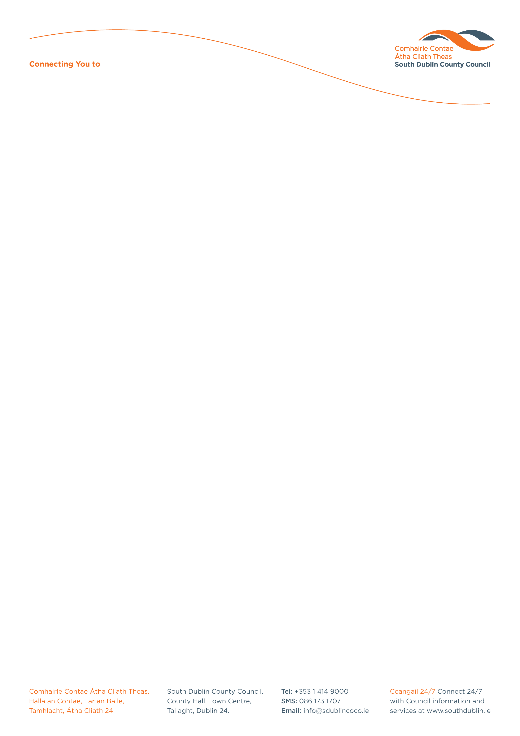

Halla an Chontae, Lár an Bhaile County Hall, Town Centre
Tamhlacht, Baile Átha Cliath 24 Tallaght, Dublin 24
Telefon: 01-4149052 Telephone: 01-4149052

Facs: 01-4149332 Fax: 01-4149332
www.southdublin.ie

Mr Alan Shatter
Minister for Justice & Equality,
94 St. Stephen's Green,
Dublin 2
September 26th, 2012
RE: Tallaght Area Committee Meeting – 24th September, 2012

Dear Sir,

At South Dublin County Council’s Tallaght Area Committee Meeting, held on 24th September, 2012, the following motion was passed:

“That this Committee is opposed to the downgrading or closure of Tallaght Courthouse, and that the relevant authorities be so informed and reassurance sought.”
I should be obliged if you would let me have a reply on the matter at your earliest convenience.

Thanking you in anticipation.

Yours sincerely,

Allyson Rooney,
SENIOR STAFF OFFICER,
HOUSING ADMINISTRATION.

Housing Administration

