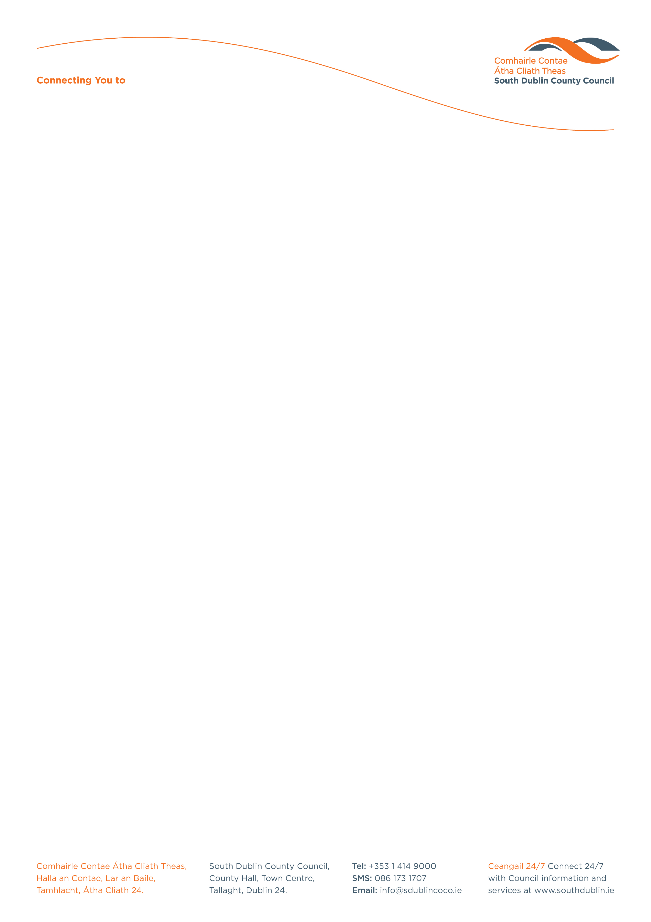

Halla an Chontae, Lár an Bhaile County Hall, Town Centre
Tamhlacht, Baile Átha Cliath 24 Tallaght, Dublin 24
Telefon: 01-4149052 Telephone: 01-4149052

Facs: 01-4149332 Fax: 01-4149332
www.southdublin.ie

The Board of Management,
Tallaght Hospital
Dublin 24

June 8th, 2012

RE: Tallaght Area Committee Meeting

Dear Minister,

At South Dublin County Council’s Tallaght Area Committee Meeting, held on 28th May, 2012, the following Motion was passed:

“That this Committee condemn the bed closures and the resultant delay in timely treatment for the public at Tallaght Hospital.”

I should be obliged if you would let me have a reply on the matter at your earliest convenience.

Thanking you in anticipation.

Yours sincerely,

Allyson Rooney,
SENIOR STAFF OFFICER,
HOUSING ADMINISTRATION.

Housing Administration

