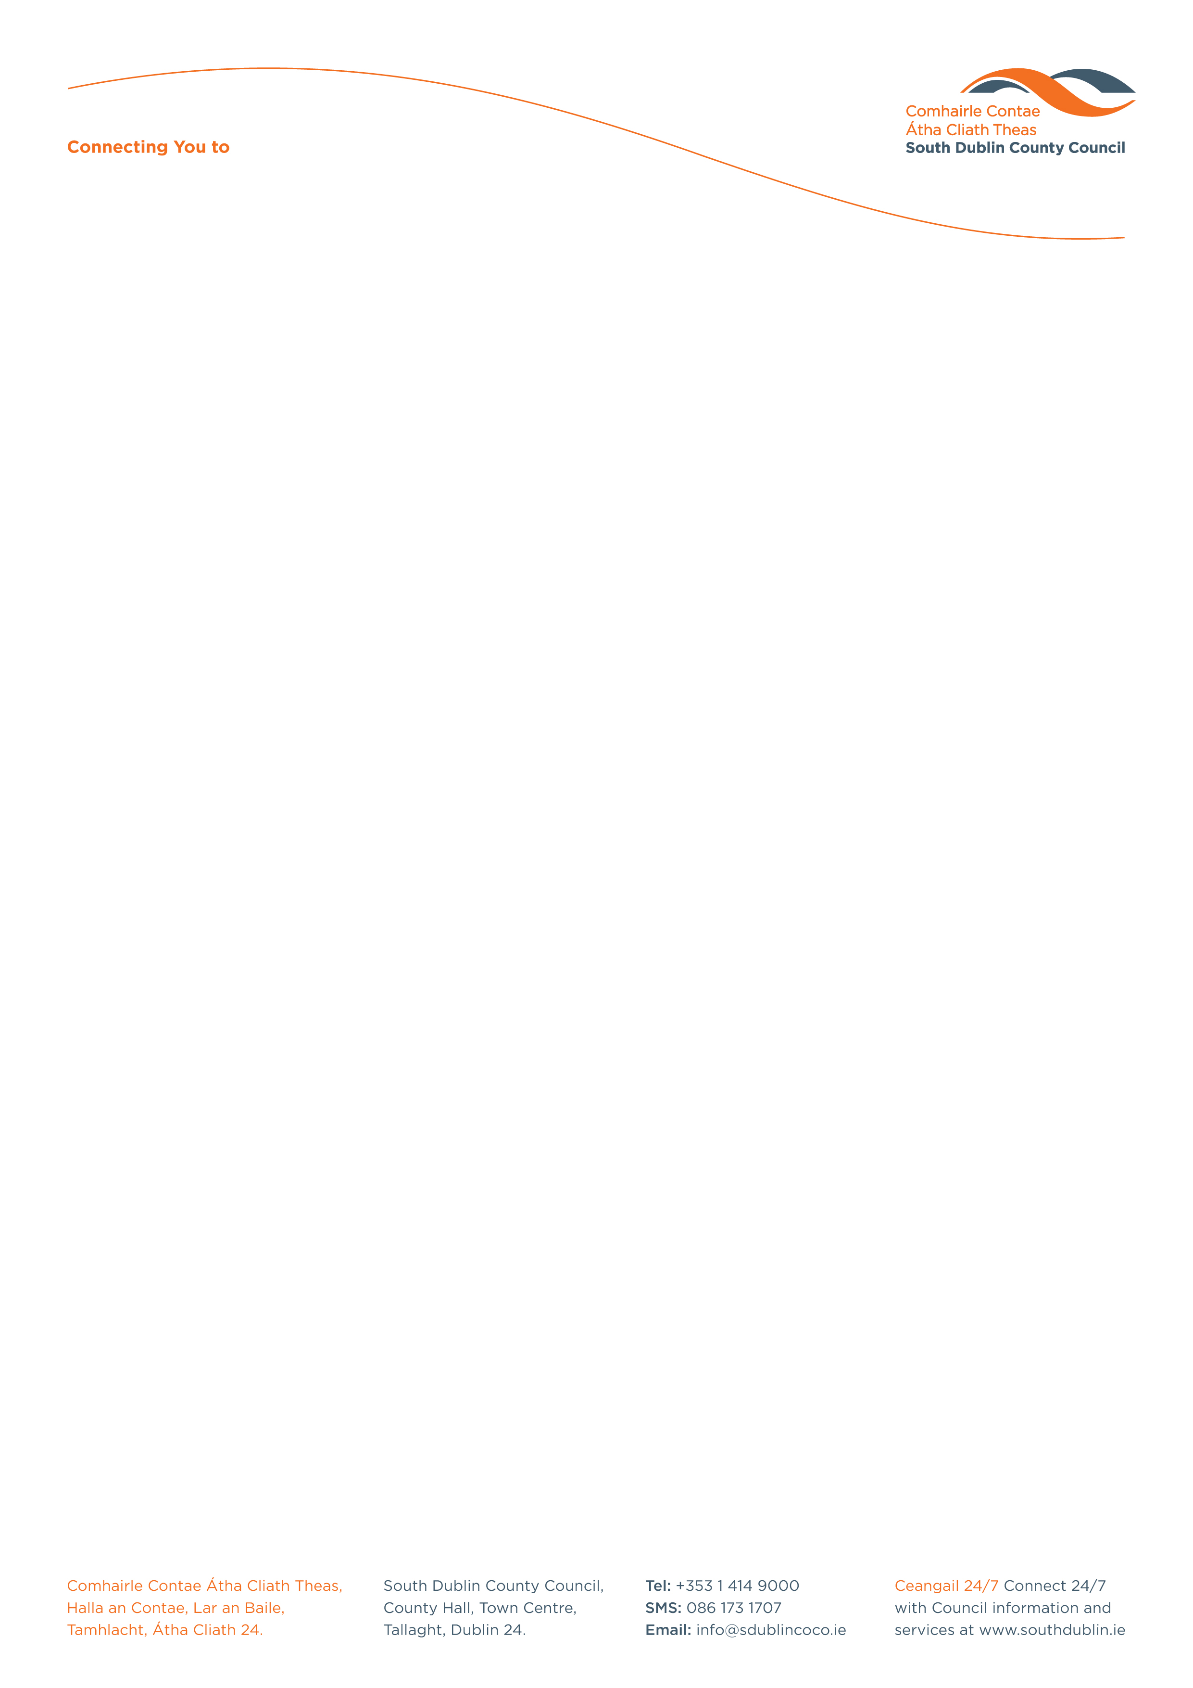

Halla an Chontae, Lár an Bhaile County Hall, Town Centre
Tamhlacht, Baile Átha Cliath 24 Tallaght, Dublin 24
Telefon: 01-4149052 Telephone: 01-4149052

Facs: 01-4149332 Fax: 01-4149332
www.southdublin.ie

Mr. Paddy Doherty,
Chief Executive,
Dublin Bus,
O’Connell Street,
Dublin 1.
July 11th, 2012

RE: Tallaght Area Committee Meeting – 18th June, 2012

Dear Mr. Doherty,

At South Dublin County Council’s Tallaght Area Committee Meeting, held on 18th June, 2012, the following Motion was passed:

“That this Committee expresses its dissatisfaction with the indefinite suspension of the introduction of the 175 route. This Council Committee calls on Dublin Bus to clarify its position and to honour commitments to second service between Tallaght and Dun Laoghaire.”

I should be obliged if you would let me have a reply on the matter at your earliest convenience.

Thanking you in anticipation,

Yours sincerely,

Eamon Conlon,
STAFF OFFICER,
HOUSING ADMINISTRATION.

Housing Administration

