COMHAIRLE CONTAE ÁTHA CLIATH THEAS
SOUTH DUBLIN COUNTY COUNCIL

MEETING OF TALLAGHT AREA COMMITTEE 2
24th September 2012
Motion No 7
Cllr D. Looney
That this Committee congratulate all involved with the Red Line Book Festival; that this Committee recognises the festival as yet another fantastic innovation from our award-winning Library Service; and that this Committee encourages members of the public to get involved with the festival by attending some of the many events planned during November.

Report
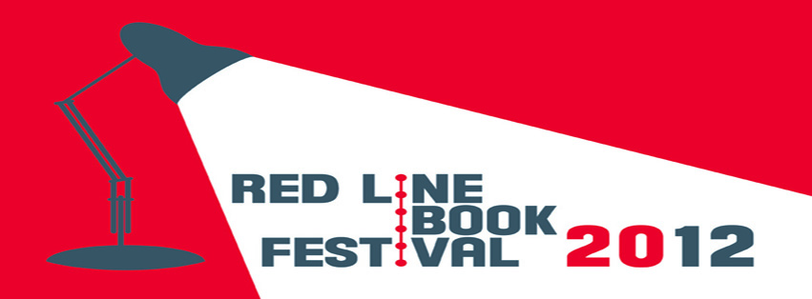

The inaugural Red Line Book Festival will take place from 13th -17th November 2012 across the County. The festival is designed to profile South Dublin as a destination for literary activity and it is hoped to make this an annual festival which will grow and develop into a significant event in the cultural calendar of the County.

The Red Line Book Festival will highlight both Irish and international contemporary authors and celebrate books, reading, and the written word. By gathering together contemporary writing talent from Ireland and abroad, the festival provides an opportunity to engage and meet with top named authors over three days.

The Festival will incorporate our traditional Readers Day on Saturday 17th November with Dermot Bolger as host. The line-up includes President Michael D. Higgins, Gerard Donovan, Anne Enright, Sean Moncrieff, Ferdia MacAnna, Christine Dwyer Hickey and Adrian Kenny. This year the event will be in The Civic Theatre, Tallaght. Tickets €10/€8 concession are on sale now.

Friday 16th November will see an evening of Crime Fiction entitled ‘A Night to Die For’ hosted by Declan Burke in the Civic Theatre. The line-up includes international best selling authors Mark Billingham and John Connolly (who are both currently in the UK bestsellers list), Declan Hughes and Niamh O’Connor. Tickets €10/€8 concession.

Lunchtime at The Civic Theatre will see non-fiction authors Catherine Fulvio (cooking), Lisa Fitzpatrick (style) and Tony Bates (psychologist) present short sessions to enjoy while eating your lunch. Tickets €5

Local authors Eileen Casey, Louise Phillips (a Tallaght author whose new book Red Ribbons is currently top of the Irish bestsellers and receiving wonderful reviews) and Colm Keegan will be speaking at an evening event Three Voices/Three Forms in The Civic Theatre on Wednesday 14th November. Tickets €5

For budding writers, there will be a workshop on ‘Writing and getting Published’ with Vanessa O’Loughlin of Writing.ie on the 15th November in the County Library.

All libraries across the County will deliver a range of book centred activity too including free workshops and major book club gatherings. The Children’s programme features authors Sarah Webb, Oisin McGann, Fiachra Sheridan, Jean Flitcroft, graphic novelist Stephen Mooney and poetry slam champion Stephen James Smith. Local schools will visit libraries during the event to meet authors and register pupils with their community library.

As a part of the festival, South Dublin Libraries are also delighted to announce the 4th annual TEDxTallaght on 15th November, an independently run TED event showcasing the best of Ireland’s new thinkers and innovators with speakers such as Maureen Gaffney, Catriona Crowe, Cathal Garvey and many more.

Events will take place at the Civic Theatre, The County Library, Tallaght, The Victory Centre, Firhouse, Clondalkin Library, Lucan Library, Castletymon Library and Whitechurch Library.

Browse the programme online at www.redlinebookfestival.com

All the events in the Civic Theatre including Readers Day and Crime Fiction Night can be booked online at www.redlinebookfestival.com, in person or by phone (01 4727477)

For more information check with your local library or contact us at info@redlinebookfestival.com

