COMHAIRLE CONTAE ÁTHA CLIATH THEAS
SOUTH DUBLIN COUNTY COUNCIL

MEETING OF SOUTH DUBLIN COUNTY COUNCIL
Monday, September 10, 2012
HEADED ITEM NO.10 (ii)

UPDATE ON FLOOD ALLEVIATION WORKS - Summary of Report
The table below shows total monthly rainfall recorded by Met Eireann at the Casement Weather Station in 2010, 2011 and 2012 to date. The 81.4mm of rain that fell on 24 October 2011 was 216% of the total rainfall recorded at Casement for the entire month of October 2010.

Total rainfall in millimetres from Met Eireann’s Weather Station at Casement

Year | Jan | Feb | Mar | Apr | May | Jun | Jul | Aug | Sep | Oct | Nov | Dec | Annual
2012 | 63.2 | 19.8 | 27.5 | 94.7 | 64.0 | 178.5 | 102.7 | 74.9 | 0.5 |  |  |  | 625.8
2011 | 34.1 | 76.2 | 15.0 | 30.0 | 51.5 | 65.1 | 53.3 | 51.6 | 76.3 | 165.9 | 54.8 | 53.0 | 726.8
2010 | 44.1 | 36.6 | 59.3 | 32.7 | 44.9 | 45.2 | 81.7 | 43.5 | 102.7 | 37.7 | 120.0 | 66.2 | 714.6
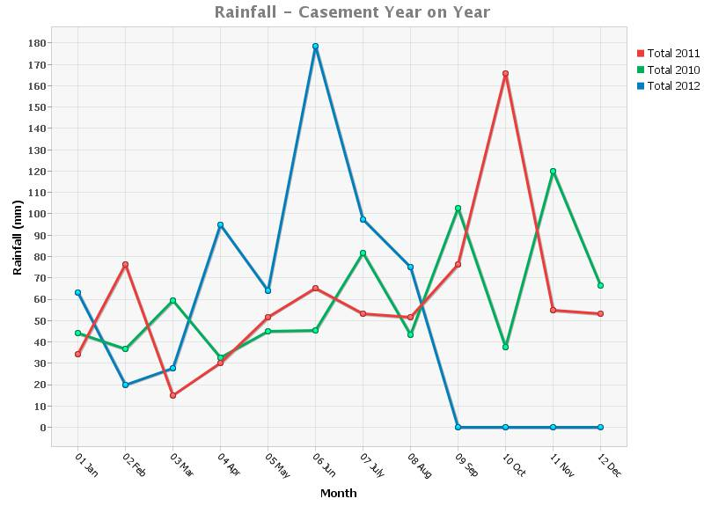
After the widespread flooding in the SDCC area on the 24th October 2011, which resulted in the flooding of 225 Domestic Houses and 42 Commercial Premises and 25 major road flooding incidents resulting in road closures a programme of flood alleviation schemes and minor works was initiated in the worst affected areas in the County.
The total SDCC Expenditure to Date is €428,220 since October 2011.
In addition a number of larger schemes were identified by the Council in conjunction with the Department and Office of Public Works (OPW) and funding has been secured for the following schemes:
The Killinarden Stream and Tributaries/Knockmore Park, has a confirmed allocation of € 333,000. The River Poddle Flood Alleviation Scheme has been approved with an allocation of €250,000 for South Dublin County Council and additional works to the value of €250,000 to be carried out directly by the OPW. The Owendoher Flood alleviation scheme has been allocated €108,000 for the design and construction of a retaining wall and associated works along approximately 70 metres of the River Owendoher at the Woodview Cottages, Rathfarnham (Total: €941,000).
Since January 2012 Met Eireann has issued heavy rain weather warnings on 11 occasions
29th January, 25/26th April, 1st May, 9/10th May, 2/3rd June, 7/8th June, 14/15th June, 28/29th June, 6/7th July, 15/16/17 August, and 27th August with the heaviest rainfalls being recorded in June and July. There were no flooding incidents reported within the County during these severe rainfall episodes largely attributable to the investment in flood alleviation works as outlined in the presentation.

Today’s Flood Alleviation Works Presentation will focus primarily on the following:

- An outline of the EU Directives and National Flood Policy
- An outline of the CFRAMS
  - Objectives
  - Structure
  - Tasks associated with CFRAMS
  - Roles and responsibilities of the various stakeholders incl OPW/ LA s
- An outline of OPW funded works in SDC area post Oct 2011 flooding incl
  - Poddle
  - Owendoher (Woodview Cottages),
  - Knockmore / Killinarden
- Members requested at Budget 2012 that the Council provide funding for drainage / flood alleviation works and the report will also provide an outline of SDCC funded works undertaken at area level.

