COMHAIRLE CONTAE ATHA CLIATH THEAS

SOUTH DUBLIN COUNTY COUNCIL

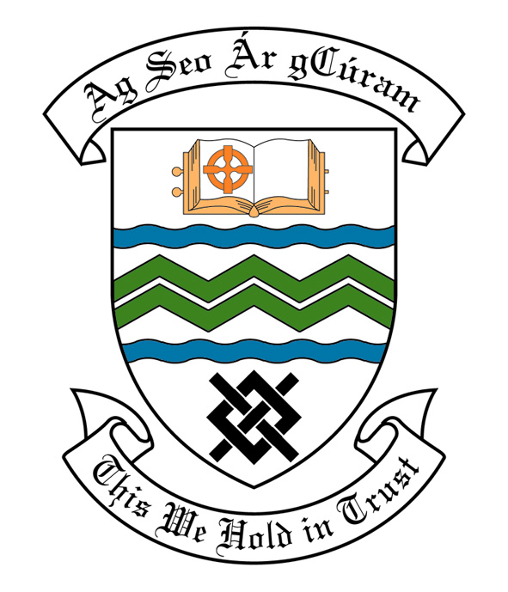

MEETING OF SOUTH DUBLIN COUNTY COUNCIL
MONDAY, 9th JULY, 2012.
HEADED ITEM NO. H-I 2 (d)

MEETING OF CLONDALKIN AREA COMMITTEE

Wednesday 20TH June, 2012.

HEADED ITEM NO: H-I (15)

Application for Arts Grants

“An application for a Arts Grant under Section 6 of the Arts Act 2003, has been received from the organisation listed below. Payment of this grant, in accordance with the conditions of the Scheme and in the amount set out hereunder, is recommended for approval:-“

Ref: | Name of Group | Type of Application | Date Received | Amount
AGF751 | Rowlagh Women’s Group | Arts Grant towards a 10 week visual arts workshops as part of its older people’s art programme | 8th May 2012 | €500

It was proposed by Councillor by Councillor T. Ridge and seconded by Councillor M. McDonagh.

“That this Committee recommends that South Dublin County Council APPROVE the grants as recommended in the forgoing report.”

