Waterstown Park

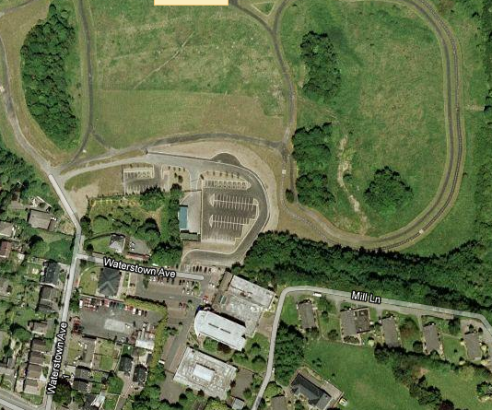

All 11 items along path in front of carpark.

Air Walker, Cross Trainer, Pull Down, Parallel Bars, Tai Chi, Waist Movement, Abdomen Bench

Hermitage Park
A
B
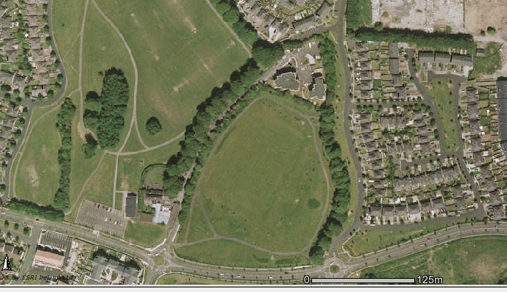

Location A:
Air Walker, Cross Trainer, Pull Down, Parallel Bars, Tai Chi, Waist Movement, Abdomen Bench.

Location B:
Air Walker, Cross Trainer, Pull Down, Parallel Bars

Griffeen Valley Park

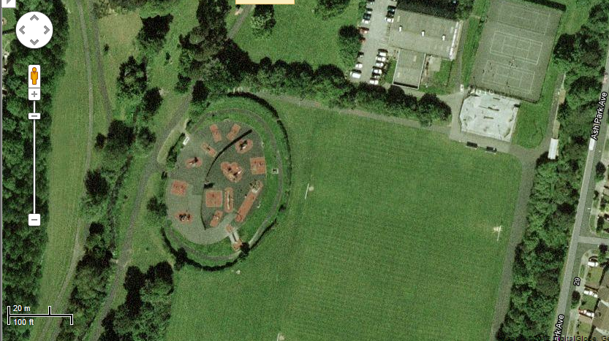
A- 7 items along path in area between arrows
A
Air Walker, Cross Trainer, Pull Down, Parallel Bars, Tai Chi, Waist Movement, Abdomen Bench

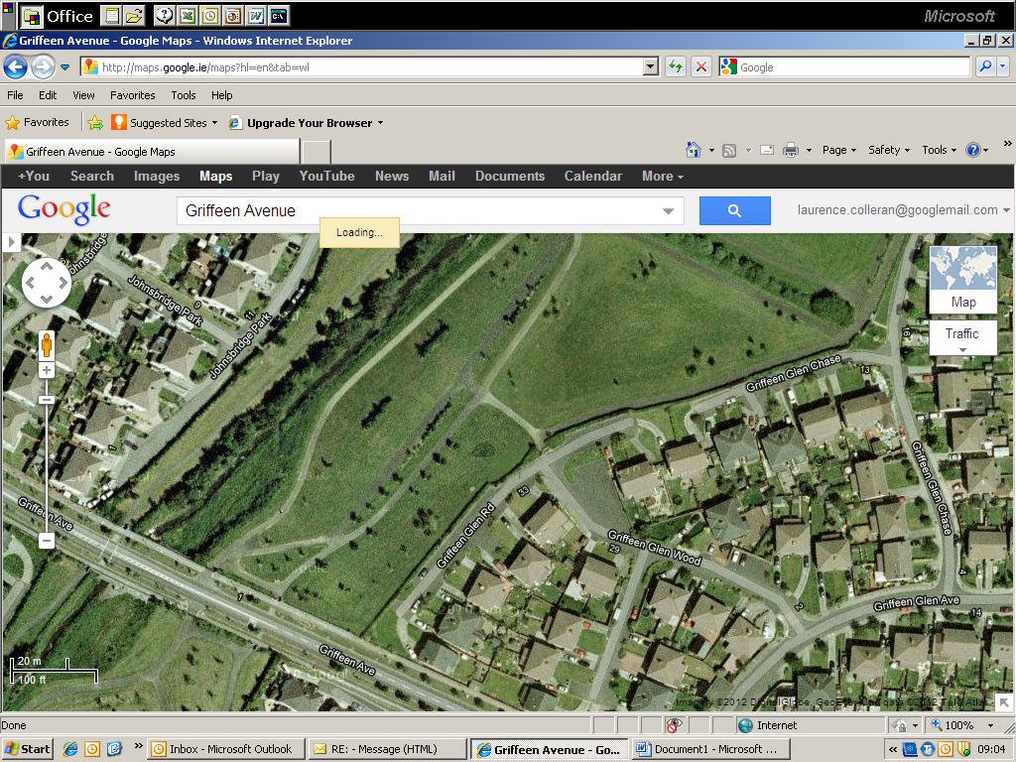
B
4 items as indicated by arrows
Air Walker, Cross Trainer, Pull Down, Parallel Bars

