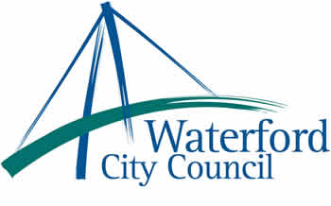

28th May 2012

To: The Meetings Administrator

The following motions were unanimously adopted by Waterford City Council at its monthly meeting held on 14th May 2012:

1. “Waterford City Council calls on the Department of Environment, Community and
Local Government to resource a national Ad Campaign to highlight the anti social
nature and health risks of dog fouling on public paths, parks and beaches etc. and
to increase awareness of the responsibility of dog owners in this matter.”

2. “That Waterford City Council call on the HSE and the Minister for Health Dr. James O'Reilly to review the long-term illness scheme to include Lupus as a long-term chronic illness”

3. “Waterford City Council supports the EU proposal to abolish the Sugar Quota
regime in 2015, as this will allow Ireland the opportunity to re-establish the sugar
beet processing industry in this country. The Council requests the Minister for
Agriculture to support the abolition of quotas in 2015.”

Yours sincerely,

Billy Duggan
Meetings Administrator

