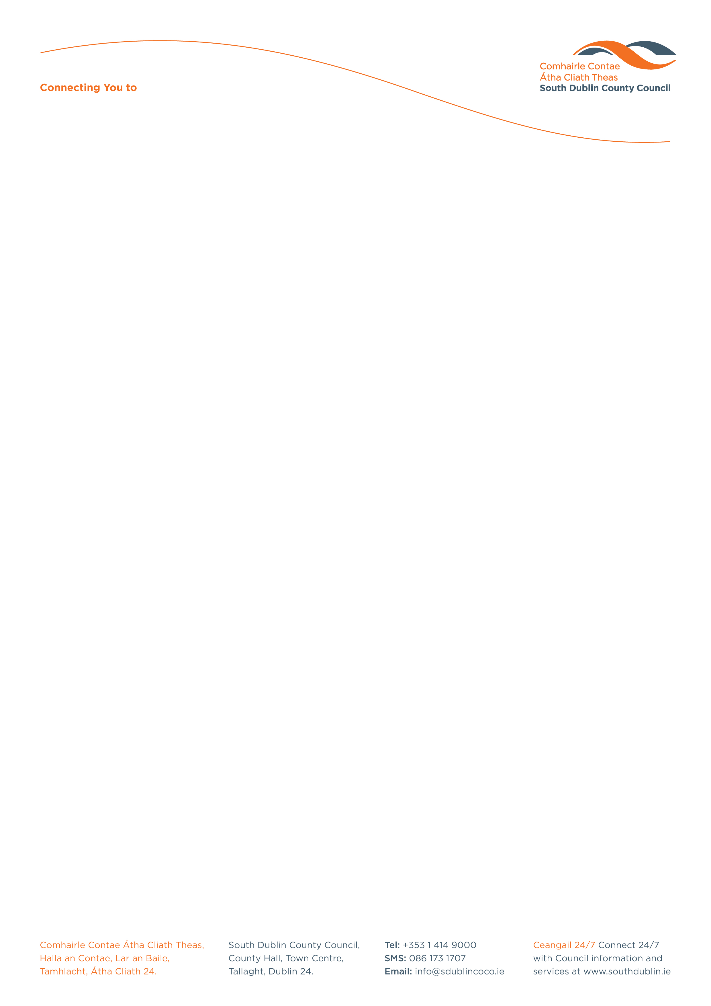

Halla an Chontae, Lár an Bhaile County Hall, Town Centre
Tamhlacht, Baile Átha Cliath 24 Tallaght, Dublin 24
Telefon: 01-4149052 Telephone: 01-4149052

Facs: 01-4149332 Fax: 01-4149332
www.southdublin.ie

The Manager,
Dublin Bus,
O’Connell Street,
Dublin 1.
March 8th, 2012

RE: Tallaght Area Committee Meeting – 27th February, 2012

Dear Sir/Madam,

At South Dublin County Council’s Tallaght Area Committee Meeting, held on 27th February, 2012, the following Motion was passed:

“That this Committee calls on service providers such as ESB, An Post, Dublin Bus etc to review their property within the West Tallaght area with a view to upgrading, replacing and maintaining where appropriate - in keeping with standards applied throughout the county.”
I should be obliged if you would let me have a reply on the matter at your earliest convenience.

Thanking you in anticipation.

Yours sincerely,

Eamon Conlon,
STAFF OFFICER,
HOUSING ADMINISTRATION.

Housing Administration

