TRAVEL SMART COMMUNITIES
REPORT TO CLONDALKIN AREA COMMITTEE MEETING
21ST MARCH 2012

1.0 Introduction

South Dublin County Council (SDCC) has secured funding from the National Transport Authority under the Sustainable Transport Measures Grants (STMG’s) to fund a Personalised Travel Planning (PTP) project in South Dublin County. Project funding is confirmed for Phase 1 to 31st December 2012.

The NTA agreed to fund a PTP programme that focused on communities in the vicinity of the Kishoge and Fonthill stops on the Kildare railway line and N4 and Outer Ring Road QBC’s.

- Project Team

This project will be managed and delivered by South Dublin County Council’s Travel Smart Communities team.

The project is overseen at a strategic level by a project Steering Group with representation from the Council’s Roads, Community and Parks Departments, SDCC Sports Partnership, HSE Health Promotion, Dublin Bus, Irish Rail and the National Transport Authority.

JMP Transport and Planning Consultants have been engaged to provide strategic advice and mentoring to SDCC throughout the project.

3.0 Target Areas

The Travel Smart Communities team carried out a review of communities in the vicinity of stops on the Kildare Railway line and the N4 and Outer Ring Road Quality Bus Corridors to identify communities that would be likely to respond to a travel campaign. An area comprising 56,000 people and 18,000 households was accessed (census 2006).

Given the intense nature of PTP engagement it would not be possible to target this entire area. SDCC analysed the socio-demographic and travel characteristics of each community, with a view to identifying communities with ‘best fit’ characteristics for a travel behaviour change campaign. All areas were similar in terms of age, family profile, nationalities. However, upon review of travel related data, such as car ownership, mode of travel for work, length of journey and destination of commuting trips the ED of Lucan Esker presented as the ‘best fit’ location for a campaign. Clondalkin Dunawley also presents as suitable.

These ED’s have the highest level of car based travel (63% Lucan Esker; 49% Dunawley), most complex travel patterns with commuters travelling to ED’s all over the region for work/school or college, lowest levels of walking & bus usage, cycling and train usage are low in all ED’s. These ED’s also have high levels of computer and internet access and good access to alternative travel options such as strategic cycle routes, rail travel and high frequency bus services.

Map 1: Target Areas

4.0 Branding

The “Travel Smart Communities” brand and logo has been developed to support the programme. A web site www.travelsmartcommunities.ie has been created to support the brand and to provide an information portal.

Fig. 1: Travel Smart Communities Logo
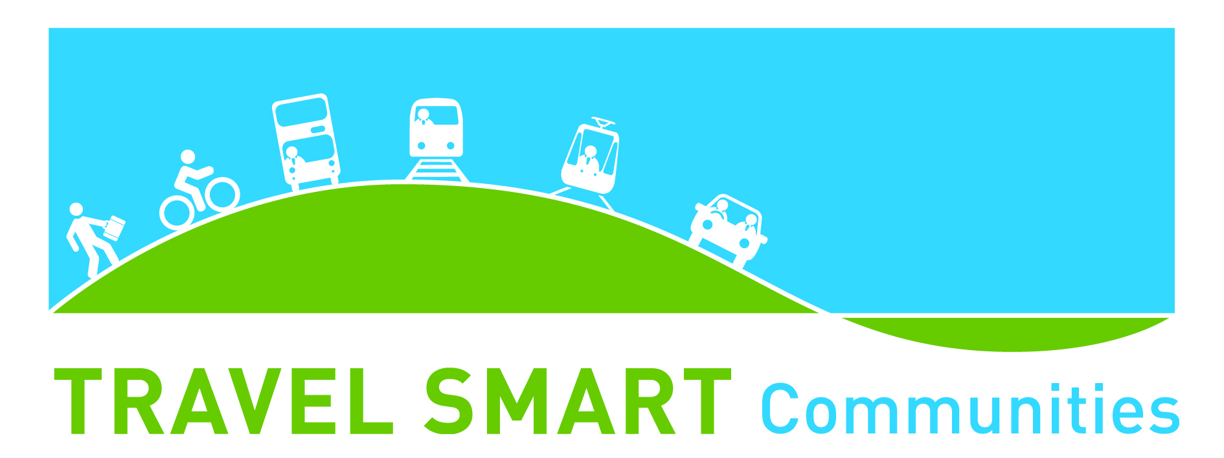

- Project Objectives

The following project objectives have been set:

PRIMARY OBJECTIVES

1. Achieve a modal shift from private car to more sustainable modes for commuting and leisure trips as follows:
(a) Reduce single occupancy car travel
(b) Increase car occupancy (car sharing) rates
(c) Increase walking mode share
(d) Increase cycling mode share
(e) Increase bus mode share
(f) Increase train mode share
2. Increase bike ownership
3. Increase awareness of sustainable travel through the Travel Smart Communities brand

SECONDARY OBJECTIVES

1. Improve local health and mental wellbeing through active travel
2. Sustain and enhance local retail economies
3. Improve access to employment opportunities
4. Reduce household car ownership levels

- Phase 1 Timetable

Project set up was undertaken in 2011; baseline monitoring is taking place in March 2012; implementation will take place between March and September 2012; and monitoring, evaluation and reporting will be undertaken between October and December 2012.

Fig. 2: Timetable Summary
Stage | Dates | Description
PROJECT DEVELOPMENT | June – Dec 2011 | Background research; steering group set up; develop project objectives & targets, analyse project area and target areas; population segmentation; engagement strategy; monitoring & evaluation framework;
PRE IMPLEMENTATION | Jan – March 2012 | Baseline surveys; recruit travel team;
IMPLEMENTATION | March - Sept 2012 | Implement agreed engagement strategy through households, schools, workplaces and community events
EVALUATION | Oct – Dec 2012 | Monitoring surveys, evaluation and reporting

7.0 Implementation

The primary aim of the campaign is to encourage individuals to take alternatives to the car where these are available by providing tailored travel advice, incentives and resources. A variety of community based initiatives will be delivered between March and September 2012 through a number of ‘pathways’, as follows:

- Household will be targeted between May and July – field staff will engage with households at the doorstep and offer travel advice, resources and incentives. Households within an 800m walkband of local retail/community centres will be targeted.
- Schools will be targeted between March and May and again in September. The team will engage with schools in the area to support students, parents and staff in developing sustainable travel initiatives. Resources and incentives will be provided to help achieve a modal shift for school journeys.
- A series of community events will be rolled out between April and September, starting with events on 24th and 26th April – Eco Week in Griffeen Valley Park and Corkage Park. A calendar of events will be finalised in April for distribution to all households in the target areas. Events will range in size from larger family events to smaller events with individual groups. All events will have a sustainable transport theme, be it to promote walking, cycling, bus or train.
- A number of community challenges to promote walking, cycling and sustainable modes will be undertaken in August/Sept.

- Monitoring & Evaluation

The programme is underpinned by a monitoring and evaluation strategy.

Existing baseline data has been sourced and where information gaps were identified new research is being undertaken in March 2012 pre-intervention. Corresponding data will be gathered or new research carried out post intervention in October 2012. The data sets will be compared to ascertain the initial impact of the programme on travel behaviour. A report with findings will be available in early 2013.

Up to Date Information on Travel Smart Communities will be posted on www.travelsmartcommunities.ie

