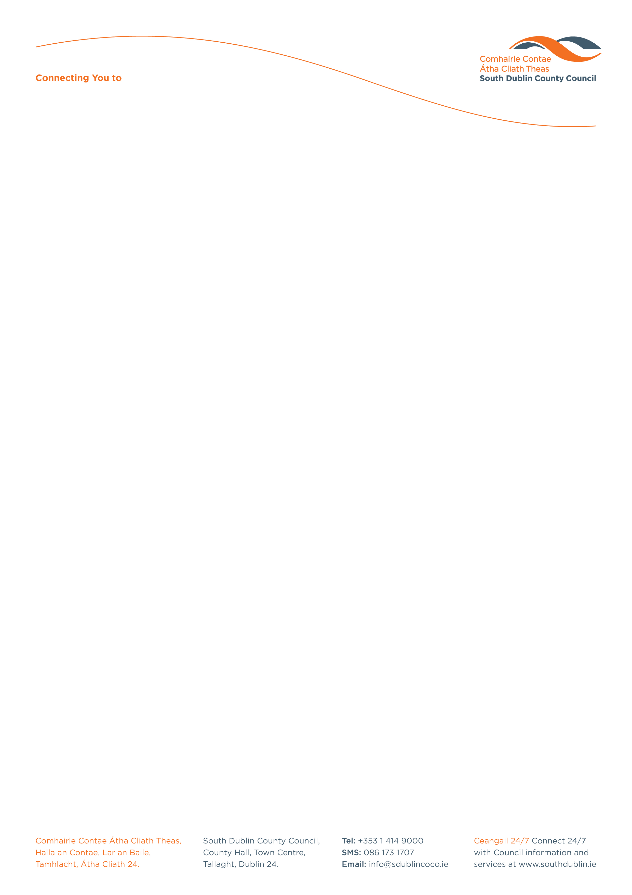

Halla an Chontae, Lár an Bhaile County Hall, Town Centre
Tamhlacht, Baile Átha Cliath 24 Tallaght, Dublin 24
Telefon: 01-4149052 Telephone: 01-4149052

Facs: 01-4149332 Fax: 01-4149332
www.southdublin.ie

National Asset Management Agency
Treasury Building
Grand Canal Street
Dublin 2 February 23rd, 2012

RE: Tallaght Area Committee Meeting – 23rd January 2012

Dear Sir/Madam,

At South Dublin County Council’s Tallaght Area Committee Meeting, held on 23rd January 2012, the following Question was raised:

"To ask the Manager to list those developments and properties in the Tallaght area that are in the control of NAMA?"

I should be obliged if you would let me have a reply on the matter at your earliest convenience.

Thanking you in anticipation.

Yours sincerely,

Eamon Conlon,
STAFF OFFICER,
HOUSING ADMINISTRATION.

Housing Administration

