5th March, 2012

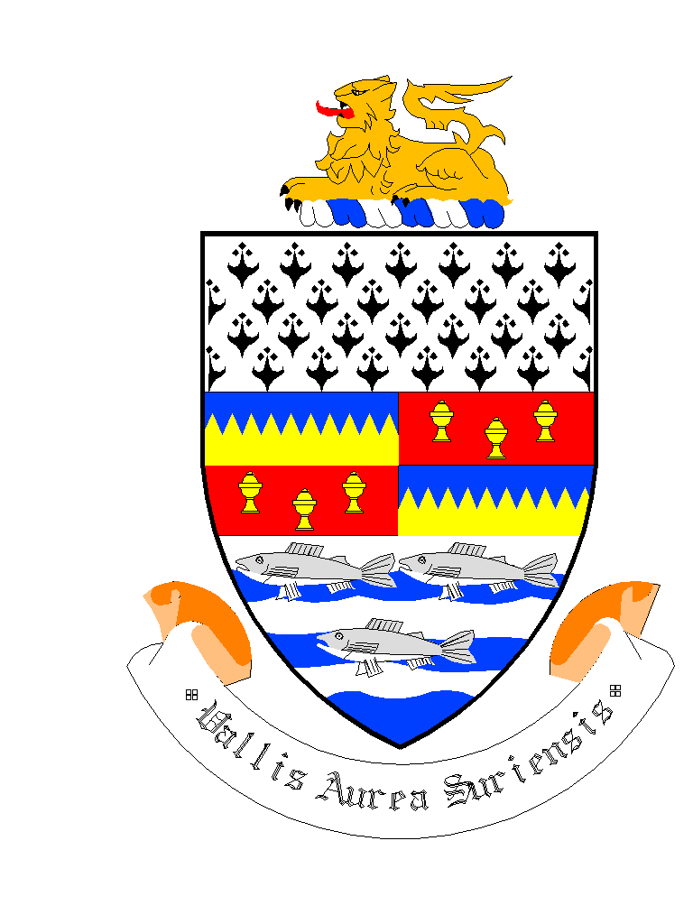

**To All Local Authorities:**

A Chara

At the March Monthly Meeting of South Tipperary County Council the members adopted the following resolution and requested that it be circulated to all local authorities:-

**“That South Tipperary County Council write to the Minister of State for primary care Roisín Shortall asking her to priortise the government proposals to adopt a public health act that will end the scourge of underage drinking and that South Tipperary County Council would ask the government to impose a minimum cost price that alcohol can able sold for to aid attempts to stop the abuse of alcohol by certain sections of society”.**

Mise, le meas

*John O’Mahoney*

__________________

John O’Mahoney

Meetings Administrator