COMHAIRLE CONTAE ÁTHA CLIATH THEAS
SOUTH DUBLIN COUNTY COUNCIL

MEETING OF TRANSPORTATION SPC
Thursday, February 23, 2012
HEADED ITEM NO. 3

The Assessment of Pedestrian Crossing Facilities

In

South Dublin County Council

Introduction:

The current position with regard to the provision of pedestrian facilities in the County was described at the last SPC meeting. It was decided that a further report would issue to this meeting.

South Dublin County council agreed in 2003, at the request of Councillors, not to install any further Zebra crossings and to provide signalised crossings only where the warrant requirements were met. This was due to compliance issues at 2 locations.
In addition it is felt that the both the purpose of, and the choice of most appropriate type, of crossing and the basis for such decision making be reviewed.

The purpose of this report is to place in context the method of assessment and the requirement for formal crossing points both uncontrolled and controlled and also to develop the criteria for selection of the most appropriate crossing type.

Pedestrian crossing points need to be safe and easy to use, especially for visually impaired and disabled people.

A formal assessment procedure is necessary to ensure that all situations, requests and locations (be they junctions, crossing points etc.,) are treated objectively and on an equal and consistent footing to ensure an adequate but not excessive use is made of Traffic Control Devices.

Extract from NRA Traffic Calming Guidelines
Clause 3.3.2 “Crossing places are provided to give access and easier movement to pedestrians. The needs of people who experience most difficulty – the old, the infirm, children – should be especially taken into account. Contrary to popular belief there is no evidence to suggest that informal crossing places well located and equipped with channelising islands are less safe than Zebra Crossings or that Zebra Crossings are less safe than Pelican Crossings.”

Extract from UK Highways Agency TA 68/96 The Assessment and Design of Pedestrian Crossings.

Clause2.1 “Crossings are provided as amenities to give access and easier movement to pedestrians without incurring excessive delays to traffic. Generally the provision of crossings should be targeted at the needs of those people who experience most difficulty and danger in crossing. It should not be assumed that the provision of a crossing alone will necessarily lead to a reduction in road accidents.”

Assessment issues

The Council’s existing assessment method is based on the relevant provision of the National Roads Authority’s publication “RT 206 Warrants for Pedestrian Crossing Facilities”.
This document is the NRA’s recommended method for assessing the provision of crossing facilities.
In the UK the Traffic Management Guidelines recommend the Criteria from LTN TA 68/96 “The Assessment and Design of Pedestrian crossing facilities” as issued by the UK Highways Agency.
Both of these documents consider such matters as
- Volume and speed of traffic
- Volume and age profile of Pedestrians and cyclists
- Road, cycle track and footpath widths
- Difficulty in crossing the road
- Delay in crossing the road
- Accident history.
Delay in crossing the road is indirectly considered as delay is directly a function of traffic volume
The volume of young pedestrians is also noted under RT 206 but TA68/96 also requires separate assessment of the elderly and those with disabilities.

The provision of pedestrian facilities is also carried out using the UK Manual for Street (2007).

Clause 6.3.8 states; “The specific conditions in a street will determine what form of crossing is most relevant. All crossings should be provided with tactile paving. Further advice on the assessment and design of pedestrian crossings is contained in Local Transport Notes 1/95 and 2/95 ….”
Clause 6.3.9 states that “Surface level crossings can be of a number of types, as outlined below:
Uncontrolled crossings - these are created by dropping kerbs at intervals along a link.. …..
Informal Crossings – these can be created through careful use of paving materials and street furniture to indicate a crossing place which encourages slow-moving traffic to give way to pedestrians.
Pedestrian refuges and kerb build-outs – these can be used separately or in combination. They effectively narrow the carriageway and so reduce the crossing distance…
Zebra Crossings – of the formal crossing types, these involve the minimum delay for pedestrians when used in the right situation
Signalised Crossings” - currently employed in SDCC

The ability of pedestrians to cross at any given point depends upon there being an acceptable gap between vehicles. It should be noted that gap refers to time rather than distance.
The gap depends on
- Number of vehicles
- Speed of vehicles
- Width of crossing
- The acceptable gap depends upon the profile of the pedestrian e.g. age, physical condition etc.

Traffic Calming/ Traffic Management also play an important part in protecting vulnerable road users
It is possible to create more crossing opportunities by
- Providing a pedestrian refuge – this reduces the width of crossing
- Traffic calming – reduces vehicle speed
- Narrowing the carriageway – reduces crossing width and may reduce speed.

Zebra Crossings:
Zebra crossings reduce pedestrian crossing delays away from junctions and are an alternative to signalised pedestrian crossings in appropriate circumstances.

By their nature they have additional benefits over pedestrian signals because:

- They minimise the waiting required by motorists for a pedestrian to cross away from a junction
- They are easier to introduce in many areas where it might be more difficult to justify a traffic signalled pedestrian crossing due to lower pedestrian crossing volumes
- Zebra crossings are also more economical to both install and maintain.

Pedestrians establish precedence by stepping onto the crossings so delays to them are minimal. Vehicle delays are typically 5 seconds for single person crossing but can be much more where irregular streams of people cross over extended periods. Compliance issues at new locations may be addressed by a installing an appropriate ramp as studies indicate that drivers are more inclined to stop in situations were they are already slowing down.

Zebra Crossing may be used where;
- a crossing is necessary but where pedestrian and vehicle flows are moderate to low.
A Zebra crossing may not be suitable
- where gaps are few and waiting times are long because people feel it may be dangerous to establish precedence.
- Higher flows of pedestrians will cause substantial delays to vehicles and drivers may be unwilling to cede right-of way making a Zebra a less satisfactory choice.
- Where traffic speeds are greater than 50kph people will require longer gaps in traffic flow or be exposed to risk of more serious injury if precedence is not conceded by traffic.
Care should also be taken at unusual sites such as contra-flow bus lanes to avoid confusion.

Signal Controlled Crossings:
Signal Controlled Crossings are used where
- Vehicle speeds are high and other options are un-suitable.
- There is a higher than normal proportion of elderly or disabled pedestrians
- Vehicle flows are very high and pedestrians have difficulty in asserting precedence.
- There is a specific need for a crossing for cyclists
- Pedestrians could be confused by traffic management measures
- There is a need to link the crossing to a nearby junction.

These can be in the form of Pelican, Pedestrian or Toucan Crossings. Puffin crossings are not approved for use in this country.
Pelican crossings have a sequence of green-amber-red- flashing amber-green to traffic and Green – flashing green – red to pedestrians.

Pedestrian Crossings have a sequence of green-amber-red –green to traffic and green –amber-red to pedestrians.

Toucan crossing are a version of either of the above with additional features to allow cyclists to cross.

Generally Pelican Crossings are not suitable where there are more than 2 lanes to cross as drivers may have difficulty seeing if the crossing is occupied during the flashing amber period.

Signal controlled crossings at grade should not be used where speeds exceed 80kph.

LTN 1/95 specifically cautions
“Caution should be exercised where pedestrian flows are generally light or light for long periods during the day. Drivers who become accustomed to not being stopped at the crossing may begin to ignore its existence, with dangerous consequences. The problems are accentuated as vehicle speeds increase.

The types of crossing facilities considered under LTN 1/95 are

Refuge Island
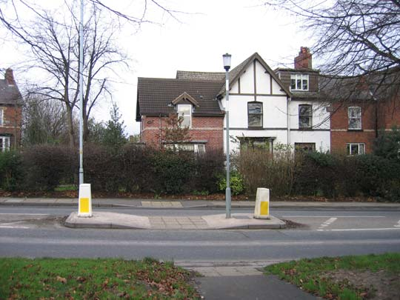

Zebra Crossing

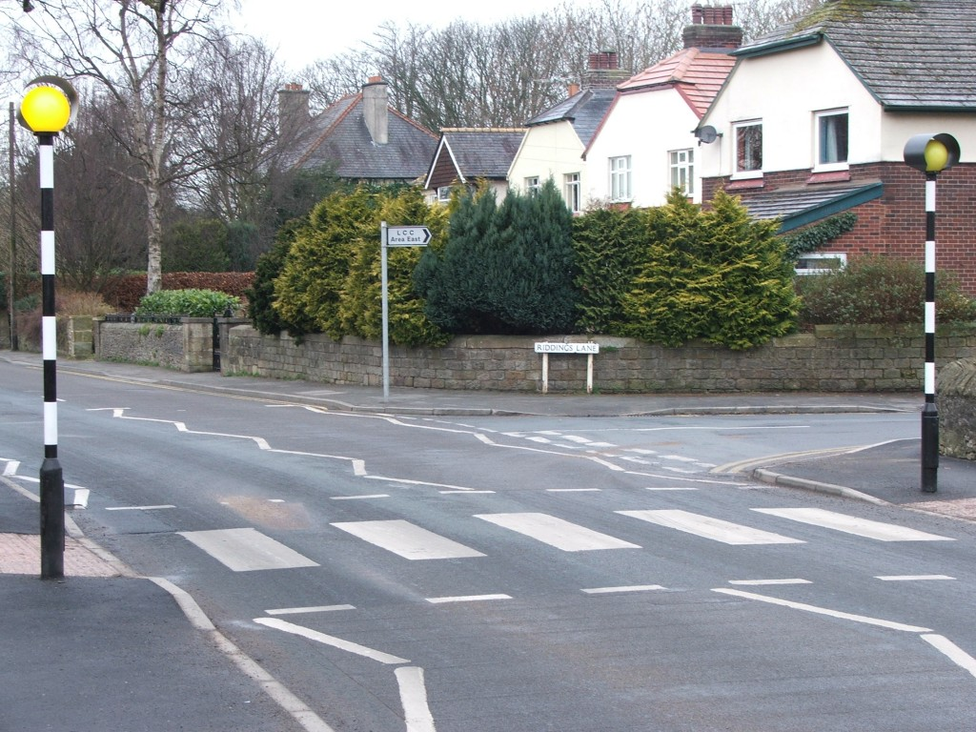

Pedestrian/ Pelican Crossings

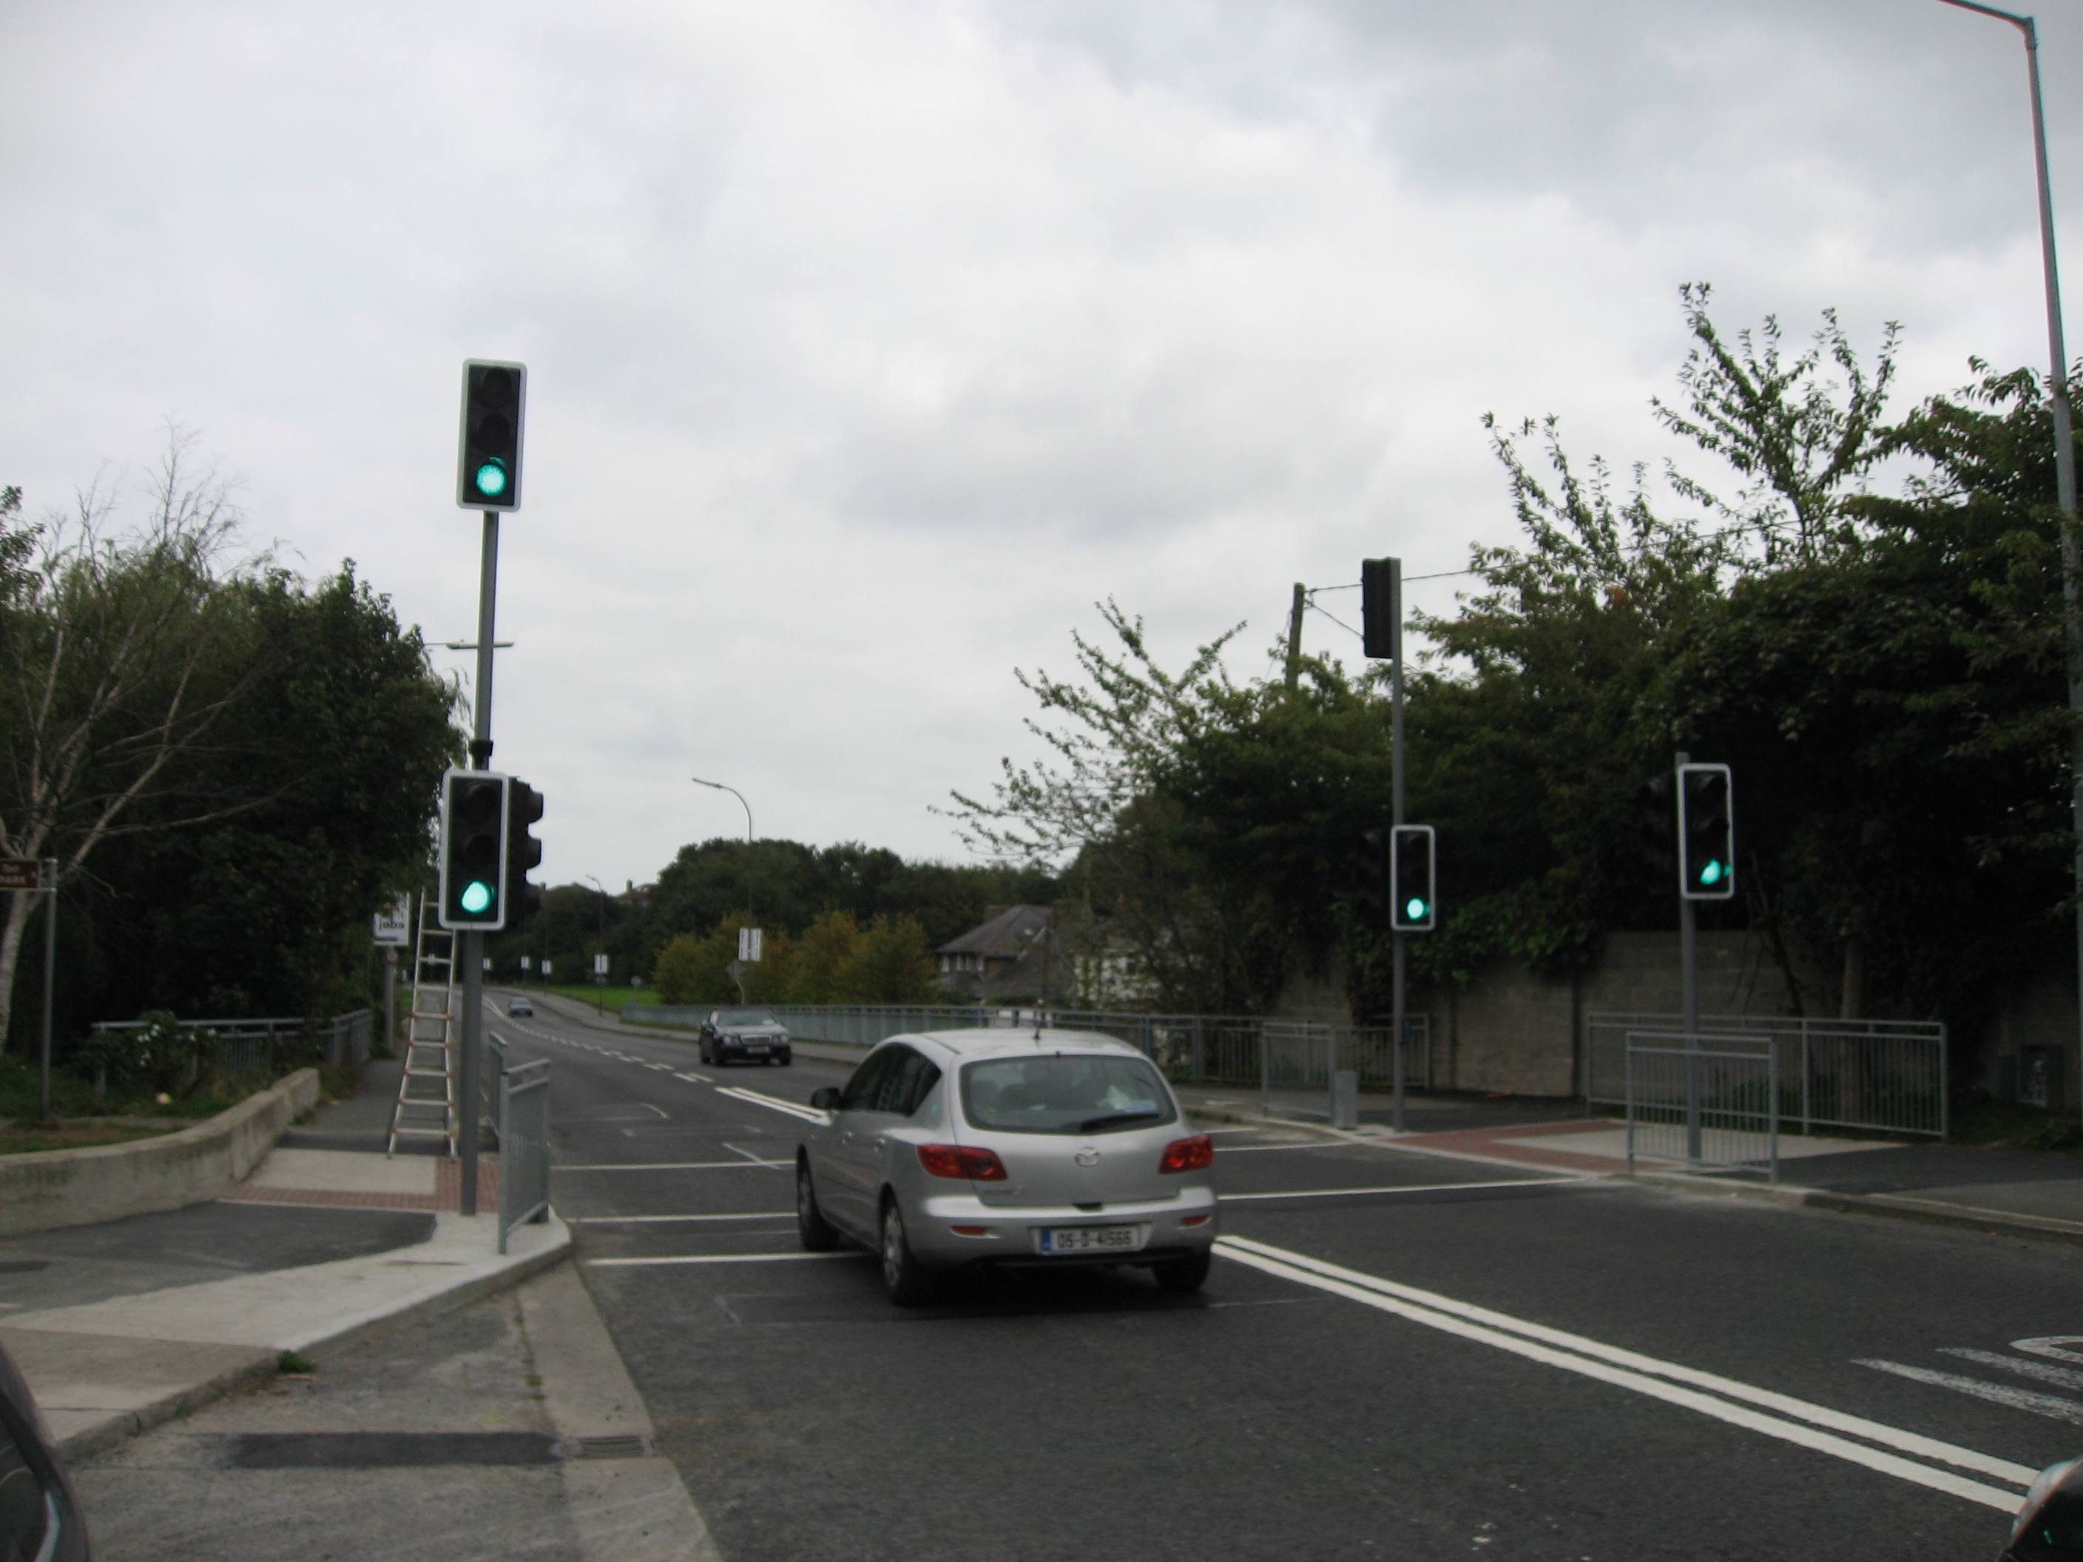

Recommendation:

It is recommended that
- The previous decision not to install Zebra crossings be changed so as to allow their installation in appropriate locations
- That the use of refuge islands and other formal uncontrolled crossing points be considered where the use of controlled crossings is not appropriate.
- That SDCC discontinue the use of the document published in 2001 as the sole method of provision of pedestrian facilities and replace it with TA 68/96 including those sections recommending the use of additional crossing types where they are appropriate.
- Fully Signalised Crossings would continue to be provided where the criteria set out in TA/68/96 are met.
The Council has a complement of 125 stand alone pedestrian lights throughout the County and a never ending list of locations for assessment to provide pedestrian lights on an annual basis. Pedestrian lights cost in excess of €25,000 per installation. It is estimated that between two and three Zebra type crossings could be installed for the same price depending on location and road parameters.

It is proposed in the first instance to arrange for a pilot scheme of one Zebra Crossing in each of the 5 electoral areas as soon as practicable in 2012. Zebra crossings have not been provided in the County for a number of years and it would be necessary to monitor them during the course of 2012 to ensure appropriate function and further development in future years. This is subject to suitable locations beings established in each area.

It should be noted that the Department of Transport are currently developing a new Manual for Streets which will include for revised pedestrian facilities in the built up area. South Dublin County Council is represented on the project team and it is intended that public consultation will commence in 2012. This new manual may, if adopted, be mandatory in all local authority areas. The ability to provide different types of pedestrian facilities in the County will not be impeded by the new manual. The National Transport Authority is also currently considering a revision of traffic management strategies and methods as part of its remit in relation to vulnerable road users and traffic management.
In addition the National Roads Authority, being the Standards agency are currently considering a revised method of assessment for pedestrian facilities which may, if issued, be in the form of a directive and thus would supercede any decision by SDCC

