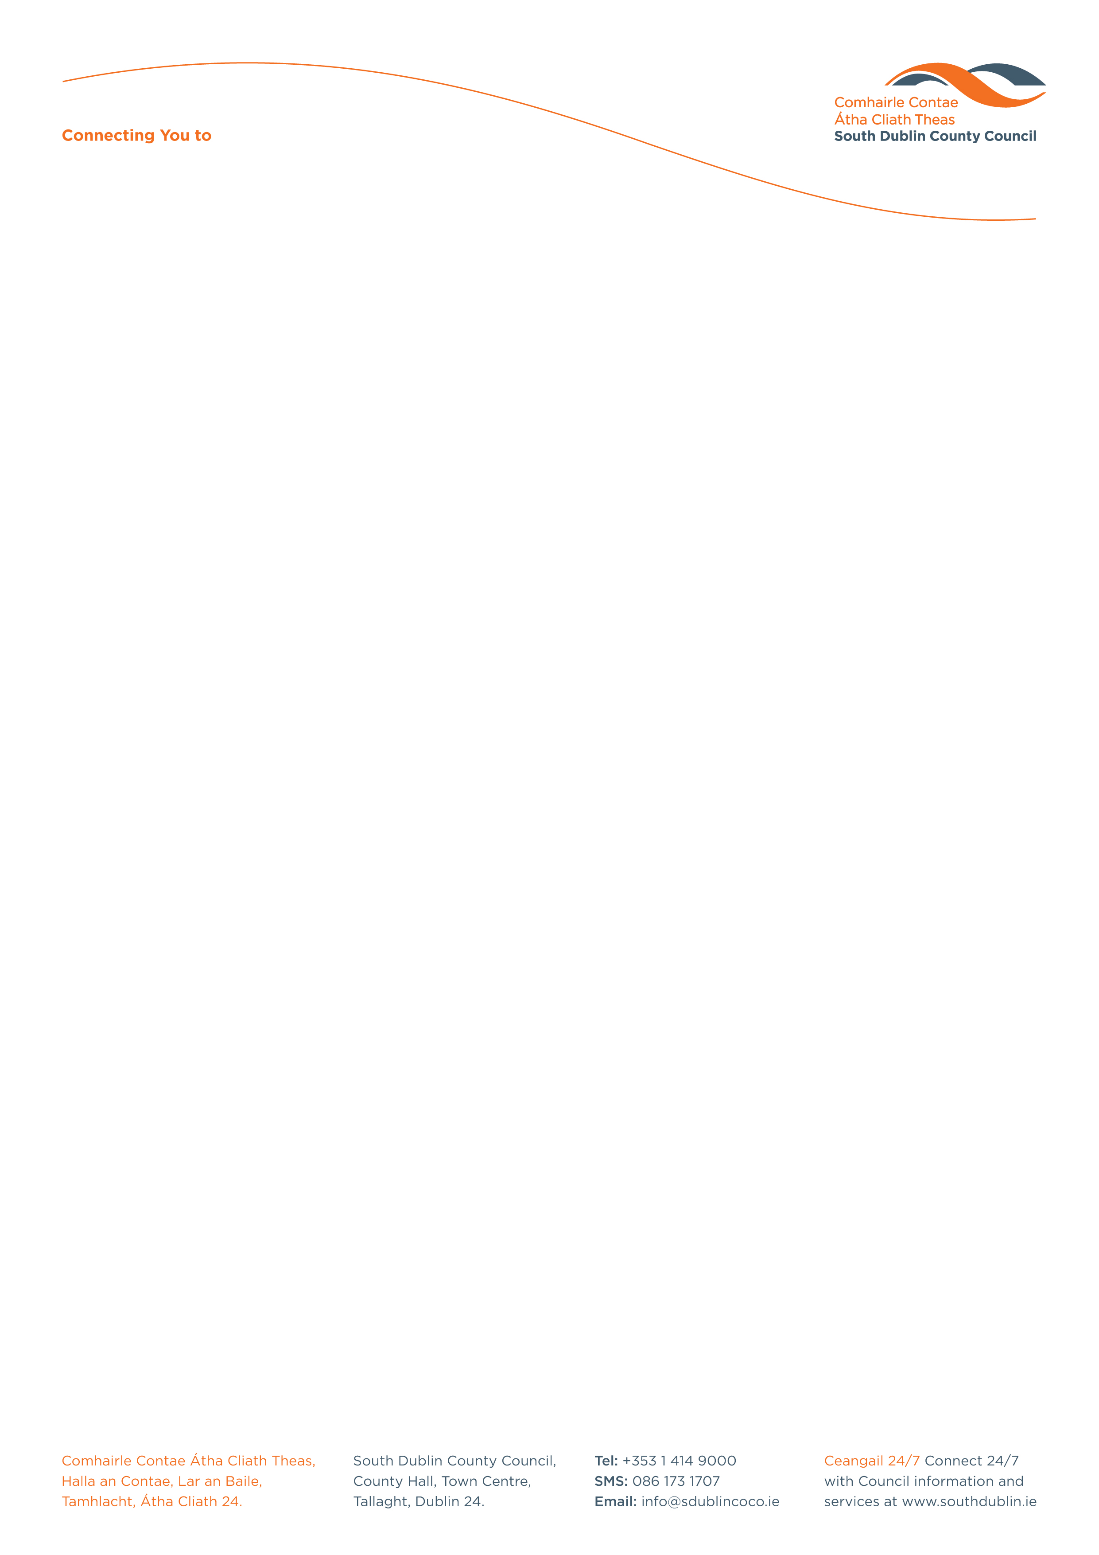

Halla an Chontae, Lár an Bhaile County Hall, Town Centre
Tamhlacht, Baile Átha Cliath 24 Tallaght, Dublin 24
Telefon: 01-4149052 Telephone: 01-4149052

Facs: 01-4149332 Fax: 01-4149332
www.southdublin.ie

The Manager,
Dublin Bus,
O’Connell Street,
Dublin 1.
February 6th, 2012

RE: Tallaght Area Committee Meeting – 23rd January 2012

Dear Sir/Madam,

At South Dublin County Council’s Tallaght Area Committee Meeting, held on 23rd January 2012, the following Motion was passed:

“That this Committee calls upon Dublin Bus to honour its commitment to provide a bus service of reasonable frequency on the Kilinniny and Ballycullen Road.”

I should be obliged if you would let me have a reply on the matter at your earliest convenience.

Thanking you in anticipation.

Yours sincerely,

Eamon Conlon,
STAFF OFFICER,
HOUSING ADMINISTRATION.

Housing Administration

