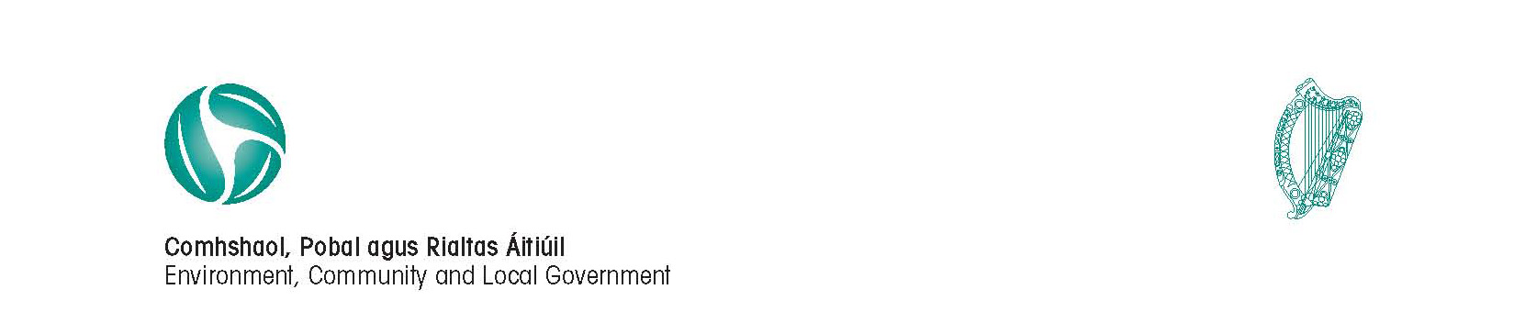

Circular Fin 06/2011

24 October 2011

Local Authority 2012 Budget Meetings

I am directed by the Minister for the Environment, Community and Local Government to inform you that the prescribed periods that apply for the holding of 2012 Budget meetings are as follows:

- County Councils: 24 November 2011 to 13 January 2012

- City/Borough/Rating Town Councils: 24 November 2011 to 15 January 2012

- Non-Rating Town Councils/Joint Bodies: 15 November 2011 to 16 December 2011

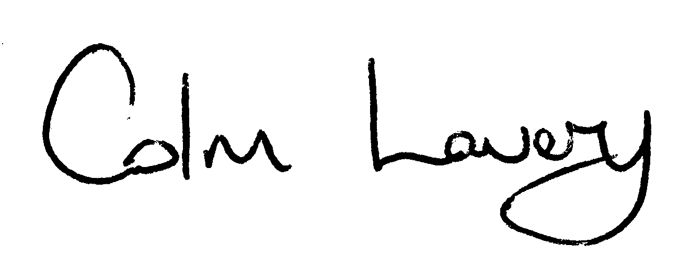
_______________________
Colm Lavery
Principal Officer
Local Government Finance

To: All Local Authorities

