UNWRAPPED
Due to the successful partnership initiated last year for the lighting of the Christmas tree, organisations involved decided to continue the Unwrapped event in 2011.

The Partnership
Unwrapped is a creative partnership between South Dublin County Council Arts Office and Corporate Services Department; South Dublin Libraries; Tallaght Community Arts; Alternative Entertainment; Contact Studio; Civic Theatre, Tallaght; RUA RED, South Dublin Arts Centre and South Dublin Music Education Partnership

Objectives:
- Marking the time of year
- Branding the Christmas tree lighting event
- Involving the community in a civic event centred around the lighting of the tree and the marking of a ‘festive’ season
- Providing the community with performance opportunities
- Providing multi-disciplinary, cultural experiences for audiences
- Potential for organisations involved to promote themselves
- An event around which organisations involved can share practices, see how one another works, learn about each other’s approaches, collaborate, explore and show the potential of what can be achieved and learned when we work together
- As the area of Tallaght is felt to not fully be able to compete with Dublin’s Culture Night, this is one way to pull the area cultural organisations together to do It’s own type of Culture night event over a few hours and at a scale appropriate

Unwrapped—the meaning
Metamorphosis-
revelations
Celebration
Gathering
Dark/light
contrast
Inside/
outside
weather
Fire, old traditions
Local stories
Lighting of Tree
Festival of Lights
Changes/
Season
Environment
Unwrapped

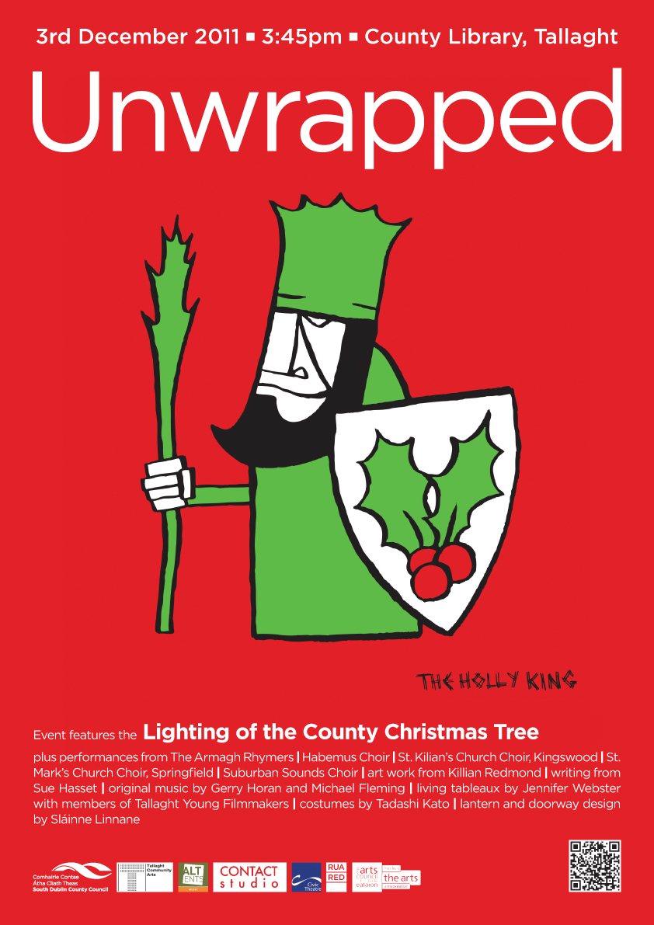
2011 Theme:
In many Celtic-based traditions, is the legend of the battle between the Oak King and the Holly King. These two rulers fight for supremacy as the Wheel of the Year turns each season. At the Winter Solstice, or Yule, the Oak King kills the Holly King, and then reigns until Midsummer, or Litha. Once the Summer Solstice arrives, the Holly King returns to do battle with the old king, and defeats him. The Holly King them rules until Yule.
The Oak King and the Holly King are seen as dual aspects of one whole. Each of these twin aspects rules for half the year, battles for the favor of the Goddess, and then retires to nurse his wounds for the next six months, until it is time for him to reign once more.
Often, these two entities are portrayed in familiar ways - the Holly King frequently appears as a woodsy version of Santa Claus. He dresses in red, wears a sprig of holly in his tangled hair, and is sometimes depicted driving a team of eight stags. The Oak King is portrayed as a fertility god, and occasionally appears as the Green Man or other lord of the forest.
Ultimately, while these two beings do battle all year long, they are two essential parts of a whole. Despite being enemies, without one, the other would no longer exist.
(Source: http://paganwiccan.about.com/od/yulethelongestnight/p/Holly_KIng_Yule.htm)
Event Details
Saturday, December 3rd 2011
3:45pm
County Library Tallaght, Chamber Square, Civic Theatre and RUA RED, South Dublin Arts Centre

Event features original music and artwork and the lighting of the County Christmas Tree

Performances from the Armagh Rhymers; Habemus Choir; St. Kilian’s Church Choir, Kingswood; St. Mark’s Church Choir, Springfield; Suburban Sounds Choir; art work from Killian Redmond; writing from Sue Hasset; original music by Gerry Horan and Michael Fleming; and living tableaux from members of Tallaght Young Filmmakers and An Cosán Drama Group.

