COMHAIRLE CONTAE ATHA CLIATH THEAS

SOUTH DUBLIN COUNTY COUNCIL

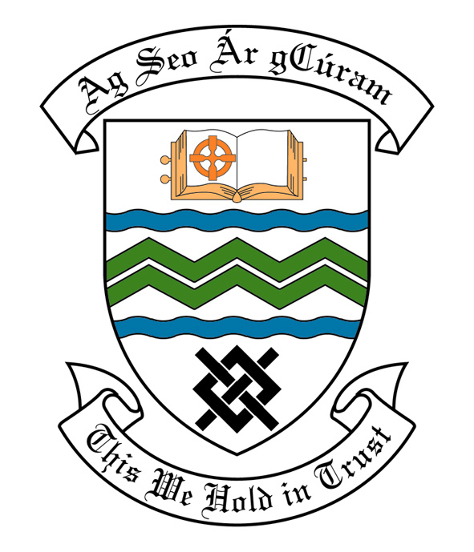
MEETING OF SOUTH DUBLIN COUNTY COUNCIL
MONDAY, 13th June, 2011
HEADED ITEM NO. 2 (e)

REPORT OF LUCAN AREA COMMITTEE MEETING HELD

TUESDAY 24TH MAY, 2011

HEADED ITEM NO: H- I (5)

Application for Grants

Applications for grants under South Dublin County Council’s Community Grants Scheme have been received from the organisations listed below. Payment of these grants, in accordance with the conditions of the Scheme and in the amounts set out hereunder, is recommended for approval:-

Ref: | Name of Group | Type of Application | Date Received | Amount
SP04 2011/ GF2025 | Griffeen Summer Project | Community Activity Grant (Including Sport Activity) | 07/03/11 | €500
SP18 2011/ GF2009 | Balgaddy Summer Proejct | Community Activity Grant (Including Sport Activity) | 29/03/11 | €500
SP24 2011/ GF2012 | Griffeen CDG Summer Project | Community Activity Grant (Including Sport Activity) | 31/03/11 | €500
GF2007 | St. Finians Newcastle Guides | Start Up Costs for Community Groups | 21/03/11 | €500
GF2018 | Foxborough Maintenance Association | Environmental Improvements Grant | 21/04/11 | €500
GF2006 | Academy Twirlers | Running Costs Grant for Community Groups | 21/03/11 | €200

Report on Summer Projects 2011

Summer Projects are aimed at providing a supervised programme of recreational and educational activities for young people over a consecutive number of weeks in the summer period. Emphasis is placed on community involvement and the development of resources and groups within localities. A wide range of activities are encouraged such as arts & crafts, sports, educational trips, drama, films, games etc. The use of available community facilities (schools, community centres, halls, open spaces) is also encouraged.

South Dublin County Council assists Summer Projects in the County area by way of grant-aid, assistance in kind, organised activities and staff support. In 2011 it is estimated that approximately 6,000 young people in the Council’s administrative area will participate in projects.

County Dublin V.E.C has agreed to continue their financial support to Summer Projects for the year 2011. These grants will be complementary to the above resulting in co-ordination between the two authorities, ensuring there is added value from this approach.

Catholic Youth Care provides insurance cover for Summer Projects.

It should be noted that in some cases the necessary insurance cost will be deducted from the grant provided by South Dublin County Council and will be paid directly to Catholic Youth Care.

Name of Project: Duration of Project Grant Amount

Lucan Youth Fun 2 Weeks €850

It was proposed by Councillor E. Tuffy, seconded by Councillor C. Jones and RESOLVED:-
“That this Committee recommends that South Dublin County Council APPROVE payment of the Community Grant as recommended in the foregoing report.”

