COMHAIRLE CONTAE ATHA CLIATH THEAS

SOUTH DUBLIN COUNTY COUNCIL

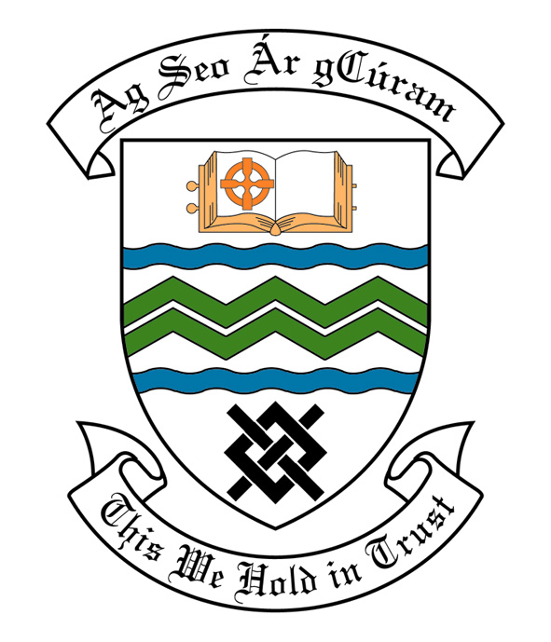

MEETING OF SOUTH DUBLIN COUNTY COUNCIL
MONDAY, 13th JUNE, 2011
HEADED ITEM NO. H-2 (e)

REPORT OF CLONDALKIN AREA COMMITTEE MEETING

Wednesday 17th May, 2011

HEADED ITEM NO: H- I (3)

Application for Grants

Application for grants under South Dublin County Council’s Community Grants Scheme has been received from the organisations listed below. Payment of these grants, in accordance with the conditions of the Scheme and in the amounts set out hereunder, is recommended for approval:-

Ref: | Name of Group | Type of Application | Date Received | Amount
GF2002 | Clondalkin Indoor Bowling Club | Major Equipment Grant | 04/03/11 | €1,000
SP03 2011/  GF2003 | Clondalkin Travellers Development Group | Community Activity Grant (Including Sport Activity) | 04/03/11 | €500
SP33 2011/ GF2017 | Quarryvale Summer Festival | Community Activity Grant (Including Sport Activity) | 04/04/11 | €500
SP35 2011/ GF2021 | South Dublin Gladiators | Social Inclusion, Equality & Anti-Poverty Grant | 04/04/2011 | €1,000

Report on Summer Projects 2011

Summer Projects are aimed at providing a supervised programme of recreational and educational activities for young people over a consecutive number of weeks in the summer period. Emphasis is placed on community involvement and the development of resources and groups within localities. A wide range of activities are encouraged such as arts & crafts, sports, educational trips, drama, films, games etc. The use of available community facilities (schools, community centres, halls, open spaces) is also encouraged.

South Dublin County Council assists Summer Projects in the County area by way of grant-aid, assistance in kind, organised activities and staff support. In 2011 it is estimated that approximately 6,000 young people in the Council’s administrative area will participate in projects.

County Dublin V.E.C has agreed to continue their financial support to Summer Projects for the year 2011. These grants will be complementary to the above resulting in co-ordination between the two authorities, ensuring there is added value from this approach.

Catholic Youth Care provides insurance cover for Summer Projects.

It should be noted that in some cases the necessary insurance cost will be deducted from the grant provided by South Dublin County Council and will be paid directly to Catholic Youth Care.

Name of Project: Duration of Project Grant Amount

Neilstown Summer Project 2 Weeks €1,000

Rowlagh Summer Project 2 Weeks €1,000

Clondalkin Youth Service
Village Project 4 Weeks €1,600

Sruleen Summer Project 3 Weeks €1,250

Knockmitten Summer Project 4 Weeks €1,600

Bawnogue Summer Project 3 Weeks €1,500

St. Ronan’s Summer Project 3 Weeks €1,500

Quarryvale Summer Project 2 Weeks €1,000

Bawnogue Youth & Community
Centre Summer Festival 2 Weeks €1,000

Application for Arts Grants

Application for an Arts Grant under Section 6 of the Arts Act 2003, has been received from the organisation listed below. Payment of this grant, in accordance with the conditions of the Scheme and in the amount set out hereunder, is recommended for approval:-

Ref: | Name of Group | Type of Application | Date Received | Amount
Agf 722 | Clondalkin Youth Theatre | Grant assistance towards the production of Clondalkin Drama Festival | 27/4/2011 | €1000
Agf 720 | Clondalkin Towers | Grant assistance towards a collaborative textile project with up to 60 asylum seeker participants. | 6/6/2011 | €800

It was proposed by Councillor M. Mc Donagh, seconded by Councillor Gino Kenny and RESOLVED:-
“That this Committee recommends that South Dublin County Council APPROVE payment of the Community Grant as recommended in the foregoing report.”

