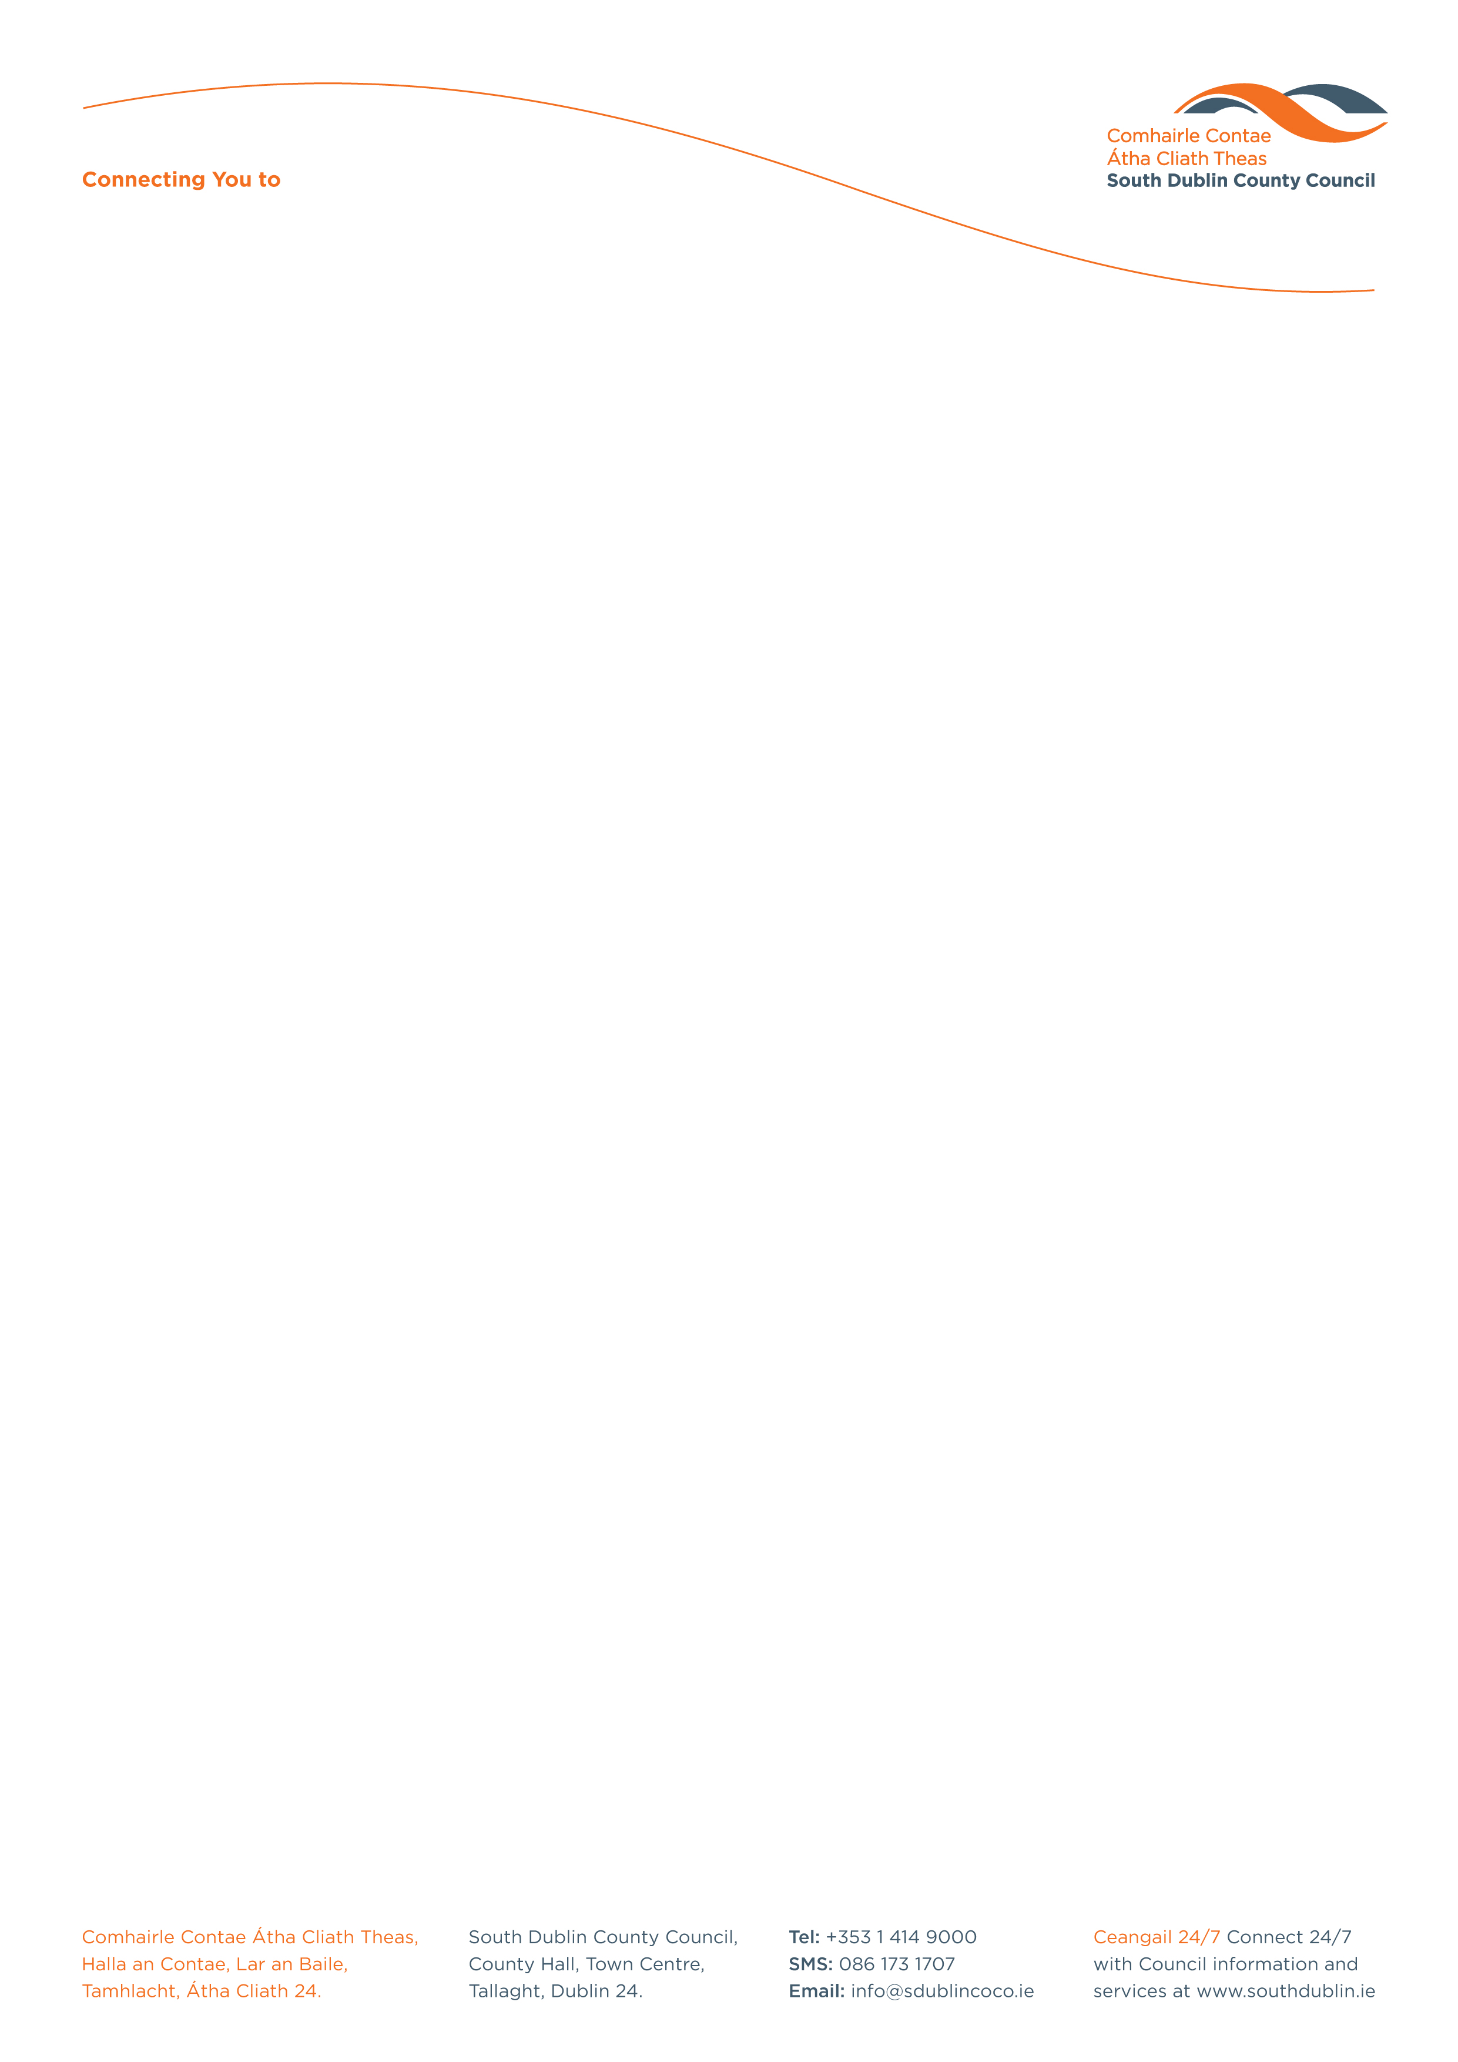

Halla an Chontae, Lár an Bhaile County Hall, Town Centre
Tamhlacht, Baile Átha Cliath 24 Tallaght, Dublin 24
Telefon: 01-4149052 Telephone: 01-4149052

Facs: 01-4149332 Fax: 01-4149332
www.southdublin.ie
Minister for Health & Children,
Department of Health,
Hawkins House,
Hawkins Street,
Dublin 2,
May 11th, 2011

RE: Tallaght Area Committee Meeting – 18th April, 2010

Dear Minister,

At South Dublin County Council’s Tallaght Area Committee Meeting, held on 18th April, 2011, the following Motion was passed:

“That this Committee rejects the building of the National Childrens Hospital at either the greenfields site or at the Mater, this Committee calls for the building of the children's hospital at the Tallaght site.”

I should be obliged if you would let me have a reply on the matter at your earliest convenience.

Thanking you in anticipation.

Yours sincerely,

Allyson Rooney,
SENIOR STAFF OFFICER,
HOUSING ADMINISTRATION.

Housing Administration

