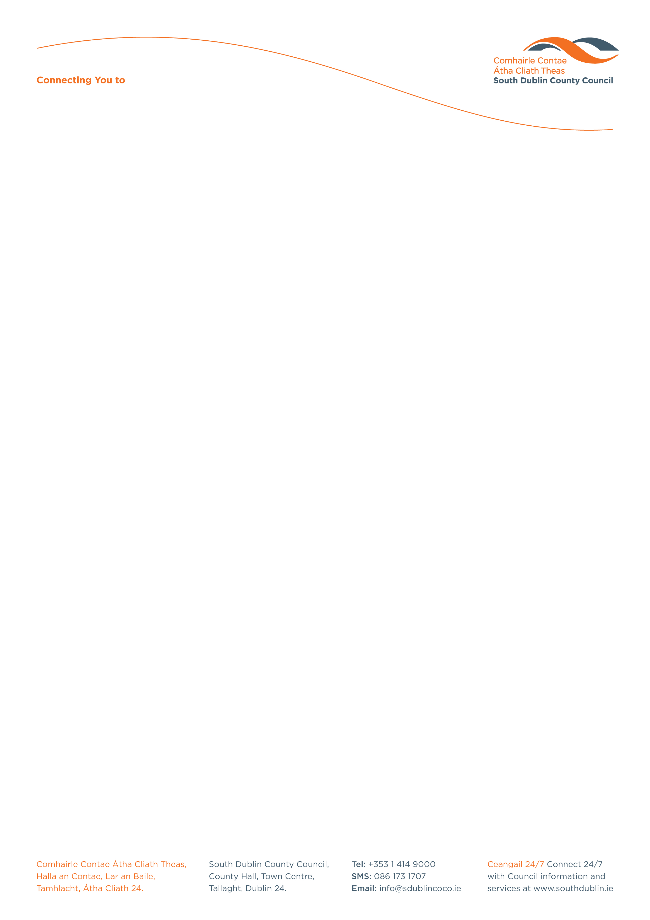

Halla an Chontae, Lár an Bhaile County Hall, Town Centre
Tamhlacht, Baile Átha Cliath 24 Tallaght, Dublin 24
Telefon: 01-4149052 Telephone: 01-4149052

Facs: 01-4149332 Fax: 01-4149332
www.southdublin.ie

The Manager,
Dublin Bus,
O’Connell Street,
Dublin 1.
May 11th, 2011

RE: Tallaght Area Committee Meeting – 18th April, 2010

Dear Sir/Madam,

At South Dublin County Council’s Tallaght Area Committee Meeting, held on 18th April, 2011, the following Motion was passed:

“That the Manager request a written update from Dublin Bus regarding plans to provide a bus shelter for the stop at Tallaght IT. This Motion had previously been discussed at this Council but without resolution.”

I should be obliged if you would let me have a reply on the matter at your earliest convenience.

Thanking you in anticipation.

Yours sincerely,

Allyson Rooney,
SENIOR STAFF OFFICER,
HOUSING ADMINISTRATION.

Housing Administration

