COMHAIRLE CONTAE ÁTHA CLIATH THEAS
SOUTH DUBLIN COUNTY COUNCIL

MEETING OF SOUTH DUBLIN COUNTY COUNCIL
Monday, May 09, 2011
QUESTION NO. 11
QUESTION: Councillor D. Looney
To ask the Manager to provide a comprehensive report on the Council's website, detailing the development of the Council' online presence since the website was launched, a breakdown of current user statistics, plans for development in the coming months and possibilities for future expanded e-governance and citizen interaction?
REPLY:

The development of the Council' online presence since the website was launched
The Council’s web site was started in December 1998. The development of the web site has progressed along a maturity path as follows;

- Establish Online Presence
- Basic Capability
- Service Availability
- Mature Delivery
- Service Transformation

In the intervening 12+ years the web site has been expanded, improved, made interactive, redesigned on a number of occasions, core technologies updated and content delivery platforms redesigned. Presently, it would be reasonable to consider the position of the council’s web site as “Mature Delivery” and impinging in a number of areas on “Service Transformation”.

In terms of the staged model above the following is true:
- Establish Online Presence – in the beginning a small number of fixed format html pages were constructed and presented information relevant to the council.
- Basic Capability – included the ability (again in the early days for people to submit information via email) and the early revisions of a databases driven web site was deployed.
- Service Availability – provided for two way interaction, content which was driven by full blown content management systems, and integrating customer care reporting deployed
- Mature Delivery – web applications such as eplanning, enhanced customer care, waste/refuse.
- Service Transformation – Online GIS in planning in particular but also through the Council's Connect Me, Historical Mapping Project, Availing of shared services such as the NPPR, dog licencing, and now Social Media.

The development of the council's web presence has been driven by and in accordance with the organisation change vision of South Dublin County Council which states the vision for:
- Interconnected Data
- Function Location and Activity Date and Time
- Electronic Document Management
- Browser-ability

Total Quality Management of Information and Data has always been a goal of the organisation and as a result of this the web presence is a by product of the activity which the organisation undertakes.

Breakdown of current user statistics
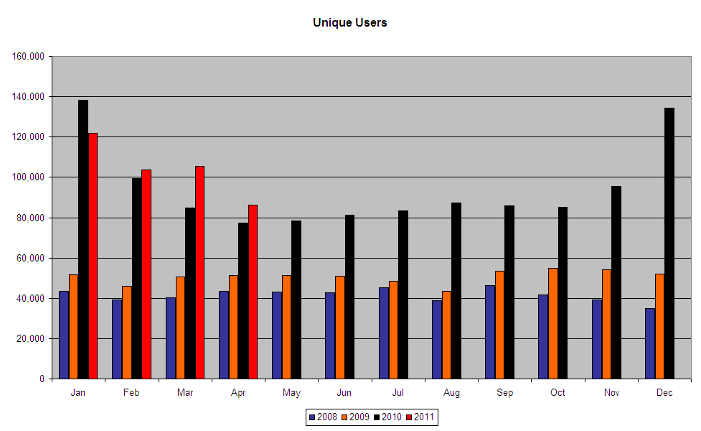

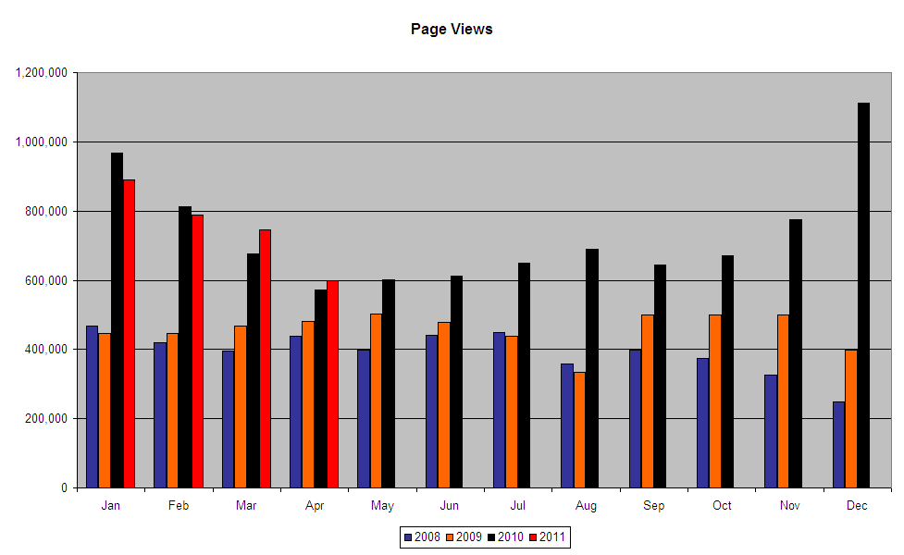

Plans for development in the coming months
South Dublin County Council has for a number of years been deeply engaged with citizen participation with local issues in an online format. Evolving from the Council’s connect project, a service known as Connect Me delivered via the Internet was made available to members of the public. This service gave users of the web site information relevant to their area incorporating location based services. A feature of this site was it’s ability to enable a citizen to report a fault with a designated number of services.

The service has recently migrated to a more advanced version with interactive mapping and additional configuration options available to the council.

With this configuration ability, the site has the potential to fulfil a broad outline of the fix my street brief contained within the current programme for government where it states:

“In local services, we will establish a website – www.fixmystreet.ie – to assist residents in
reporting problems with street lighting, drainage, graffiti, waste collection and road and path
maintenance in their neighbourhoods, with a guarantee that local officials will respond within two
working days.”

The interactive mapping facility that the Council is able to provide can be configured to accept any of the items listed and indeed any other facility which may be required.

It works by the citizen locating a position on a map which they wish to report an issue to the local authority. The user simply follows the option to “fix my street”. They then give details of the issue which they would like to report. The details submitted are logged and forwarded to our customer care staff for actioning once integrated with the customer care database.
In terms of issue resolution - within the Council's customer care application the issue is allocated and work-flowed through the organisation in order to meet the appropriate and relevant member of staff as quickly as possible. Under normal circumstance, this happens in real time. Issues are given target dates and can be reported on statistically to yield appropriate management information.

Possibilities for future expanded e-governance and citizen interaction
Personalisation of services delivered by the Council to the citizen is always the goal of moving the Council's web offerings into the “Service Transformation” classification. This is a challenge facing the Council into the future as there is no single recognised, verifiable and usable online identity. Establishing the identity of the individual thereby enabling the Council to provide personalised service offerings is critical.

The future of the web development will include closer integration with social media even with the possibilities and potential of social media being a source of authentication or through services such as open id. Such an identification for specific service offerings would in some instances require further verification to ensure obligations of data protection are complied with.

The council has previously provided the possibilities of citizen interaction on strategic developments such as the development plan process and although not widely used, it would appear given the emphasis on social media at the present time, that this will become incredibly important in the future and augment some of the traditional methods of interacting with the citizen.

The future of expanded egovernance and citizen interaction will shift from a predominantly web based approach as it presently is to the web being a supporting infrastructure to the citizen's needs. We are presently seeing a growing trend in customers/citizens choosing to interact using mobile devices such as the smart phone technology being deployed by the telecommunications companies today – on their way to work, whilst at recreation, or with specific intent. The Council views the availability of such smart phones to the wider public as being incredibly valuable. Many customers will now have GPS and camera capability on them at all times. This means that the quality of the interaction with the customer/citizen becomes more rich in terms of the information which they can yield to us. This ultimately means that the outcome will be better for the customer.

It is imperative that the council quickly follows where our customers are interacting. We recently surveyed our online customers and found facebook, twitter, linked in, and boards.ie were the present social media streams which our customers were using with facebook being the ubiquitous. Almost ironically, it is these tools which broadly speaking are available at no cost or small cost to organisations. The challenge is to harness their ultimate power to make the process of dealing with queries, reports and requests for service more efficient and effective for the customer.

