COMHAIRLE CONTAE ATHA CLIATH THEAS

SOUTH DUBLIN COUNTY COUNCIL

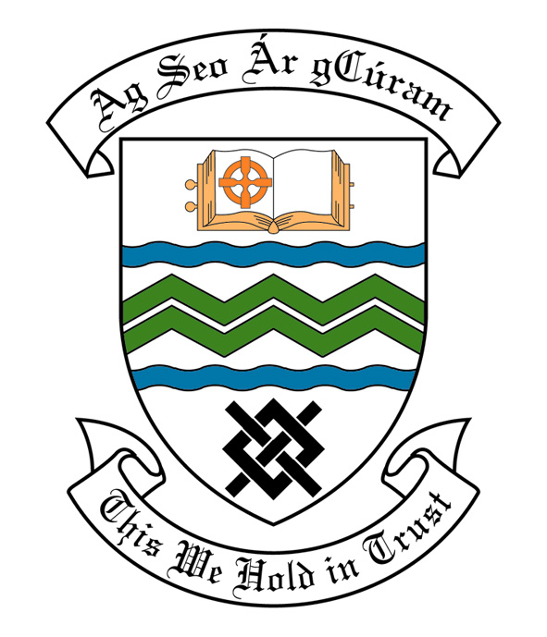

MEETING OF TALLAGHT AREA COMMITTEE (1)

Monday 18th April, 2011

HEADED ITEM NO: H- I (2)

Application for Arts Grants

Application for an Arts Grant under Section 6 of the Arts Act 2003, has been received from the organisation listed below. Payment of this grant, in accordance with the conditions of the Scheme and in the amount set out hereunder, is recommended for approval:-

Ref: | Name of Group | Type of Application | Date Received | Amount
Agf 715 | Tallaght Probation Project | Grant Assistance towards promotion and materials of exhibition | 4/4/2011 | €600

Application for Arts Contribution

An Application for an Arts Contribution under Section 6 of the Arts Act 2003, has been received from the organisation listed below. Payment of this contribution, in accordance with the conditions of the Scheme and in the amount set out hereunder, is recommended for approval:-

Name of Group | Type of Application | Date Received | Amount
Greenhills College | Assistance towards costs of mounting and production of Visual Arts Exhibition | 24/03/2011 | €150
St Dominic’s Community Centre | Assistance towards costs of art workshops for young people | 29/3/2011 | €250

