

LOCAL GOVERNMENT AUDIT SERVICE

Statutory Audit Report

to the

Members of South Dublin County Council

for the

Year Ended 31 December 2009

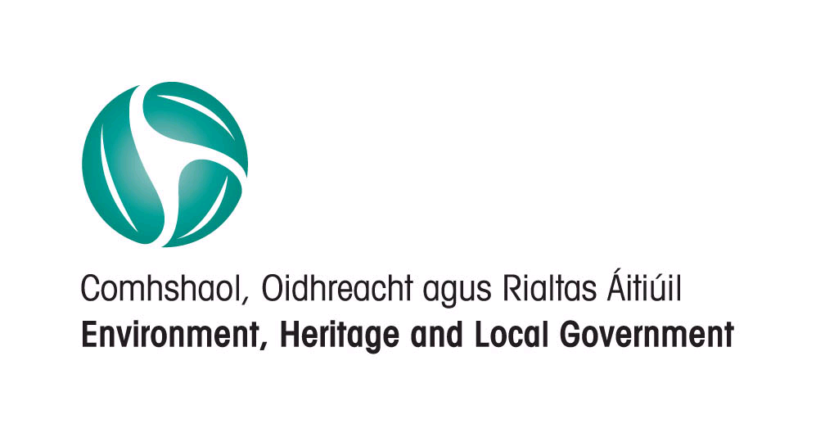

CONTENTS

Paragraph

Introduction 1

Main Issues 2

Financial Performance 3

Financial Standing 4

Capital Account 5

Major Revenue Collections 6

AUDITOR’S REPORT TO THE MEMBERS OF SOUTH DUBLIN COUNTY COUNCIL

1 Introduction

1.1 I have completed the statutory audit of the accounts of South Dublin County Council for the year ended 31 December 2009. My audit opinion on the Annual Financial Statement (AFS) of the Council, which is unqualified, is stated on page 6 of the AFS.

1.2 This report is issued in accordance with Section 120 of the Local Government Act, 2001.

2. Main Issues

Attention is drawn to the following main issues in this report:

- The cost of the Council’s stock of affordable housing units at 31 December,2009 was €29.5m. The cost of these units has been funded by bridging loans from the Housing Finance Agency. Due to the current depressed housing market the demand for affordable housing units remains low and these units have mainly been leased for a five year period under the terms of the Department of the Environment, Heritage and Local Government’s Affordable Leasing Scheme. The Council is also committed to purchasing additional affordable housing units. Any shortfall in the carrying value of these units will have to be funded by the Council (paragraph 5.4).

- The commercial water charges collection percentage decreased to 43% in 2009 from 51% in the previous year (paragraph 6.2).

- There has been a significant decrease in the collection percentage for rates to 86% in 2009 from 92% in 2008 with a consequent increase in the closing arrears at the year end (paragraph 6.3).

3. Financial Performance

3.1 The Income and Expenditure Account with comparative figures for the previous year may be summarised as follows:

 | 2009  €000 | 2008  €000
Expenditure | 241,174 | 254,385
Income | 253,288 | 260,116
Surplus for Year before Transfers | 12,114 | 5,731
Transfers from/(to) Reserves | (12,463) | (8,611)
Overall Deficit for Year | (349) | (2,880)
Opening Balance at 1st January | 12,419 | 15,299
Closing Balance at 31st December | 12,070 | 12,419

3.2 The deficit for the year can be explained by comparing the outturn with the adopted budget as follows:-

€000
Expenditure lower than budget (net) 28,494
Income lower than budget (net) (27,867)
Provision in budget for net credit balance (976)
(349)

The shortfall in budgeted income resulted in reduced expenditure and a small deficit for the year was incurred.

3.3 Expenditure in excess of the budget on various divisions was approved by the Council.

Manager’s Response

Midway through 2009 the Council implemented measures to reduce expenditure by €28.7m as it was clear that a number of important income sources were adversely affected by the economic downturn. As a result the potential deficit of €28.7m for 2009 was reduced to an actual deficit of €0.3m.

4. Financial Standing

4.1 The Balance Sheet shows net assets of €3,765m at 31 December 2009, consisting of the following:
 | 2009  €000 | 2008  €000
Fixed Assets | 3,605,476 | 3,515,481
Work In Progress and Preliminary Expenses | 135,676 | 183,565
Long Term Debtors | 214,212 | 207,433
Net Current Assets | 74,907 | 105,701
Long Term Creditors | (264,886) | (275,873)
Net Assets | 3,765,385 | 3,736,307
Represented by:
Capitalisation Account | 3,605,476 | 3,515,481
Income WIP | 90,128 | 136,012
Specific Revenue Balance | 11,528 | 11,528
General Revenue Balance | 12,070 | 12,419
Other Balances | 46,183 | 60,867
 | 3,765,385 | 3,736,307

4.2 Fixed Assets

The value of fixed assets after accounting for depreciation increased from €3,515m to €3,605m. The main reason for the increase was the purchase of land, houses and buildings and the transfer from work in progress of completed and housing schemes and buildings.

4.3 Work in Progress and Preliminary Expenses

Work in progress and preliminary expenses mainly includes gross expenditure on roads and infrastructure, water and sewerage networks, and housing construction projects. The funding of these projects which mainly includes grants is included in Income WIP.

  - Net Current Assets

Net current assets mainly comprised trade debtors and prepayments €116.9m (2008 €161.1m), creditors and accruals €70.6m (2008 €110.7m) and bank investments and cash of €28.5m (2008 €55m). The decrease in trade debtors and prepayments and creditors and accruals mainly related to balances due and recoupable on capital projects.

4.5 Creditors (Amounts greater than one year)

Creditors (Amounts greater than one year) are mainly comprised of loans payable which have decreased in the year by €8.9m. Loans payable include bridging finance loans of €47.2m (2008 €53.9m) used to finance the Council’s investment in affordable housing (see paragraph 5.4).

4.6 Other Balances

The total of other balances is a net credit balance of €46.2m (2008 €60.8m) and includes debit balances on unfunded project/non project balances of €73.6m (2008 €89.6m) and funded project balances of €56.9m (2008 €33.6m). Unfunded balances on these completed projects may need to be funded from the revenue account.

5. Capital Account

5.1 The capital account records income and expenditure in respect of the acquisition and provision of assets related to services provided by the Council. It has been de-aggregated with the various accounts included under relevant account headings in the balance sheet.

5.2 A summary of the transactions on the capital account, with comparative figures for 2008 is as follows:

 | 2009  €000 | 2008  €000
Expenditure (Including Transfers) | 228,375 | 401,976
Income (Including Transfers) | 208,605 | 378,518
Outturn for the year | (19,770) | (23,458)
Opening Balance Favourable | 14,252 | 37,710
Closing Balance (Adverse)/Favourable | (5,518) | 14,252

  - Capital expenditure in 2009 mainly included expenditure on housing and building of €94.8m, roads and infrastructure of €62.1m, water and sewerage network of €20.5. There was a debit balance of €5.5m on the capital account at 31 December 2009.

5.4 Affordable Housing

Under the provisions of Part V of the Planning and Development Acts 2000-2007, the Council acquired affordable housing units for sale to qualifying purchasers. The cost of the Council’s stock of affordable housing units at 31 December, 2009 was €29.5m and is included in agents works recoupable under trade debtors and prepayments in the balance sheet. The cost of these units has been funded by bridging loans from the Housing Finance Agency. Due to the current depressed housing market the demand for affordable housing units remains low and these units have mainly been leased for a five year period under the terms of the Department of the Environment, Heritage and Local Government’s Affordable Leasing Scheme. Any shortfall in the carrying value of these units will have to be funded by the Council.

The Council is also committed to purchasing additional affordable housing units that may require additional funding.

Manager’s Response

The Council has operated this scheme in accordance with the guidance from the Department of the Environment, Heritage and Local Government. 108 housing units from this scheme have been transferred to a new leasing scheme during 2009 and 2010. These will return to affordable housing stock after five years but in the meantime the income from the leasing scheme is funding the interest on the loans for the properties.

5.5 M50 Improvement Scheme (N4 Interchange to Ballymount Interchange)

Cumulative expenditure to 31 December 2009 on this project was €271.4m, of which payments to the contractor amounted to €223.5m. Significant additional costs have been incurred on this project arising from approved additional works and contractual claims. The final account has not yet been agreed and has been referred to arbitration. The project is funded by the National Roads Authority.

5.6 Total capital income in 2009 amounted to €208.6m and consisted mainly of grants €113.9m, sale of land and property €27.7m, non mortgage loans €19.3m , development contributions €17.7m and transfers from revenue €6.9m.

5.7 Three Year Capital Programme Report

A report on proposed capital projects for the period 2010 to 2012 was prepared under section 135 of the Local Government Act 2001.

6. Summary of Major Revenue Collections

6.1 The percentage yields from the main revenue collection accounts were as follows:

 | 2009 | 2008
Rates | 86% | 92%
Housing Rents | 79% | 78%
Housing Loans | 105% | 110%
Commercial Water Charges | 43% | 51%
Refuse Domestic | 82% | 85%
Refuse Commercial | 41% | 87%

6.2 Commercial Water Charges

The commercial water charges collection percentage decreased to 43% in 2009 from 51% in the previous year. The regional project to install and/or replace meters for non domestic water consumers commenced in late 2006 and was rolled out during 2007/8. While work on this project had a certain disruptive effect on billing, the collection percentage continues to remain low and this is mainly due to the late reading of water meters and the resulting late issue of bills.

6.3 Rates

There has been a significant decrease in the collection percentage for rates to 86% in 2009 from 92% in 2008 and this resulted in an increase in the arrears to €18.1m at 31 December 2009 (2008 €9.3m). Commercial rates income is the major source of income to the Council and accounted for 48% of the Council’s total revenue income in 2009.

6.4 Rents & Annuities,

The collection percentage for housing rents remains weak and this area requires attention to improve collections.

Manager’s Response

Non Domestic Water Charges

The billing cycle for metered water charges was adversely affected by the regional project in 2007/8 to install and/or replace meters for non-domestic water consumers. The timely provision of meter reading was outside the control of the council during 2009 and resulting delays in billing customers affected the collection of income from this source. The council is now in a position to obtain meter readings on a timely basis and this has improved billing and debt management in 2010. Significant efforts have been made since 2009 to collect arrears. This has included disconnection from the water network for non-payment of debt. The concentration on debt management continued in 2010 and this has improved the collection in 2010.

Commercial Rates

The deterioration in the collection of commercial rates reflected the continuing downturn in the economic climate during 2009. Commercial rates debts are pursued vigorously and legal processes are initiated as early in the collection process once it becomes clear that other methods of debt collection are not succeeding.

Housing Rents

The collection of rents improved during 2009 and this has continued into 2010. The council has a policy of early intervention when a tenant fails to make full, regular payment of their rent. Arrangements are made to support the tenant in paying current rent and reduce arrears which may have built up. In addition routine maintenance and/or replacement of windows and doors requests from tenants in arrears are not carried out unless satisfactory arrangements to clear the arrears are in place.

7. Acknowledgement
7.1 I wish to record my appreciation for the courtesy and co-operation extended to the audit team by the management and staff of the Council.

_______________________________

Conor Cummins
Principal Local Government Auditor
22nd December, 2010

