COMHAIRLE CONTAE ÁTHA CLIATH THEAS
SOUTH DUBLIN COUNTY COUNCIL

MEETING OF SOUTH DUBLIN COUNTY COUNCIL
Monday, January 10th 2011
HEADED ITEM NO.11

REPORT TO CORPORATE POLICY GROUP ON SOUTH DUBLIN COUNTY COUNCIL’S RESPONSE TO PROLONGED ADVERSE WEATHER CONDITIONS.
(November 2010 to 10th January 2011)

Report from Roads Section on Adverse Weather Conditions
from 24th October 2010 to 31st December 2010

Arising from experiences gained during the prolonged period of adverse weather in 2009/2010, a programme to manage Winter Maintenance was agreed for the 2010/2011 season which included the following actions, staff resources and plant:

- South Dublin County Council would operate a fleet of 8 Gritters and would have a compliment of 8 Gritting Ploughs.

- A schedule of gritting routes across the County was agreed and these were presented and agreed by the Area Committees in advance of the gritting season.

- The schedule covers approximately 350 km of road and these are prioritised as categories 1, 2 and 3 to be operated in extreme conditions and in emergency situations.

- The salt barn at Ballymount, which has a capacity of 750 ton, would continue to be the base for the gritting operations and this would be shared when the new additional barn off the N4 was completed.

- Salt would be procured by a National Tender under the control of the NRA who would distribute to Local Authorities depending on usage and demand.
- The spread application would be in accordance with NRA Winter Services Manual Rev D1 of October 2010.

- Co-ordination of footpath clearing by available staff would be a key response again in the 2010/2011 season.

- Members of South Dublin County Council and Members of the Oireachtas would be kept informed of the current situation on an ongoing basis during periods of adverse weather.

- The public and business community would be kept advised of the ongoing situation using the Council’s Website, Customer Care Team, Twitter, Facebook, E-Mail, SMS text and regular press releases.

The 2010/2011 gritting season commenced with the first call out on
24th October 2010 and from this date to 31st December 2010 the response of the Council to the adverse weather was as follows:

- The gritting crews were all out on 92 occasions.
  - during the protracted period of adverse weather (25th November 2010 to 31st December 2010) gritting crews were called out 82 times and in this period gritting was being carried out daily, almost on a 24 hour basis.

- The Council spread over 3,000 tonnes of salt on the scheduled routes.

- A further 1,800 tonnes of grit was also applied.

- All Council appropriate plant, supplemented by additional hired plant (JCBs, mini diggers, tractor shovels), were assigned to the clearing of non scheduled roads.

- Approximately 150 – 200 staff were deployed daily (total of 15,000 man hours) during continuous adverse period to clear footpaths – giving priority to Schools, Hospitals, Churches and Community buildings.

The total cost of the Council’s response to this period is estimated to be €700,000 and when added to the expenditure incurred from January 2010 to March 2010 the total cost of dealing with the Winter Maintenance Programme for 2010 is approximately €1.3 million.

Report from Environmental Services

Waste Management Service

The severe weather conditions resulting in poor road conditions particularly in housing estates affected the waste collection service performance in December 2010. The green, black and brown bin collections were hampered by the situation and in the case of the brown bin, the material froze in the bins.

The uncertainty of the conditions made it difficult to plan for additional collections as without a considerable improvement in the conditions no such collection would be possible to implement.

Issues addressed
- Brown bin – material freezing in the bin.
This was a new issue for the council as it was the first time organic waste was held separately. It was also the first indication of the very cold weather affecting the bin collections. Where customers had less than 5kg of waste emptied from their bins the Council is making refunds and accounts are at present being credited.

- Brown/ Black Bin collections affected.
Road conditions hampered collections throughout the month of December. Road conditions made driving hazardous, increased volumes of cars were parked in estates and the footpath conditions also hampered the collection. Assessments of ability to enter had to be made on a case-by-case basis. Conditions were, at times, changing from hour to hour.

Mid December
Disruption was experienced in some areas in the week of 6th December. Backlog collections were arranged each day with an additional collection on Saturday 11th December. These collections were to overcome the disruption. A black bin collection was arranged for customers in the afternoons throughout week commencing 13th December – a brown bin collection week.

End December
Disruption occurred again on the week of 20th December. Collections of both brown and black bins were arranged Wednesday, Thursday and Friday (December 29 to 31), both bins were collected together and special arrangements made so that the waste from these collections went directly to landfill.

Even though weather conditions changed from Sunday December 26th the road and footpath conditions in many estates continued to pose problems during the early part of the week. As a result it was necessary to continue to run spare trucks through the entire week collecting from areas that were missed on their normal schedule due to the poor conditions.

Taking the second sever weather incident and an analysis of collection data on week commencing the 20th December shows presentation rates reducing significantly from Wednesday 22nd December and low tonnages collected.
For comparison purposes the average presentation on a black bin week averages 50% (or 7500 lifts per day), while on a brown bin week averages 20% (or 3000 lifts per day).

Date | Collection type | Number of lifts | Presentation rate | Tonnage collected
20/12 | Black bin | 9,731 | 65 % | 283 tonnes
21/12 | Black bin | 6,929 | 46 % | 194
22/12 | Black bin | 1,590 | 11 % | 46
23/12 | Black bin | 3,411 | 23 % | 86
24/12 | Black bin | 2,018 | 14 % | 56
27/12 | Brown bin | 407 | 3 % | 10 tonnes
28/12 | Brown | 1,957 | 13 % | 46
29/12 | Brown & Black | 9,243 | 31 % ** | 306
30/12 | Brown & Black | 9,748 | 33 % ** | 300
31/12 | Brown & Black | 8,651 | 29 % ** | 262
3/1 | Black bin | 5,415 | 36 % | 162 tonnes

** Note – Presentation rates shown on December 29, 30 & 31 are calculated on the basis of both bins being acceptable for presentation on these 3 days and therefore the calculation is on the basis of total possible presentation.

Cost of extra collections:
The total additional cost of labour to provide additional collections is approximately €68,000 including bank holiday collections. €18,000 relates to the extra collection caused by weather conditions.

- Green Bin collections affected:
The road conditions also affected green bin collections.
Additional collections were arranged and it was agreed that additional waste may be placed beside the green bin provided it is neatly and securely tied up to and including Monday 17th January. The green bin contract contains clauses to deal with missed collections and the full range of problems will be dealt with in this context.

Communications
Information was made available to householders as facts emerged. The website and social media were used to provide the most up to date information throughout this period. In addition customers who had provided mobile contact details were contacted by sms when there were changes to the service. The conditions were such that the best means of communication was as near to the event as possible. The text service provided excellent up-to-the-minute information to customers with 105,274 texts issuing in December compared with 3,663 in the same period in 2009.

Water Services
Regional and South Dublin water demand began to increase significantly from the end November 2010 as the changes in weather and temperature began to take their toll.

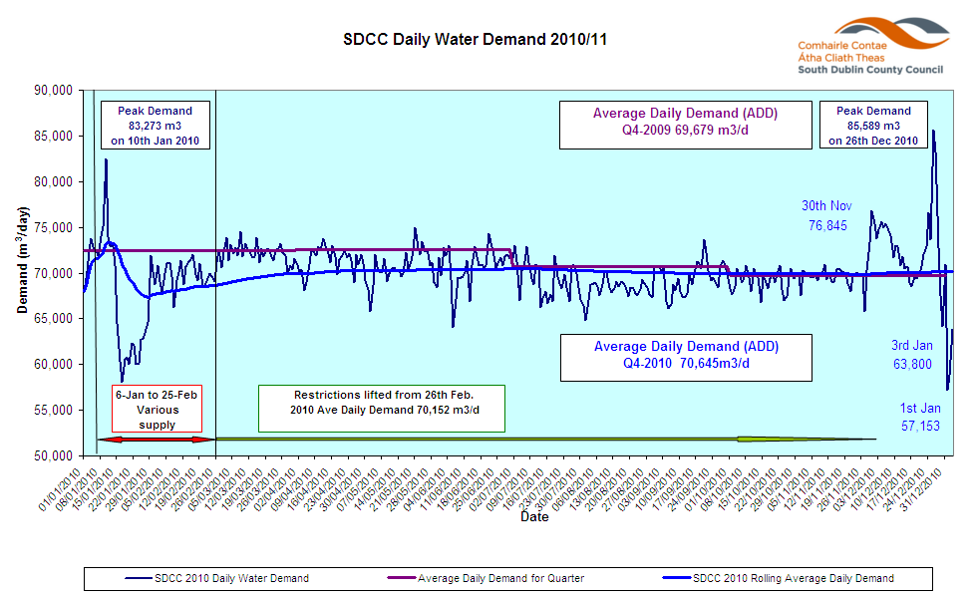

In order to maintain water storage levels to feed supply, on the 1st Dec, South Dublin County Council reduced water pressures throughout the County during the day and to a greater extent at night. While this action had some impact it did not reduce demand in South Dublin sufficiently (5th Dec -74.8ML, 6th Dec 75.4ML) and also led to customer raising issues of very low pressure in the day time period. Therefore on 7th Dec it was agreed to revise the strategy to give full water supply pressure during the day and to restrict water levels at night. This regime continued during the freezing conditions until 26th Dec.

The ground temperature variation from Christmas Day to St Stephens day was approx 20 degrees from -17.1 deg C (25th Dec) to + 2.7 deg C (26th Dec) as recorded at the Casement Aerodrome. When there are sudden changes in temperature the movement in the earth alone can cause pipes to burst. This resulted in water demand increasing to 120% of normal daily demand in South Dublin rising to 85,600ML. On 27th Dec the water levels at the Belgard reservoir were critically low and a decision was taken to turn off water supply in the Lucan/Clondalkin area. It was agreed that South Dublin along with the wider Dublin region would have to impose widespread restrictions in order to manage the limits of production, storage and demand. South Dublin initiated countywide water shut offs from 7pm to 7am each night. On the first day 27th Dec, all areas that could be shut off were shut at 7pm, and Lucan which had been off since 11am was turned on from 7pm until midnight. The county-wide shut-off however is easier to follow for customers and removes ambiguity. This regime has been in place since with the exception of New Year’s Eve to allow for the traditional celebrations. Customers were helpful in not storing water unnecessarily and usage levels began to stabilize enabling the gradual build-up of storage.

The rise in demand was cause by a number of reasons including:-
1. Thaw causing frozen services and internal domestic and commercial plumbing to burst
2. Significant temperature change resulting in ground movement and water mains breaking. The Water Section repaired 41 burst mains in December 2010 which is the highest number in the past 4 years. Attached is a summary of burst mains from 2007 to 2010.
3. Frozen water mains and fittings thawing and bursting. This occurred on mains that are not buried, e.g. mains strapped to bridges.
4. Wastage due to some customers leaving taps running

The burst history illustrates the large volume of natural bursts which took place on the public mains. Third party bursts are those which are caused to the main.

In addition there were a substantial number of individuals who had issues with their own supply. The drawing below indicates where the responsibility of the local authority lies. While the Council crews did provide assistance in some instances and answered a number of calls to verify the position ultimately both domestic and non-domestic customers are responsible for their own connections to the mains. There can be a number of reasons why such bursts happen including the depth to which the services are buried below ground resulting in them being more exposed to the freezing temperatures. Reductions in pressure to conserve water did in some instances affect apartment dwellers and the absence of adequate internal pumping within the developments hindered their supply

Business Sector
The Business sector use approximately 20% of water produced in the County

All premises are required to have 24 hour storage available to them which is adequate to meet their needs. Some non-domestic customers will now need to review their individual requirements and reassess their storage needs with a view to ensuring they have this storage on hand as well as exploring conservation measures to maximise their storage. Section 12.3 of the Agreement and Conditions for Supply of Water states that the “consumer shall provide sufficient water based on anticipated maximum water consumption to the satisfaction of the relevant County Council Engineer.” The recent conditions demonstrate that this condition is not being adhered to and the Council will now engage in an audit of non-domestic customers using meter readings against the on-site storage to assess the situation and to ensure that consumers bring their storage capacity to their own required levels.

Dublin Regional Water Conservation Programme
The updated Generále Des Eau Report 2000 recommended a reduction of distribution losses to 20% by 2007 and 16% by 2016.

SDCC is working progressively towards the 2016 Distribution Losses (DL) target.
The final audit of all corrected 2009 demands indicates that our 2009 DL: averaged 21.91%
Using this as our starting point for 2010, the average target DL for 2010 is 21.07%.
Subject to end of year results this target will reduce annually by 0.845%. South Dublin has the lowest leakage in the region.

Report from Housing Department

Emergency Callouts from 23rd December to 3rd January
Heating | Burst Pipes | Air Locks | Electrics | Alarm Actv. | Vandalism | Leaks | No Water | Misc | Total
Tallaght
6 | 10 | 3 | 2 | 1 | 3 |  |  | 1 | 26
Rathfarnham
1 |  |  |  | 1 |  |  |  |  | 2
Clondalkin
26 | 11 | 5 | 2 |  |  | 2 |  |  | 46
Lucan
4 | 7 | 1 |  |  |  |  | 1 | 2 | 15
Overall T |  |  |  |  |  |  |  |  | 89

Report from Corporate Services & IT Services

Communications Update

During the adverse weather conditions and the water disruptions which followed during the period 26th November 2010 to the 4th January 2011.The Council used all our media outlets including the Web, Facebook and Twitter on an ongoing basis (including weekends and the holiday period) to keep the Public and Elected Members updated with the latest news and projections. The Council received some very positive responses from the public in relation to the timeliness and quality of information that was made available to them over this period. In addition the Council monitored customer queries throughout the weekend/holiday period and appropriate staff were in place to deal with situations as they arose. In order to deal with the number of queries in relation to water supply restrictions/disruptions over the holiday period additional staff from the Customer Care Unit and the IT Department were deployed over the holiday period, especially on the 30th and 31st December to deal with web queries and take calls on the Council’s landline 01-4149000. In addition to the Council’s emergency number 01-4574907 was available 24/7 over the Christmas/ New Year period.

Customer Contact system

Dec 2010 Dec 2009
Phone calls 26,701 20,751
Web based queries 1,745 747
Customers at Counter 2,243 2,640

The figures show a large increase in customer contact activity both on the phones and through the web in comparison to figures for December 2009.

Members update

The Mayor and elected members were updated by email on a daily basis or as relevant information was available.

SDCC Website

South Dublin County Council’s updates and information on the adverse weather conditions and water supply restrictions were placed on the front page of the website www.sdcc.ie on an ongoing basis in November and December 2010 and January 2011 (including regular updates over the holiday period).

Web Views:

26th November 2010 to 4th January2011

Page views: 1,423,201
User sessions: 335,294
Unique users: 165,288

Page Views: Month of December, 2010

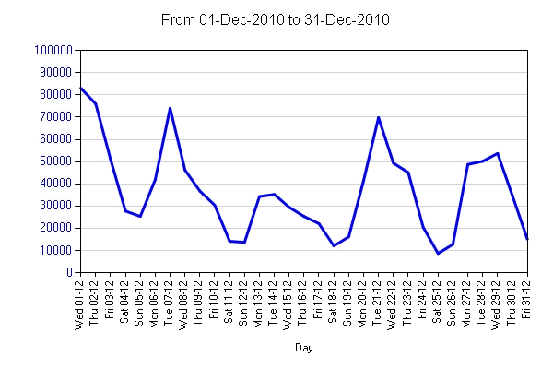
Social Media

Twitter - December 2010

Elected Members and the Public were also able to follow South Dublin County Council on our Twitter Account www.twitter.com/sdublincoco. The number of followers on Twitter increased from 378 to 1009 over this period. On average the council posted 20.4 tweets per day, totalling 635 tweets for the month of December 2010.
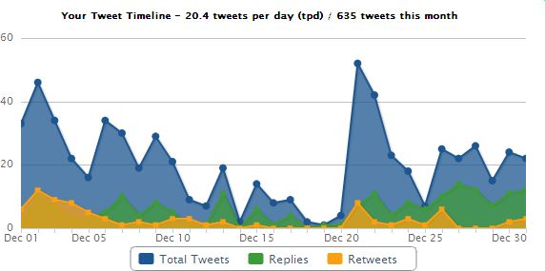
Tweet Density: Times of the Day. Coverage from 7am - 12midnight
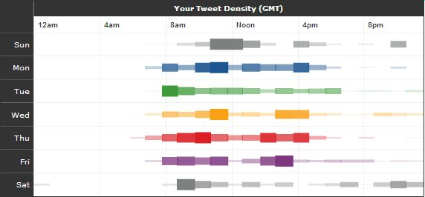

Tweet distribution over days of the week
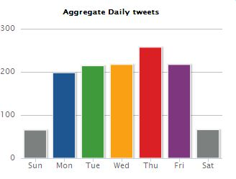

Tweet distribution by hour of day

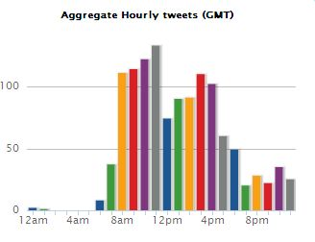
Facebook – December 2010

The Council also created a Facebook Page to keep the Public/Elected Members informed when the adverse weather conditions first commenced over the week-end of the 26th /27th November 2010. www.facebook.com/SouthDublinCountyCouncil now has over 550 followers and 593 comments have been created on SDCC Facebook page since its creation.

Facebook Impressions:

Facebook Stream Impressions - 244,269
Unique Logged in FB Users - 1,968
Page views from Logged in FB Users - 6002
Comments created on SDCC FB Page - 593

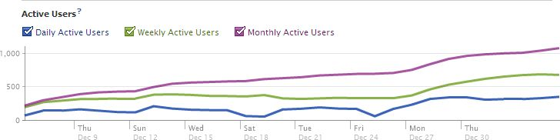

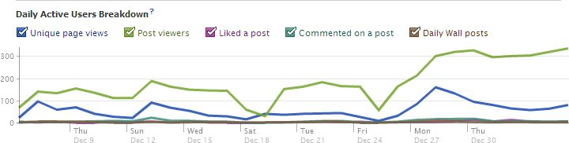

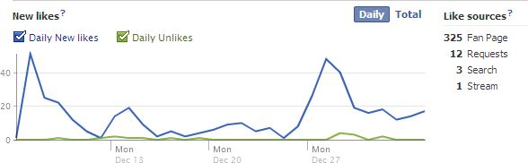

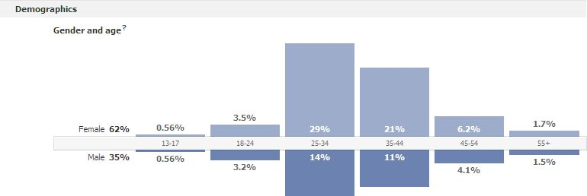

Media Queries

Press releases and updates to website were circulated to the media on a daily basis. Over 50 queries and interviews were dealt with regarding the Council’s response to weather conditions and water supply information. In addition the national and local media were also following SDCC on Twitter and Facebook and relaying this information to the public through their media channels.

National Task Force and Inter – Agency Meetings

Throughout the adverse weather period South Dublin County Council gave daily and sometimes hourly updates to the National Task Force that was set up to co-ordinate responses nationally. These meetings were attended by the Ministers and officials for Transport, Defence and Environment, Met Eireann, Michael Phillips Dublin City Engineer and John Tierney (on behalf of the Dublin LA’s), the NRA, the HSE, the HSA, Bus Eireann, Dublin Bus, LUAS, Irish Rail and the CCMA.
-----------------------------------------

